Appendix E – Step Stool Safety Awareness
(Page 1 of 2)

Instructions: Reviewing this document is required for employees whose only ladder use involves using step stools such as these types pictured below:

Common examples of step stools:
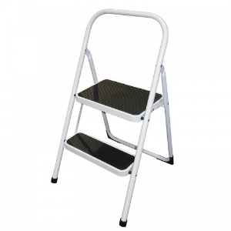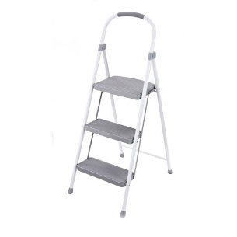

Reviewing this document is not required if only using these types of step stools:
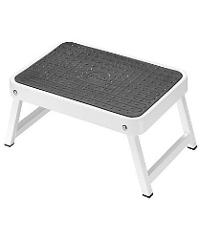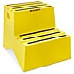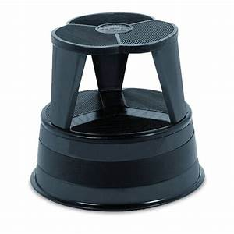

Ladders are a potential source of workplace injuries. Most of these incidents can be prevented when proper safety precautions are implemented.

Proper Use
Step stools are intended for use by one person.
A step stool requires level ground support for all four of its side rails.
A step stool must not be used unless its base is spread fully open and the spreaders are locked. Step stools are not to be used as single ladders or in the partially open position.
In order to prevent tipping over sideways due to over-reaching, the user must climb or work with the body near the middle of the steps or top cap. The step stool should be set up close to the work. Never attempt to move the step stool without first descending, relocating the step stool, and then re-climbing. Do not attempt to mount the step stool from the side or step from one ladder or step stool to another unless the step stool is secured against sideways motion.

Appendix E – Step Stool Safety Awareness
(Page 2 of 2)

When ascending or descending the step stool, users must always face the step stool.
The braces on the rear of a step stool are not intended for climbing or standing and must not be used for that purpose.
The anti-slip feet at the bottom of the step stool side rails must be present and in good condition prior to using. The step stool must not be used on ice, snow or slippery surfaces unless suitable means to prevent slipping is employed.
A step stool must never be placed upon other objects such as boxes, barrels, scaffolds, or other unstable bases in an effort to obtain additional height.
Do not wear sandals, flip flops, or footwear with leather / smooth soles. Clean mud or other slippery substances off of shoes before climbing.

Proper Care
A thorough inspection must be made when the step stool is initially purchased and each time it is placed into service. Clean the climbing and gripping surfaces if they have been subjected to oil, grease or slippery materials. Working parts, bolts, rivets, step-to-side rail connections, and the condition of the anti-slip feet (safety shoes) shall be checked. If structural damage, missing parts, or any other hazardous defect is found, the step stool must not be placed into service and discarded.
A step stool exposed to excessive heat, as in the case of fire, may have reduced strength. Similarly, step stool exposed to corrosive substances such as acids or alkali materials may experience chemical corrosion and a resulting reduction in strength. Remove these step stool from service.
Step stool with bent or broken side rails must not be placed into service.
Do not store other materials on the step stool while it is in storage.
In the event a step stool is discarded, it must be destroyed in such a manner as to render it useless. Another person must not be afforded the opportunity to use a step stool that has been deemed unsafe.

Information retrieved from American Ladder Institute.org

