Procedures for the Proper Disposition of Equipment and Materials through
Lion Surplus
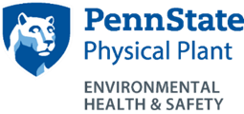
July 2018

Table of Contents

I. Introduction 1
II. Items Prohibited from Lion Surplus 2
A. Asbestos Containing Material (ACM) 2
B. Batteries 4
C. Fire Extinguishers 4
D. Gas Cylinders 5
E. Mercury 7
F. Polychlorinated Biphenyls (PCBs) 9
III. Items with Regulatory or Safety Restrictions as to Sale or Transfer 10
A. Laser Systems 10
B. Gas Chromatographs 11
C. Liquid Scintillation Counters 12
D. Radiation-Producing Equipment 13
E. Equipment Containing Coolants, Oils, and Refrigerants 15
F. Equipment and Labware used with Hazardous Substances 17

Introduction
Lion Surplus is responsible for the collection, sale and/or disposal of University-owned equipment, supplies and/or materials which have become obsolete, surplus or scrap to the needs of any University department. Lion Surplus operates a public sales store.
Some equipment and material may not be appropriate for resale due to the presence of hazardous materials or characteristics, or regulatory constraints. It is the responsibility of the department to ensure that the equipment is rendered safe for resale or disposal as detailed in this document prior to submitting a pickup request.
The descriptions provided on the following pages are examples of the types of hazards and potential items that may be a concern. This is not intended to be a complete and all-encompassing list but rather a summary compilation of existing policies and best practices. It is not intended to replace or supersede any established university policies.
Questions about a potentially hazardous item or material should be directed to Environmental Health and Safety (EHS), 814-865-6391. Any spills during transport, loading, unloading, or storage must be reported to the appropriate supervisor and EHS immediately. Clean-up costs will be charged to department which owns the equipment.
Items that do not meet the requirements of this document must not be offered for disposal or picked up. It is not permitted to drop off any items at Lion Surplus without prior notification or during non-working hours.
Refer to Business Services Policy 15 for proper instructions on property transfer.
This Procedures for the Proper Disposition of Equipment and Materials through Lion Surplus is maintained as Environmental Health and Safety document number EHS-0027.

Items Prohibited from Lion Surplus

Asbestos Containing Material (ACM)
Description
Asbestos is a naturally occurring fibrous mineral that was used extensively for its insulating and fireproof properties. It is often white or gray in appearance and may be in the form of braided or paper wire insulation, woven cloth-like material, cement-like sheeting known as transite or stone lab bench tops (soapstone). Contact EHS for confirmation as to whether the item contains asbestos.
Associated Hazards
- Long term over-exposure to airborne asbestos fibers has been shown to cause diseases such as asbestosis and cancer. Since asbestos is naturally occurring, there are allowable exposure limits.
- Manipulating asbestos containing materials (e.g., drilling, sanding, or sawing) may generate dangerous levels of respirable asbestos fibers. These activities are strictly regulated and can only be conducted by licensed OPP Asbestos Workers or OPP/EHS-approved contractors using equipment and procedures that are specifically approved for these materials.
Procedures for Proper Disposition
- For disposal at University Park, a Work Order must be submitted through OPP. This may require the disposal of entire pieces of equipment.
- For disposal at facilities other than University Park contact EHS for guidance.
- Asbestos contractor work must be coordinated with EHS.
- Disposal costs are the responsibility of the originating work unit.

Examples of asbestos containing materials
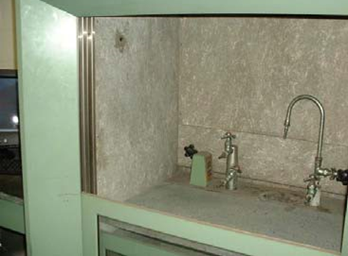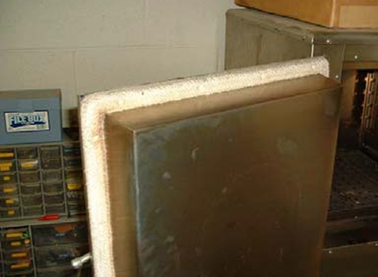
Transite fume hood liner (asbestos cement board, gray or black) Oven door gasket/seal (coarse woven asbestos cloth)
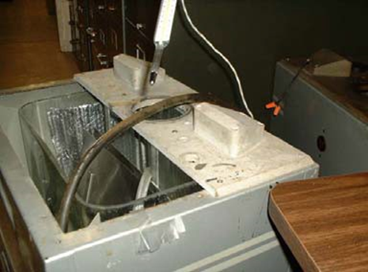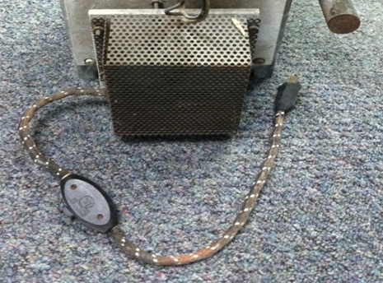
Transite sheet on water bath High Temperature Wire Insulation (old cloth/paper insulations, white, black, colored)
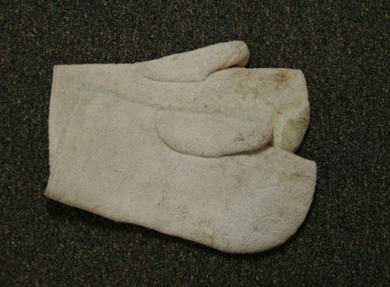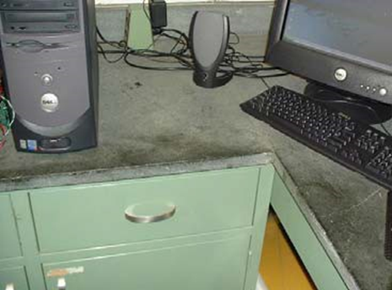
Lab Mitts/Gloves (coarse woven asbestos cloth) Lab Bench Top and Adhesives (usually soapstone but can be other types)

Batteries
Description
Lion Surplus will not accept any batteries except as part of functional equipment.

Associated Hazards
- Mercury and other heavy metals can cause a variety of health effects including kidney and neurological damage.
- The acid contained in some batteries can cause skin and eye burns.
- Improper disposal of hazardous chemicals may result in the contamination of soil and ground water.

Procedures for Proper Disposition
Alkaline batteries may be disposed of in the trash. For all other batteries, follow the University Battery Recycling Program.

Examples of batteries that may contain hazardous material

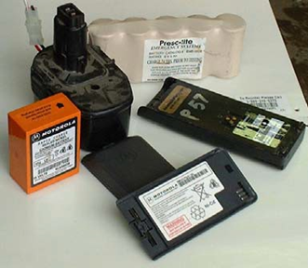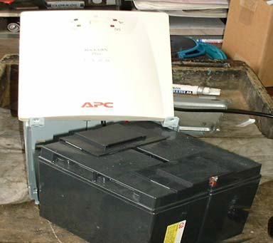
Rechargeable Batteries UPS Battery

Fire Extinguishers
Description
Fire extinguishers come in a variety of styles including pressurized water, chemical powder, carbon dioxide, halon, and specialty extinguishers for metal fires.
Associated Hazards
Fire extinguishers are pressurized devices that may cause serious injury if ruptured.
Procedures for Proper Disposition
- For University Park, a work order must be submitted through OPP.
- For locations other than University Park contact EHS for guidance.

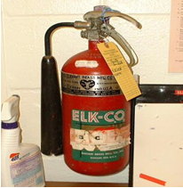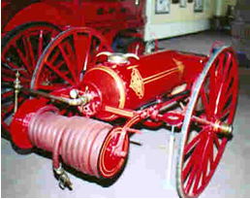
Carbon dioxide extinguisher Industrial sized extinguisher

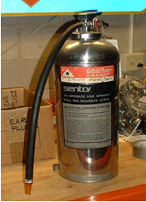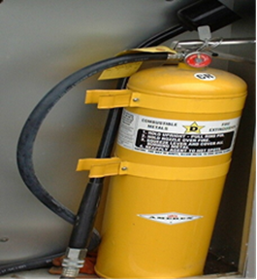
Class A water filled Class D for Metal Fires

Gas Cylinders
Description
Gas cylinders are manufactured in a variety of styles and are used to store compressed or liquefied gasses under high pressure. Examples include:
- Laboratory gas cylinders
- Lecture bottles
- Commercial propane cylinders
- Oxygen bottles
- Other pressurized devices
Associated Hazards
- Gas cylinders may contain hazardous or toxic gases, or can cause a hazardous environment.
- Gas cylinders are pressurized devices that may cause serious injury if ruptured.
Procedures for Proper Disposition
- To move cylinders (whether when in use or for disposal) the regulator and tubing must be removed and the cylinder recapped.
- For University Park, cylinders purchased through General Stores are to be used in accordance with University Safety Policy SY25 returned through General Stores when empty or no longer needed.
- Cylinders at locations other than University Park or purchased through vendors other than General Stores, should be returned to the gas supplier when possible.
- For unknown or otherwise non-returnable gas cylinders, the generator shall complete and submit a Chemical Waste Disposal Request Form on the EHS web site.
- Gas cylinder disposal costs are normally covered by the EHS waste budget.

Examples of gas cylinders

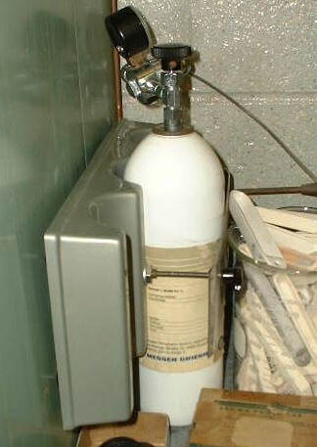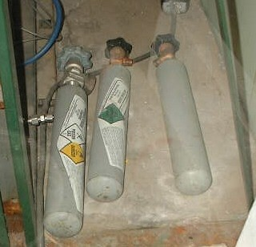
Calibration gas cylinders Lecture bottles
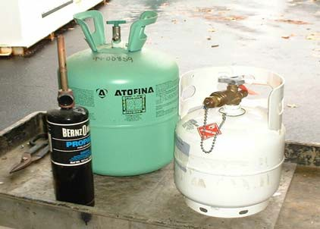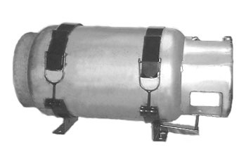
Miscellaneous cylinders Propane tank
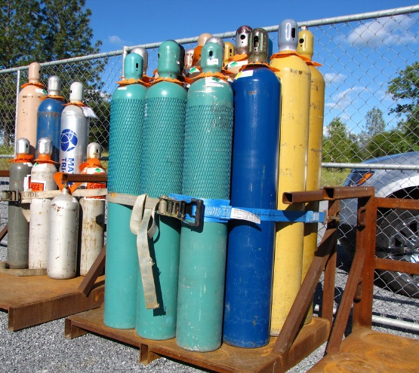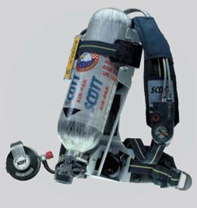
Miscellaneous cylinders Supplied air breathing apparatus (SCBA)

Mercury
Description
Mercury, a silver liquid metal, is a toxic chemical most commonly used in: thermometers, vacuum pumps, manometers, barometers, switches, and many types of lab equipment. Items often found contaminated with mercury include incubators, heating blocks, ovens, refrigerators, and water baths. Spilled mercury is often found when moving lab equipment or furniture. Take a few moments to carefully check the floor or bench top for small beads of mercury that may have spilled.
Associated Hazards
- Mercury is a poison that can cause kidney and lung damage in high concentrations. Mercury vapor can cause neurological damage.
- Mercury spills can also lead to potential environmental implications.
Procedures for Proper Disposition
- Contact EHS immediately for any mercury spills. EHS will initiate cleanup when an item is found contaminated with liquid mercury. Items free of mercury contamination may be sold or auctioned. If unable to be cleaned the item will be disposed of as waste through EHS.
- If equipment to be disposed of contains mercury, it must be removed prior to disposal. Contact EHS for guidance.
- Vacuum pumps must be checked by EHS for mercury contamination before being sold.

Examples of items that may contain mercury
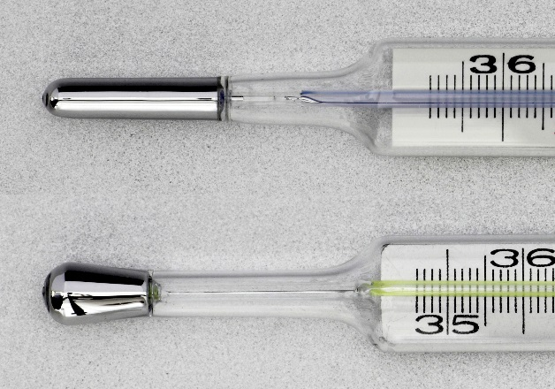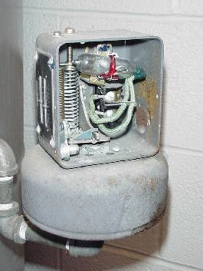
Thermometers Mercury switch
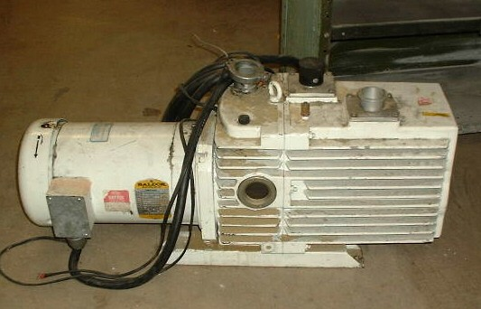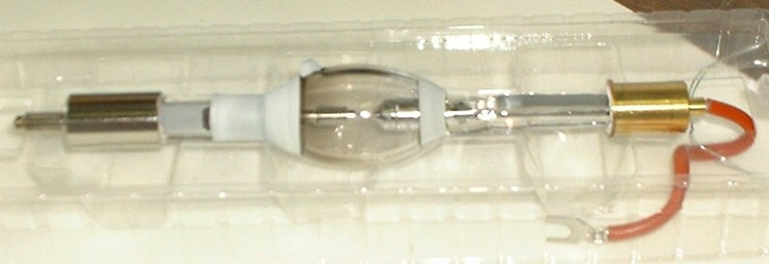
Vacuum pump Mercury lamp
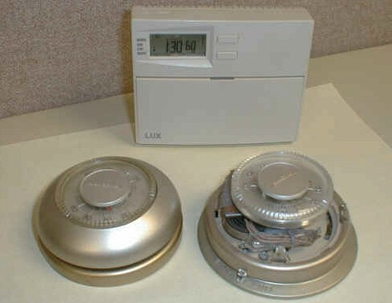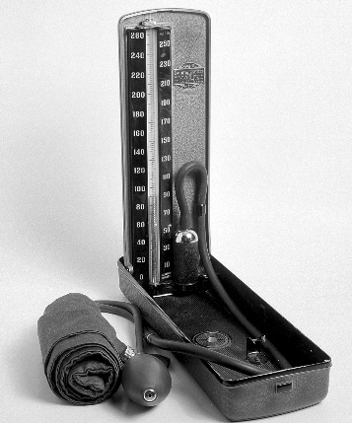
Thermostats Blood pressure monitor

Polychlorinated Biphenyls (PCBs)
Description
PCBs belong to a broad family of man-made organic chemicals known as chlorinated hydrocarbons. PCBs were used for their heat absorbing capacity in electrical and hydraulic equipment.
Associated Hazards
- PCBs can cause health effects from long term high exposure.
- PCBs are stable, biomagnify, and do not break down in the environment.
Procedures for Proper Disposition
Click here for information on disposal of PCB containing light ballasts. Light ballasts labelled “non-PCB” may be disposed of as scrap metal.
For equipment that may contain PCBs, contact EHS with the description, origin, and serial number, if available. EHS will determine if the item contains PCBs. EHS will either authorize the items resale as a non-PCB item, or arrange for proper disposal. For transformers and capacitors, see Section E, Equipment Containing Coolants, Oils, and Refrigerants
Examples of items that may contain PCBs

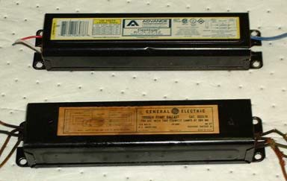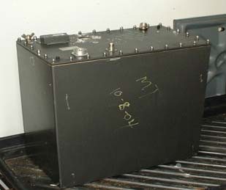
Fluorescent light ballasts Oil-filled transformer

Items with Regulatory or Safety Restrictions as to Sale or Transfer

Laser Systems
Description
Lasers are a source of intense, directional visible or invisible light. Lasers can be freestanding or embedded as part of analytical and other scientific equipment. For additional information and guidance, see the University laser safety policy, SY17.
Associated Hazards
- Laser light can damage the eyes and burn unprotected skin.
- Laser systems can contain hazardous chemicals, coolants, oils or dyes used to generate the laser beam.
Procedures for Proper Disposition
- Systems in working order may only be resold to the original manufacturer; other manufacturer of similar equipment; a manufacturer-certified installer; educational or research institutions; or private companies who currently use similar equipment. Lasers being transferred, donated, or sold to another institution, company, or individual, requires prior notification to EHS per Safety Policy SY17.
- When a suitable buyer for a Class 3B or 4 lasers, or systems with embedded Class 3B or 4 systems, cannot be found, the system must be made inoperable. EHS is responsible for ensuring that the system has been made inoperable by Lion Surplus; the equipment can then be scrapped.
- Laser systems may also contain hazardous chemicals, coolants, oils, or dyes used to generate the laser beam. It is the responsibility of the owner of the equipment to drain the equipment of all hazardous materials and arrange for their disposal through EHS before requesting the system be picked up by Lion Surplus.
- Class 1, 2, and 3A lasers, with no embedded Class 3B or 4 systems, may be sold without restriction.

Examples of various types of laser systems
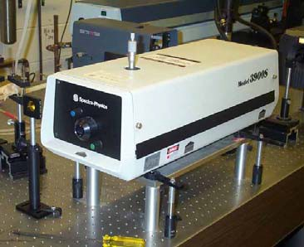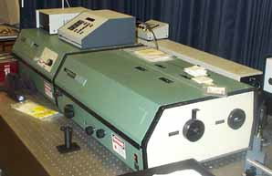
Sample lasers

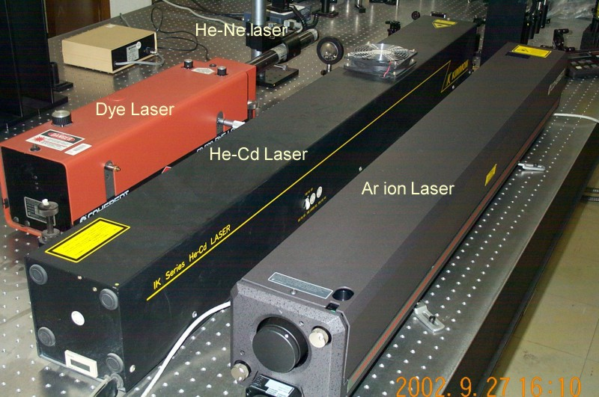

Gas Chromatographs
Description
Gas chromatographs are analytical instruments used to separate and identify components within a mixture of chemicals, gases, or compounds.
Associated Hazards
- Some gas chromatographs contain radioactive sources known as Electron Capture detectors.
- Some equipment can be contaminated with chemicals.
Procedures for Proper Disposition
Contact EHS to inspect each system prior to disposal. Equipment must be decontaminated of chemical, biological, or radioactive materials prior to disposition through Lion Surplus. If it contains a radioactive source EHS will remove the source and perform a survey to confirm the system is free of any radioactive contamination prior to disposal at Lion Surplus.
Examples of gas chromatographs
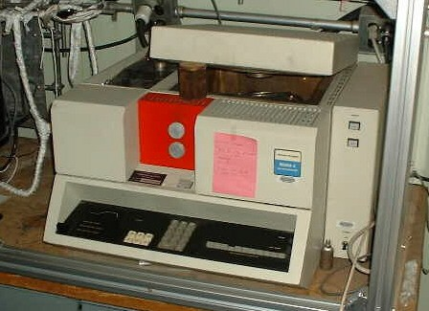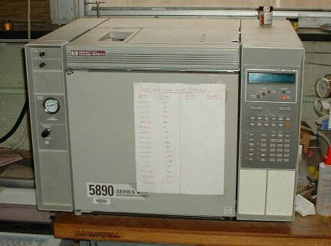
Hewlett Packard/Agilent Perkin-Elmer

Liquid Scintillation Counters
Description
Liquid scintillation counters are analytical instruments used to measure very low levels of radioactive materials.
Associated Hazards
Liquid Scintillation Counters typically contain internal radioactive sources.
Procedures for Proper Disposition
- Contact EHS to inspect each system. If it contains a radioactive source EHS will remove the source and perform a survey to confirm the system is free of any radioactive contamination.
- Once the source has been removed and the system confirmed free of radiological and chemical contamination, the system can be sold without restriction.
Examples of liquid scintillation counters
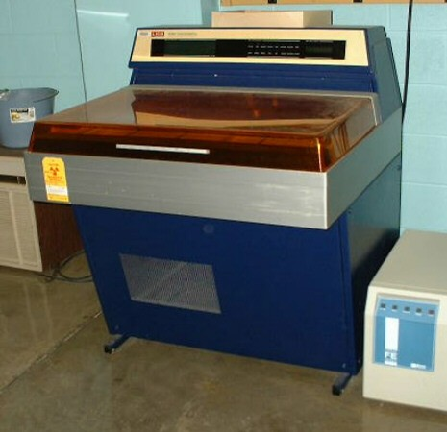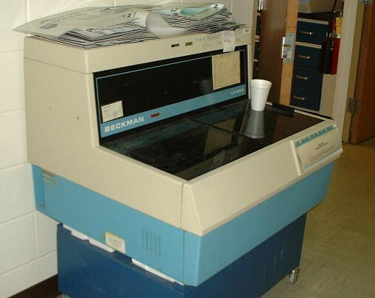
Beckman Model LKB Model

Radiation-Producing Equipment
Description
Radiation-producing equipment includes a variety of analytical instruments typically used to study the structure and composition of materials. These devices are subject to state and federal regulations governing the ownership, sale, and transfer of such devices.
Radiation-producing equipment includes the following:
- Analytical x-ray and fluorescence systems
- Electron microscopes
- Electron spectroscopy for chemical analysis systems (ESCA)
- Medical radiograph and fluoroscope systems
- X-ray photoelectron spectroscopy systems (XPS)
- X-ray vacuum spectroscopy systems
For additional information and guidance on the university’s radiation-producing equipment see safety policy SY15.
Associated Hazards
- High level exposure to some radiation producing equipment is associated with immediate health risks and long term risk of increased cancer incidence.
- Radiation producing equipment may also contain hazardous chemicals, coolants, and oils.
Procedures for Proper Disposition
- Radiation producing equipment may only be resold to the original manufacturer or other manufacturer of similar equipment; a manufacturer certified installer and/or representative; educational or research institutions; or private companies who currently use similar equipment.
- Potential buyers of radiation producing equipment shall provide a letter or email to EHS acknowledging their experience and awareness of the hazards associated with the equipment. The letter must state the intended use of the equipment and include their radiation safety officer’s contact information. EHS will review the proposed buyer's information and make a recommendation approving or disapproving the sale.
- When a suitable buyer for system cannot be found, the system must be made inoperable. EHS is responsible for ensuring that Lion Surplus has made the equipment inoperable; the equipment can then be scrapped.
- It is the responsibility of the owner of the equipment to drain the equipment of all hazardous materials and arrange for their disposal through EHS before requesting the system be picked up by Lion Surplus.
Examples of radiation-producing equipment
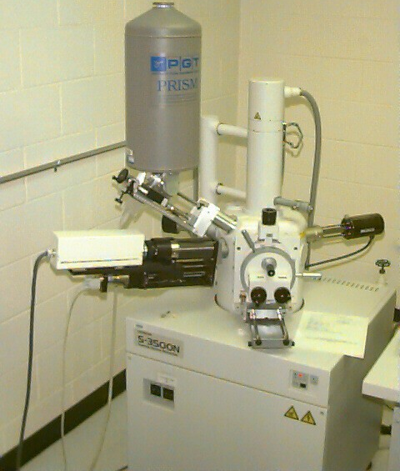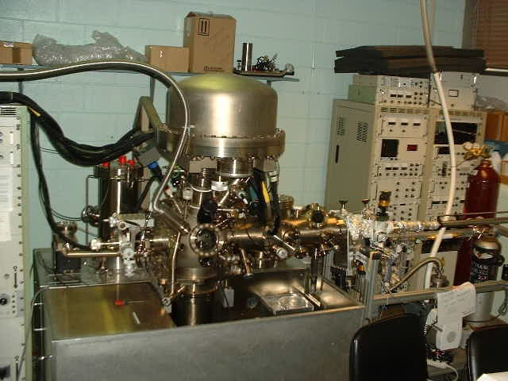
X-ray vacuum spectroscopy system Electron microscope
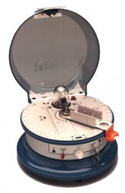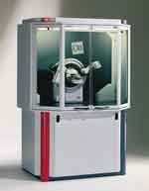
Physics lab demonstration x-ray unit Analytical x-ray unit

Equipment Containing Coolants, Oils, and Refrigerants
Description
Equipment that contains coolants, oils, and refrigerants, such as refrigerators, freezers, air conditioners, milling machines, cutting lathes, hydraulic presses, and vacuum pumps require proper processing prior to final disposition.
Associated Hazards
- As part of a working system, coolants, oils, and refrigerants do not typically pose a hazard. However, when an item is no longer useable, these materials must be removed before items are disposed and to prevent accidental release to the environment.
- Refrigerators and freezers that have been used to store chemicals, infectious agents, or radioactive materials must be cleaned and decontaminated of any hazardous material before being offered to Lion Surplus (See Section F, Equipment and Labware used with Chemicals, Petroleum Products, Oils, Infectious Agents, or Radioactive Materials, below.)
Procedures for Proper Disposition
- Equipment in working order and containing coolants, oils, and refrigerants as part of the equipment’s function and design may be transferred intact to Lion Surplus for sale. If the equipment contains a reservoir tank, such as those on milling machines, vacuum pumps, or hydraulic presses, the tank must be drained and the material disposed through EHS prior to transfer to Lion Surplus.
- Equipment that is not functioning must have coolants, oils, and refrigerants removed prior to transfer to Lion Surplus. Refrigerants and refrigerant oils must be recovered by an EPA certified technician. For University Park, a work order must be submitted to the Physical Plant to arrange removal of these materials. At all other locations, contact the maintenance supervisor for direction.
Examples of equipment containing coolants, oils, and refrigerants
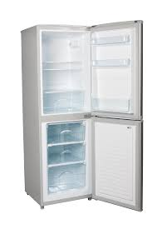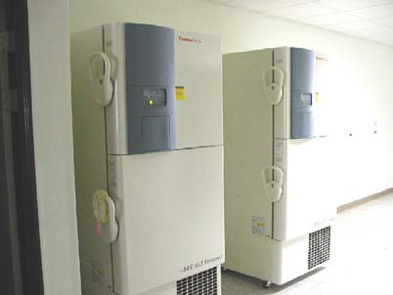
Standard refrigerator/freezer -80 degree freezer
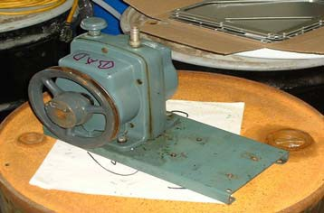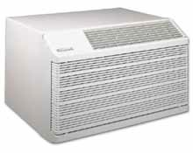
Vacuum pump Air-conditioning unit
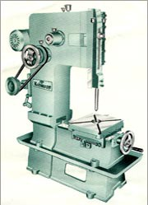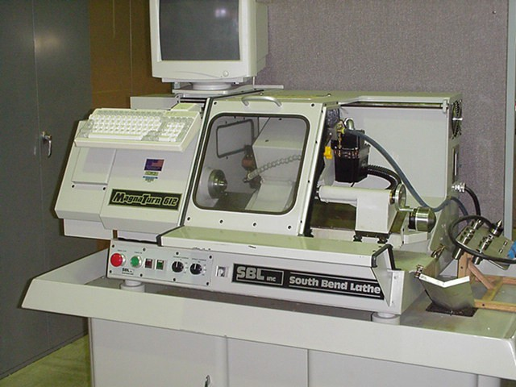
Drill presses, milling machines, lathes, and machine tools that use cutting oils

Equipment and Labware used with Hazardous Substances
Description
Equipment and labware that has been used with hazardous substances including chemicals, petroleum products, oils, infectious agents, or radioactive materials must be properly cleaned and free of any harmful contaminants before being offered to Lion Surplus for sale. Excess and unneeded products such as janitorial chemical supplies, empty drums, paint, and other items may not be appropriate for resale and may be prohibited due to regulatory constraints.
Items may require special processing and approval include:
- Autoclaves
- Biological safety cabinets
- Centrifuges and micro-centrifuges
- Diagnostic or therapeutic medical and athletic equipment
- Empty drums
- Equipment used to apply pesticides
- Glassware
- Heating blocks
- Hoods, including laminar flow hoods
- Incubators
- Laboratory ovens
- Petroleum or other types of storage tanks
- Refrigerators/Freezers
- Vacuum pumps
- Vortexes
- Water baths

Associated Hazards
- Equipment contaminated with chemicals, infectious agents, or radioactive materials can present an exposure hazard to someone unaware of the contamination.
- The residues remaining in “empty” containers may render the container incompatible with certain intended uses after resale.
Procedures to Ensure Proper Disposition
- Items that may have been in contact with chemicals, infectious agents, or radioactive materials must be decontaminated prior to being offered to Lion Surplus. Contaminated equipment can often be effectively decontaminated. EHS can advise as to proper decontamination techniques.
- Contact EHS regarding the disposition of surplus materials such as paints, oils, empty containers, or chemicals. EHS will either approve the transfer of the materials to Lion Surplus for sale or dispose of the materials.
- Complete the Laboratory/Research Equipment Clearance Form, tape a copy to the equipment, and email a copy to EHSLabSafety@psu.edu.

Examples of potentially contaminated items
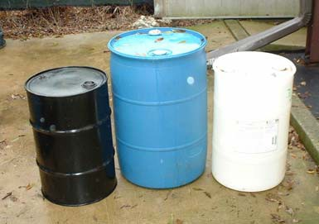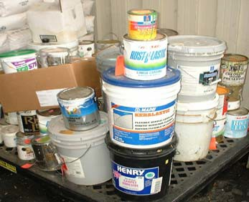
Empty drums Surplus chemicals
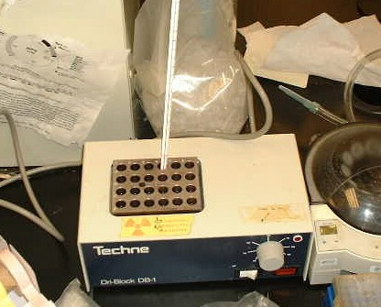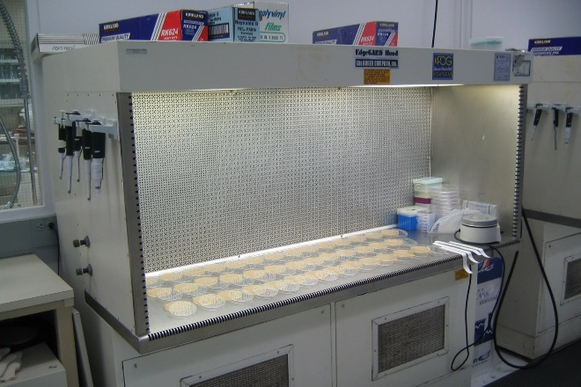
Heating block Laminar flow hood
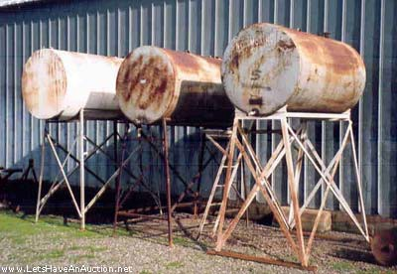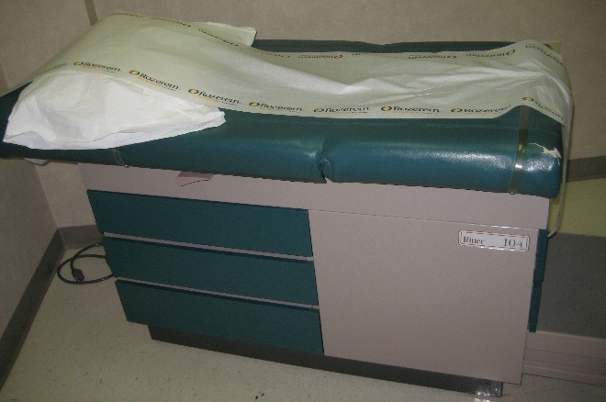
Fuel storage tanks Examination table

