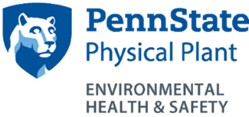 LABORATORY/RESEARCH EQUIPMENT CLEARANCE FORM

This is to certify that the laboratory/ research equipment listed below is considered safe for maintenance work and/or transfer to Lion Surplus. All hazardous materials must be removed and all potentially contaminated surfaces decontaminated in accordance with Environmental Health and Safety (EHS) Office requirements.

Tape a copy of the completed form to the piece of equipment AND email the completed form to EHSLabSafety@psu.edu.

Principal Investigator: Department:

Building: Room number:

Type of Equipment:

Manufacturer:

Model Name/Number:

Serial Number or PSU Inventory Number:

CHECKLIST | YES | N/A | INTIAL & DATE
Hazardous Materials Removed by Lab Personnel
(except asbestos, which is removed by OPP only)
Cleaned by Lab Personnel
Hazard/Warning Signs Removed/Covered
Radiation Survey Completed by EHS
Fluids (oil, refrigerant, etc.) removed by OPP

Laboratory Supervisor Printed Name:

Laboratory Supervisor Signature:

Date:

