If you receive an “INVALID LOCATION” error, you must update your employee record to reflect the location of your waste accumulation area. Do this by following these steps:

Step 1: Open your employee record on the Quick start screen
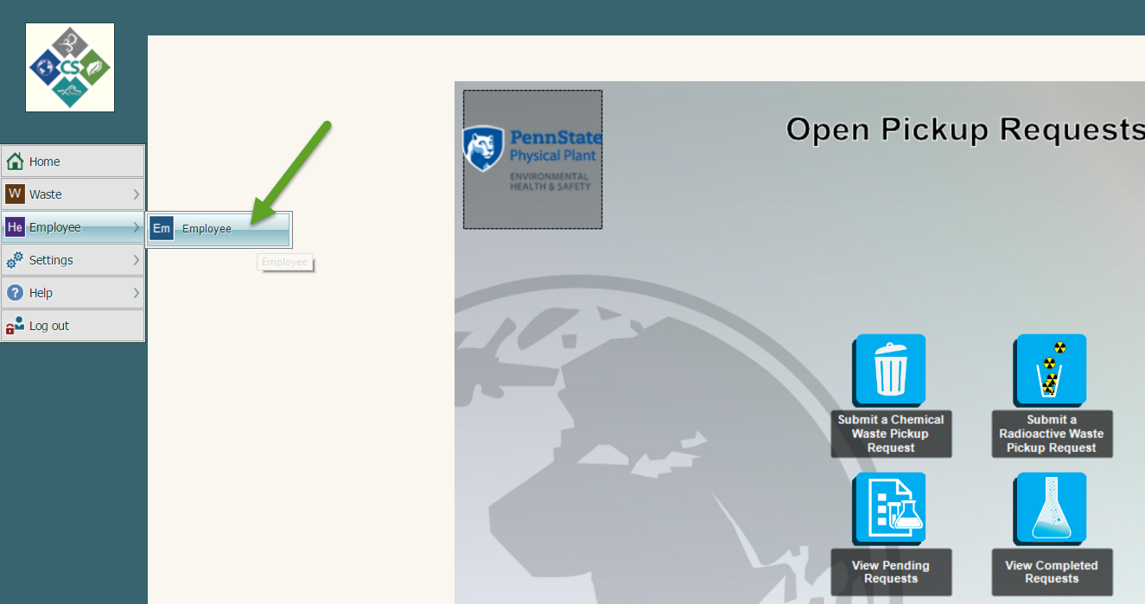
Step 2: Type in your last name and click SEARCH
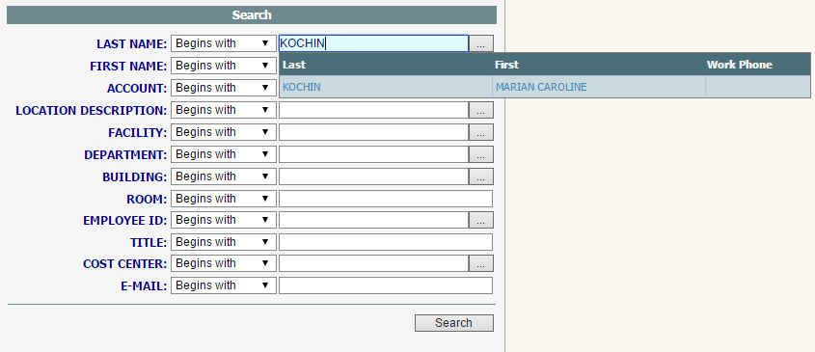
Step 3: Open your employee record by clicking the Edit button
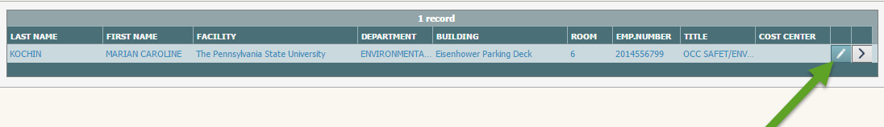
Step 4: Type in the location information and click Save.
If your location information is not in the system, contact EHS and provide your Penn State email, Building name, and Room Number.
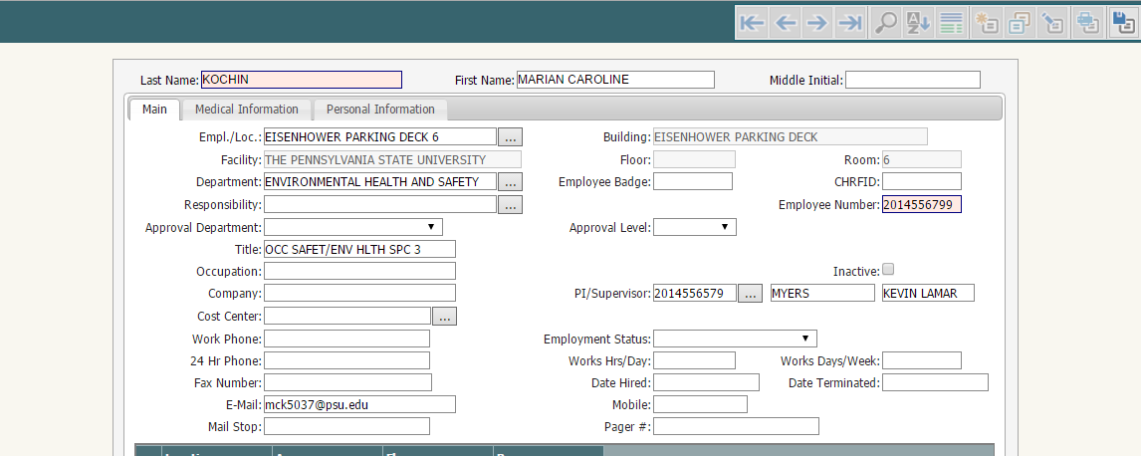
Once you have saved your employee information, log out of the system, and log back in. This information will be saved in your record and will be valid for future requests.

