Ethidium Bromide Disposal
Ethidium Bromide (3, 8-Diamino-5-ethyl-6-phenylphenanthridinium bromide) is a commonly used DNA staining dye. It binds very tightly to DNA by intercalation (slipping in between the base pairs), and is therefore considered mutagenic and should be handled appropriately due to its DNA binding properties. Inactivation with bleach has not been proven to be completely effective so the following guidelines must be met for proper disposal.
Solid Waste
Solid laboratory waste such as gloves, pipette tips, bench paper, and electrophoresis gels that are contaminated with ethidium bromide should be collected into a biohazard bag, sealed, and placed directly into the white infectious waste disposal barrel located in the autoclave room without being autoclaved (autoclaving will not inactivate ethidium bromide). Contamination of these items can be verified by scanning them with an ultraviolet light. If any of the waste contains/ is contaminated by other hazardous materials then all material must be collected, stored, and disposed of according to the University’s chemical waste program.
Liquid Waste
Ethidium bromide extractor funnel
Aqueous solutions of ethidium bromide can be passed through an activated charcoal funnel. The resulting liquid should be checked with a UV light for fluorescence. Lack of fluorescence indicates no residual ethidium bromide and the filtrate may be drain disposed, assuming there are no other hazardous materials in the liquid. Spent funnels should be handed as ethidium bromide solid waste as listed above. An example of these funnels is shown below and are available from VWR Scientific as item number 10057-756 (for 2) or 10057-758 (for 6). Other manufacturers also offer these funnels.
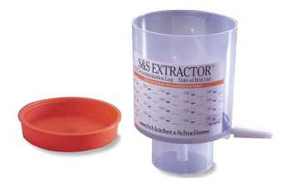
Large quantities of aqueous solutions of ethidium bromide that cannot be passed through the above funnel must be collected, stored, and disposed of according to the University’s chemical waste program.
Destaining Bags
Destaining bags are large plastic bags which contain a small “tea bag” packet of activated charcoal. Aqueous waste containing ethidium bromide is poured into the bag, and the ethidium bromide concentrates in the activated charcoal bag. They are available from BIO101 (www.bio101.com) or Amresco. The resulting liquid should be checked with a UV light for fluorescence. Lack of fluorescence indicates no residual ethidium bromide and the filtrate may be drain disposed, assuming there are no other hazardous materials in the liquid.
Activated Charcoal
Aqueous waste can also be filtered through activated charcoal. The resulting liquid should be checked with a UV light for fluorescence. Lack of fluorescence indicates no residual ethidium bromide and the filtrate may be drain disposed, assuming there are no other hazardous materials in the liquid.

February 21, 2018

