The Pennsylvania State University
Crane, Hoist and Sling Safety Program

Introduction:

Cranes, hoists and slings pose a serious safety hazard if not used properly. It is the policy of the Pennsylvania State University (PSU) to ensure employees are trained on the hazards of using cranes, hoists and slings and also to ensure that such equipment is safely maintained.

Purpose:

This program has been established to:
- Ensure the safe use of cranes, hoists and slings.
- Ensure that work units understand and comply with safety standards related to cranes, hoists and slings.

Assign responsibilities to personnel which are necessary for successful implementation of this program.

Scope & Applicability:

This program applies to all employees at all PSU locations except the Hershey Medical Center and the College of Medicine.

This program covers the following cranes and hoists used by PSU employees: overhead and gantry cranes, semi-gantry cranes, cantilever gantry cranes, wall cranes, monorail cranes, bridge cranes, single girder cranes, overhead hoists, and other hoists and cranes having the same fundamental characteristics. (See Appendix C for examples)

This program does not cover mobile cranes (wheel-mounted, rough-terrain, all-terrain, commercial truck-mounted, and boom truck cranes), engine hoists or winches. (See Appendix C for examples)

The program covers the following types of slings used by PSU employees: alloy steel chain, wire rope, metal mesh, natural and synthetic fiber rope, and synthetic webbing. (See Appendix D for examples)

Table of Contents:
- References
2.0 Responsibilities
3.0 Definitions
4.0 General Requirements
5.0 Training
6.0 Inspections
7.0 Maintenance
8.0 Recordkeeping
9.0 Contractors
Appendix A: Pre-Use Crane, Hoist and Sling Inspection Guidelines
Appendix B: Crane & Hoist Monthly Inspection Checklist
Appendix C: Examples of Cranes and Hoists
Appendix D: Examples of Slings
Appendix E: Crane and Hoist Training Certification Form
Appendix F: Safe Work Practices for Cranes, Hoists and Slings
Appendix G: Bridge Crane Operator Evaluation Form
Appendix H: Instructions for Conducting Bridge Crane Operator Evaluations

1.0 References:
(The following have been used as references in the development of this program)
- Pennsylvania State University Personal Protective Equipment Program
- Pennsylvania State University Lockout Tagout Policy – SY35
- OSHA Publication – Sling Safety - #3072
- OSHA Standard – Overhead and Gantry Cranes – 29 CFR 1910.179
- OSHA Standard – Slings – 29 CFR 1910.184
- ANSI/ASME B30.9 – Slings
- ANSI/ASME B30.10 - Hooks
- ANSI/ASME B30.11 – Monorails and Underhung Cranes
- ANSI/ASME B30.16 – Overhead Hoists (Underhung)
- ANSI/ASME B30.17 – Overhead and Gantry Cranes (Top Running Bridge, Single Girder, Underhung Hoist)
- HMI (Hoist Manufacturers Institute) – Manually Lever Operated Hoist Inspection and Hoist Maintenance Personnel Manual

2.0 Responsibilities:
  - Budget Executives and Budget Administrators
      - Ensure that responsibilities assigned within this program are carried out within their administrative work unit.
- Designate individuals responsible for the implementation of this program within their work unit.
- Actively support this program as part of the work unit’s overall safety effort.
      - Ensure adequate funding is available to support this program.

2.2 Department of Environmental Health and Safety
- Assist work units in implementing the provisions of this program.
- Periodically review and update this written program.
- Periodically evaluate the overall effectiveness of this program.

2.3 Safety Officers
- Determine the applicability of this program to activities conducted within their work unit.
- Coordinate implementation of this program within their work unit.
- Be knowledgeable of components of program and ensure program compliance.
- Assist in the investigation of serious accidents related to cranes, etc.
- Actively support this program as part of the work unit’s overall safety effort.

2.4 Supervisors
- Be thoroughly informed of the contents of this program and its application to their areas of responsibility and authority.
- Ensure employees comply with all provisions of this program.
- Ensure employees receive training appropriate to their assigned tasks and maintain documentation of such training.
- Ensure employees are provided with and use appropriate protective equipment.
- Take prompt corrective action when unsafe conditions or practices are observed.
- Investigate injuries and incidents within their work unit related to crane, hoist and sling usage.

2.5 Employees
- Follow the work practices described in this program, including the use of appropriate protective equipment.
- Attend all training required by this program.
- Immediately report any unsafe conditions or concerns related to cranes, hoists or slings to their supervisor.

- Definitions:

Authorized Person (Repair): Someone with training and experience pertaining to crane and hoist repair. There are specific safety considerations that are unique to cranes and hoists, thus the person must have training and experience in crane and hoist repair.

Bridge: means that part of a crane consisting of girders, trucks, end ties, foot walks, and drive mechanism which carries the trolley or trolleys.

Bridge Crane: A load lifting system consisting of a hoist which moves laterally on a beam, girder, or bridge which in turn moves longitudinally on a runway made of beams and rails. Loads can be moved to any point within a rectangle formed by the bridge span and runway length.

Bumper: a device for reducing impact when a moving crane or trolley reaches the end of its permitted travel, or when two moving cranes or trolleys come into contact. This device may be attached to the bridge, trolley, or runway stop.

Competent Trainer: An employee who has demonstrated familiarity with the type of crane/hoist in their work unit. A contractor or equipment vendor who has experience training crane/hoist operation and is familiar with the equipment is also permitted to be a Competent Trainer.

Competent Evaluator: An employee in the department/work unit who is experienced and competent with the crane. An employee must be familiar with the equipment and its safe operation. In order to be considered competent in regards to conducting the evaluation portion of the crane training, an employee must have successfully completed the classroom portion of crane/hoist training. This employee could be but is not limited to a certified operator, supervisor/manager or safety officer.

Crane: is a machine for lifting and lowering a load and moving it horizontally, with the hoisting mechanism an integral part of the machine. Cranes can be driven manually or by power.

Drum: the cylindrical member around which rope is wound for lifting or lowering the load.

Designated Person (monthly inspections): means selected or assigned by the employer or the employer’s representative as being qualified to perform specific duties.

End Truck: an assembly consisting of the frame and wheels which support the crane girder(s) and allow movement along the runway.

Floor operated crane: crane controlled by an operator on the floor or an independent platform using a pendant or non-conductive rope.
Gantry crane: A crane that has a hoist in a trolley which runs horizontally along gantry rails, usually fitted underneath a beam spanning between uprights which themselves have wheels so that the whole crane can move at right angles to the direction of the gantry rails.
Hoist: a suspended machinery unit that is used for lifting or lowering a freely suspended (unguided) load.
Limit Device: a device that is operated by some part or motion of a power-driven hoist to limit motion.
Monorail: A trolley suspension crane hoist, whose trolley is suspended from a single rail. This type of crane hoist is used to move a load horizontally.
Overhead crane: a crane with a movable bridge carrying a movable or fixed hoisting mechanism and traveling on an overhead fixed runway structure.
Reeving: a system in which a rope or chain travels around drums, sheaves, or sprockets.
Rope: refers to wire rope unless otherwise specified.
Sheave: a grooved wheel or pulley used with a rope or chain to change direction and point of application of a pulling force.
Trolley: the unit which travels on the bridge rails and carries the hoisting mechanism.
Wall mounted jib crane: A crane with a jib and with or without a trolley. The wall crane is supported from a side wall or columns of a building.

- General Requirements for Cranes, Hoists and Slings:
  - The work unit must notify Environmental Health and Safety when a crane or hoist is installed. This is required so that EHS can add the unit to the monthly and annual inspection schedule.
  - Only trained employees shall operate a crane or hoist. If the need arises to operate crane or hoists not owned by PSU, contact EHS for further guidance.
  - Cranes and hoists shall go through a pre-use, monthly and annual inspection.
  - Slings shall go through pre-use and annual inspections.
  - Any unsafe condition noted during an inspection shall be corrected before the equipment is used.
  - Operators shall comply with the manufacturer's specifications and limitations applicable to the operation of the equipment.
    - Where manufacturer's specifications are not available, the limitations assigned to the equipment shall be based on the determinations of a qualified engineer competent in this field and such determinations will be appropriately documented and recorded.
  - Operators shall follow safe work practices when operating a cranes, hoists and slings. (See Appendix F)
- Training:
  - Training must be completed prior to any use of a crane or hoist. Training of crane and hoist operators at PSU is a two-step process for the majority of cranes/hoists which consists of classroom instruction & hands-on training.
    - In additional to the above requirements, a documented operator evaluation is required for operators of Bridge Cranes. (Appendix G)

  - Classroom instruction, hands-on training and operator evaluations can be conducted by either a competent trainer in the work unit, the equipment manufacturer, a safety consultant and/or a vendor who specializes in crane/hoist training.

5.2.1 Hands-on training and hands-on evaluation portions of the training can also be conducted by an employee in the department/work unit who is experienced and competent with the equipment. This person could be a trained operator, supervisor/manager, or safety officer.

5.3 Training must be specific to the type of equipment being used.

5.4 Training shall include the following:
5.4.1 Characteristics of safe crane and hoist operation;
5.4.2 Inspection procedures;
5.4.3 Basic load handling considerations;
5.4.4 Operator responsibilities;
5.4.5 Communication used during crane and hoist operation;
5.4.6 Hands-on equipment training.

5.5 Trainees must successfully complete hands-on training before being allowed to operate the equipment independently. Trainees will be given adequate supervision and time to learn basic operating skills.

5.6 Refresher training in relevant topics will be provided to a crane or hoist operator when any of the following occur:

- The operator has been observed to be using the equipment in an unsafe manner.
- The operator has been involved in an accident or a near-miss incident.
- The operator is assigned to operate a different type of equipment.
- A condition in the workplace changes in a manner that could affect safe operation of the equipment.
- Inspections for Cranes, Hoists and Slings:
Work unit is responsible for ensuring inspections are conducted at the following frequencies:

  - Pre-Use Inspection – (See Appendix A)

    - Prior to use the operator shall visually inspect the crane, hoist and/or slings for defects.
    - The pre-use inspection will identify conditions that could affect the safe use of the equipment.
    - Operators must immediately report any unsafe crane conditions to their supervisor. The supervisor is then responsible for ensuring the necessary arrangements are made for repair.
    - Only authorized personnel shall perform repairs and adjustments.
      - All replacement parts shall be the same design as the original or an equivalent design as designated by the manufacturer.

  - Monthly Inspection (Crane and Hoists) – (See Appendix A & B)

    - A documented monthly inspection of all cranes and hoists shall be performed. These inspections must be performed by a designated person. The designated person must be a trained crane/hoist operator and have gone through monthly crane/hoist inspection training.
    - All University Park cranes and hoists, with the exception of those located in ARL facilities, will have monthly inspections completed by the Office of Physical Plant elevator crew.
    - Cranes and hoists located within ARL facilities or at non-University Park locations must have monthly inspections completed by either a designated person or a third party.

  - Annual Inspection (Cranes and Hoists)

    - A documented annual inspection of all cranes and hoists shall be performed by a third party.
    - At UP locations, with the exception of ARL facilities, crane and hoist annual inspections will be scheduled through the Office of Physical Plant.
    - At ARL facilities and Campus locations the annual inspections must be scheduled by the work unit.
    - All cranes and hoists shall be labeled or marked to show date of last annual inspection.

  - Annual Inspection (Slings) –
    - A documented annual inspection of all slings shall be performed by a designated person or third party who has gone through sling inspection training.

  - If any unsafe conditions exist, the equipment shall be removed from service. In order to remove a crane or hoist from service it shall be locked out and tagged out to prevent use.

  - Cranes and hoists not in regular use

    - A unit which has been idle for a period of one month or more shall be given a monthly inspection before placing in service.

  - Prior to initial use, all new, altered, modified or repaired cranes and hoists shall have the following testing performed by the installation company or third party:

    - Hoisting and lowering
    - Trolley travel
    - Bridge travel
    - Limit switches, locking and safety devices
    - Load Tests
      - Shall not be more than 125% of the rated load unless otherwise recommended by the manufacturer.

- Maintenance:

Preventive maintenance shall be performed as prescribed by the manufacturer as detailed in the owner's manual.

8.0 Recordkeeping:

8.1 Each work unit is responsible for maintaining the following records in order to meet the requirements of this program:

8.1.1 A listing of all cranes and hoists.

8.1.2 A record of training which includes: (Use Appendix E or equivalent)
8.1.2.1 Name of trainer.
8.1.2.2 Name of operator.
8.1.2.2 Date of training (classroom, hands-on training, hands-on evaluation).

8.1.3 Monthly inspections, annual inspections, repair records and load tests according to the frequencies listed in 8.2 below. (Pertains only for work units which OPP does not conduct the monthly inspections)

8.2 OPP is responsible for maintaining the following records in order to meet the requirements of this program:

8.2.1 Copies of all monthly inspection records for one year after completion.
8.2.2 Copies of annual inspection records for at least four years.
8.2.3 Copies of repair records for the life of the equipment.
8.2.4 Copies of load test results for the life of the equipment.
8.3 EHS is responsible for maintaining the following records in order to meet the requirements of this program:
8.3.1 EHS will retain training records for training they have provided indefinitely.
9.0 Contractors:
Contractors are required to follow all applicable OSHA regulations and manufacturer’s instructions. Contractors are not permitted to use any crane, hoist or sling owned by Penn State.

Appendix A
Pre-Use Crane, Hoist and Sling Inspection Guidelines

Item (Cranes and Hoists) | Yes | No | N/A
Load rating marked on each side of the crane.
Load rating of the hoist marked on the hoist or its load block and legible from the ground? (If the crane has more than one hoisting unit, each hoist shall have its rated load marked on it or its loading block and this marking shall be clearly legible from the ground.)
At least 3 inches of overhead clearance and 2 inches laterally between crane and obstructions.
All controller functions labeled and legible.
All operational controls and functional operating mechanisms working properly, properly adjusted and no unusual sounds.
Upper limit switch operating properly. It shall be tested with no load on the hook. Extreme care shall be exercised; the block shall be "inched" into the limit device or run in at slow speed.
Excessive wear of components on any functional operating mechanisms.
Deterioration or leakage in lines, tanks, valves, drain pumps, and other parts of the air or hydraulic system.
Excessive dirt, grease, or foreign matter.
Deformation and/or cracking of the hook, load block, drums and/or sheaves.
Safety latch on crane/hoist load block that automatically closes.

Appendix A - Pre-Use Crane, Hoist and Sling Inspection Guidelines
Item (Slings) | Yes | No | N/A
Chain Slings:
Nicks, cracks, breaks, stretches, distortions, twists, gouges, bends, heat damage, discoloration, worn or damaged links and components,
Lack of ability of the chain or components to hinge (articulate) freely,
Pitting, corrosion or weld splatter,
Missing or illegible sling identifications,
Other conditions that cause doubt as to the continued safe use of the sling.
Wire Rope Slings:
Broken wires,
Pitting or corrosion,
Localized wear (shiny worn spots), abrasion or scrapes,
Damage or displacement of end fittings, hooks, rings, links, or collars,
Distortions, kinks, bird caging, crushing, or other evidence of damage to wire rope structure,
Missing or illegible sling identifications,
Other conditions that cause doubt as to the continued safe use of the sling.
Synthetic Fiber Rope / Synthetic Webbing Slings:
Melting, charring or burning of any part of the surface,
Snags, punctures, tears, cuts, fraying, broken or worn stitches,
Change in diameter,
Discoloration,
Hard or stiff areas,
Wear or elongation exceeding the amount recommended by the manufacturer,
Distortion of fittings,
Missing or illegible sling identifications,
Other conditions that cause doubt as to the continued safe use of the sling.
Metal Mesh Slings:
Broken weld or brazed joints,
Broken wire in any part of the mesh,
Abrasion, corrosion, distortion, pitting, twisting, bending, cracking, gouging of any component,
Lack of flexibility,
Missing or illegible sling identifications,
Other conditions that cause doubt as to the continued safe use of the sling.

Appendix B
Crane & Hoist Monthly Inspection Checklist

# | Inspection Item | Yes | No | N/A
1 | Conduct pre-use inspection of equipment. Does it pass the pre-use inspection? (See Appendix A)
2 | Any deformed, cracked, or corroded members?
3 | Are there worn, cracked, or distorted parts such as pins, bearings, wheels, shafts, gears, rollers, locking and clamping devices, bumpers, and stops?
4 | Is there excessive wear or improper operation of the brake system parts, linings, pawls, chain sprockets or ratchets?
5 | Any cracked or worn sheaves and drums?
6 | Are there loose or missing bolts, nuts, pins or rivets?
7 | Is there any signs of pitting or deterioration of controllers, master switches, contacts, limit switches, and push button stations?
8 | Are load, wind, and other indicators properly operating?
9 | Are gasoline, diesel, electric, or other power plants performing properly?
10 | Are stops provided at the limit of travel of the trolley?
11 | Corroded, cracked, bent, worn, or improperly applied end connections?
12 | Load chain reeving for compliance with hoist manufacturer’s recommendation?
 | Hook
13 | Is there any gouges, nicks, weld spatter, corrosion, deformation, cracks?
14 | Has the hook throat opening increased 5%, not to exceed ¼ inch (6 mm), more than the normal throat opening measured at the narrowest point?

15 | Is there any bend or twist from the plane of the unbent hook?
 | Chain
16 | Is there excessive drive chain stretch?
17 | Test the hoist under load in lifting and lowering directions and observe the operation of the chain and sprockets. Does the chain feed smoothly into and away from the sprockets?
18 | Does the chain bind, jump, or is noisy? If so, clean chain. If trouble continues inspect the chain and mating parts for wear, distortion, or other damage.
19 | Slacken the chain and move the adjacent links to one side to inspect for wear at the contact points. Is wear observed? Is stretching suspected?
Refer to owner’s manual for any additional inspection items:

Comments:

Crane ID number or identifier:______________________________________________

Inspector (print):________________________________________________________

Sign:_________________________________________________________________

Date:_________________________________________________________________
Appendix C
Examples of Cranes and Hoists

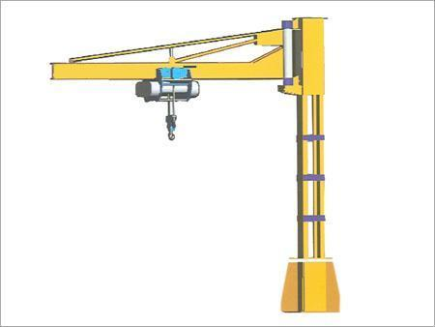  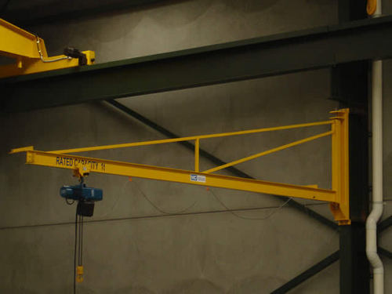 | A type of crane where a horizontal member (jib or boom), supporting a moveable hoist, is fixed to a wall or to a floor-mounted pillar.  Jib Crane  Wall Crane
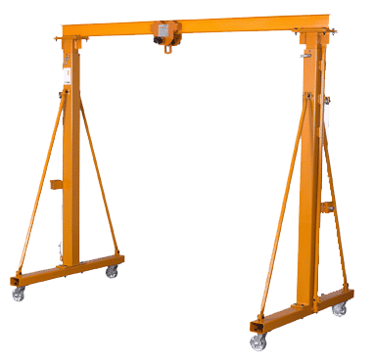  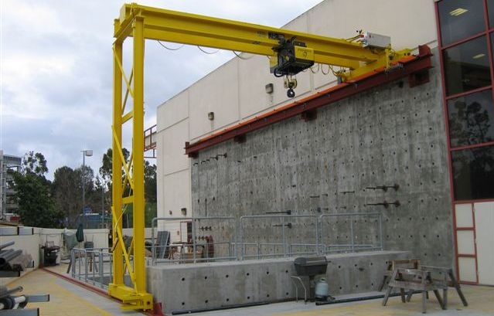  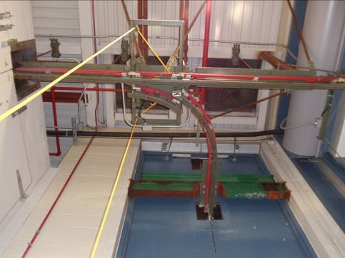  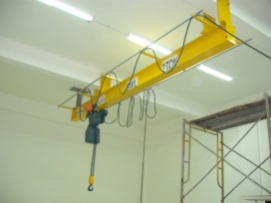 | A type of crane has a hoist which typically runs horizontally along rail/s.  Gantry Crane  Semi Gantry Crane  Monorail  Switching Monorail
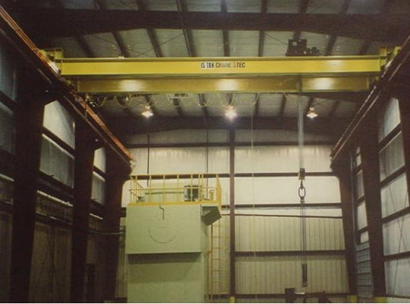 | A load lifting system consisting of a hoist which moves laterally on a beam, girder, or bridge which in turn moves longitudinally on a runway made of beams and rails. Loads can be moved to any point within a rectangle formed by the bridge span and runway length.  Bridge Crane
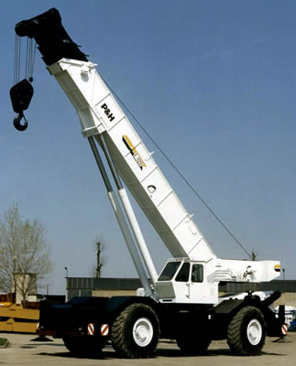 | Mobile Cranes  ARE NOT COVERED IN THIS PROGRAM
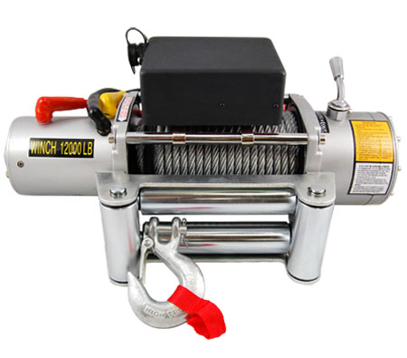 | Winches  ARE NOT COVERED IN THIS PROGRAM  Follow the manufacturer’s recommendations
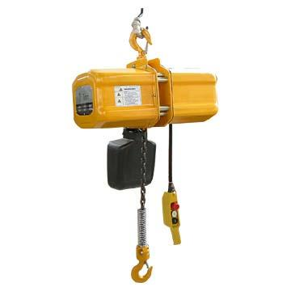 | Electric Chain Hoist
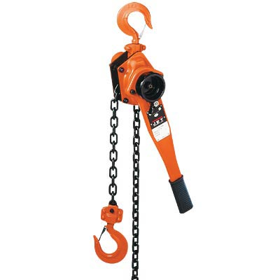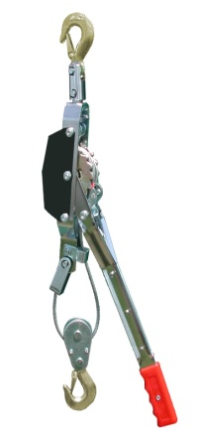 | Manually operated hoists  Lever Hoist  Chain Fall Hoist  Come Along Hoist
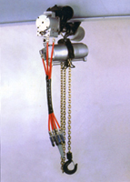 | Pneumatic Chain Hoist
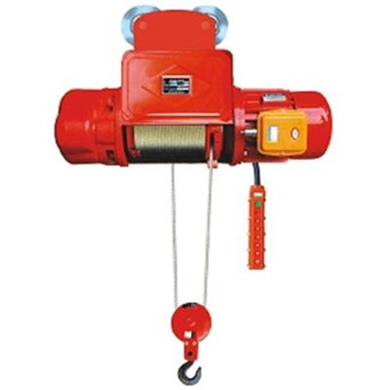 | Electric Wire Rope Hoist
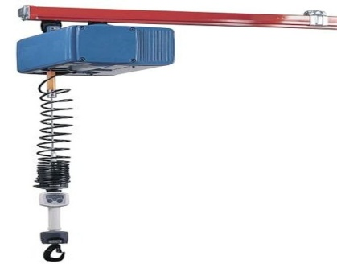 | Pneumatic Wire Rope Hoist
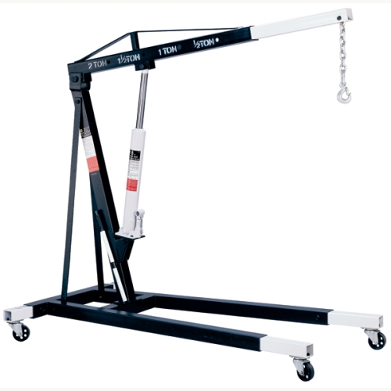 | Engine Hoists  ARE NOT COVERED IN THIS PROGRAM  Follow the manufacturer’s recommendations

Appendix D

Examples of Slings

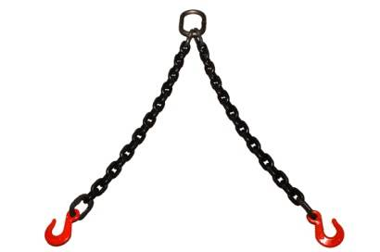 | Alloy Steel Chain
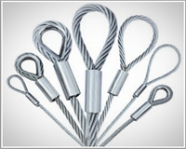 | Wire Rope
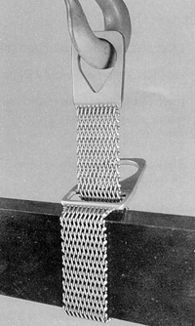 | Metal Mesh
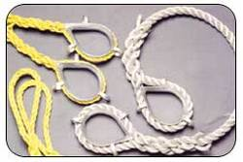 | Natural and Synthetic Fiber Rope
 | Synthetic Web

Appendix E
Crane and Hoist Training Certification Form

Name of Trainer (print) _____________________________________________________
(Sign):___________________________________________________________________

Name (Print) | Date of classroom training | Date of hands-on training | Date of Evaluation (if required) | Signature
Appendix F
Safe Work Practices of Cranes, Hoists and Slings
Cranes and Hoists
General:
- A personal protective equipment (PPE) hazard assessment must be performed for the task. PPE considerations should include a hardhat, safety glasses and safety shoes.
- Rated load capacities, recommended operating speeds, special hazard warnings and/or instructions, shall be conspicuously posted on all equipment. Instructions or warnings shall be visible to operators while they are at their control stations.
- Do not exceed the rated load capacity of the crane, hoist, slings, or other components. (Keep in mind that the hoist may be higher rated that the rail/beam or vice versa)
- Persons operating the crane, hoist or sling shall inspect all machinery and equipment prior to each use to make sure it is in safe operating condition. (See Appendix A)
- Belts, gears, shafts, pulleys, sprockets, spindles, drums, fly wheels, chains, or other reciprocating, rotating, or other moving parts or equipment shall be guarded if such parts are exposed to contact by employees, or otherwise create a hazard.
- No modifications or additions which affect the capacity or safe operation of the equipment shall be made without the manufacturer's written approval. If such modifications or changes are made, the capacity, operation, and maintenance instruction plates, tags, or decals, shall be changed accordingly. In no case shall the original safety factor of the equipment be reduced.
- Disconnect power to a hoist or crane that is unsafe or in need of repair. Arrange to have the equipment locked out and tagged out.
- Never operate a hoist or crane that in your opinion is UNSAFE TO OPERATE.

Engaging the Load:
- The sling or other device shall be properly seated and secured in the base of the hook.
- The load shall not be applied to the point of the hook or the hook latch.
- Before moving the load, the operator shall be sure chains and wire rope are not kinked or twisted and that multiple part chains or ropes are not twisted about each other.
- The rope or chain must be properly seated on the drum, sheaves, or sprockets before the lift takes place.
- Remove slack from the sling, chain, or cable before lifting a load.
- The hoist must be centered over the load.
- The operator shall not pick up a load in excess of the rated load of the hoist or crane.
- Specific attention should be given to balancing of the load to prevent slipping.

Moving the Load:
- The operator shall not engage in any activity that will divert his/her attention from the task.
- The operator shall respond to signals from a designated person only. However, the operator shall obey a stop signal at all times, no matter who gives it.
- The operator shall make sure the load and hoist will clear all obstacles before moving or rotating the load.
- A person shall be designated to observe clearance of the equipment and give timely warning for all operations where it is difficult for the operator to maintain the desired clearance by visual means.
- The operator shall inch powered hoists and cranes slowly in engagement with a load, but should avoid unnecessary inching and quick reversals of direction.
- A load shall not be lifted more than a few inches until it is well balanced in the sling or lifting device.
- When lifting loads at or near capacity, brake action shall be tested by lifting the load a few inches off the surface to verify that the brakes are holding.
- On rope hoists, the load shall not be lowered below the point where less than two wraps of rope remain on each anchorage of the hoist drum, unless a lower limit device is provided. In this case no less than one wrap may remain on each anchorage of the hoist drum.
- Loads shall not be suspended over personnel.
- All employees shall be kept clear of loads about to be lifted and of suspended loads.
- Under no circumstances may anyone ride the hook or load.
- Directional movement should be made smoothly and deliberately to avoid swing.
- Never pull a hoist by the controller cable.
- Contact between trolleys (on two trolley cranes) or between trolleys and stops should be avoided.
- The operator shall not use the upper (or lower, if provided) limit device(s) as a normal means of stopping the hoist. These are emergency devices only.

Placing the Load:
- Never leave the controls unattended while a load is suspended. If it becomes necessary to leave the controls, lower the load to the floor.
- The load block should be positioned above head level when the hoist is not in use.
- Care shall be exercised when removing a sling from under a landed and blocked load.
Slings
- Slings shall be inspected prior to each use to make sure they are in safe operating condition. (See Appendix A)
- Slings that are damaged or defective shall not be used.
- Slings shall not be shortened with knots or bolts or other makeshift devices.
- Sling legs shall not be loaded in excess of their rated capacities.
- Slings used in a basket hitch shall have the loads balanced to prevent slippage.
- Slings shall be securely attached to their loads.
- Slings shall be padded or protected from sharp edges of their loads.
- Suspended loads shall be kept clear of all obstructions.
- Hands and fingers shall not be placed between the sling and its load while the sling is being tightened around the load.
- Shock loading is prohibited (abrupt starting or stopping of the load).
- A sling shall not be pulled from under a load when the load is resting on the sling.
- Slings shall be properly stored when not in use so that they are not subject to mechanical damage, moisture, corrosives, extreme temperature or kinking.

Appendix G

Bridge Crane Operator Evaluation Form

Trainee Name: | Work Unit:
Evaluator Name: | Department:
Crane location: | Date:
NOTE: Operators must be evaluated on each type of bridge crane.
Step | Evaluation | N/A | Pass | Fail
1. Pre-use equipment inspection | Did operator utilize appendix A of this document (Pre-Use Hoist, Crane and Sling Inspection Guidelines)?  If not, was the operator able to explain all of the items they were looking for?  Was the owner’s manual referenced for any additional items to be checked?
2. Load inspection | Was the weight of the load identified as not to exceed the rated capacity?
 | Was load properly secured, balanced and stable?
3. Move plan | Was a destination identified?
4. Control operation | Was operator familiar with all controls?
 | Was load speed and control satisfactory? (no sudden stops or acceleration)
5. Worksite Inspection | Was operator aware of activities in the vicinity including personnel and equipment?
6. Post move | Was hoist/crane properly stowed? (Hook near bottom of the hoist)
 | Were slings properly stored? (not subject to mechanical damage, moisture, corrosives, extreme temp., or kinking)
7. Comments | Must be included for all “Failed” tasks. If task is failed the evaluator must explain what was done incorrectly and have the trainee repeat the task until it is completed correctly.
Trainee Signature:
Evaluator Signature:

Appendix H
Instructions for Conducting Bridge Crane Operator Evaluations
(Note: The evaluation can be done in-house using an experienced and competent PSU employee or an outside vendor/safety consultant may be used.)

- Pre-Requisites:
  - Completed the classroom portion of a crane / hoist training class.
  - Review and become familiar with the PSU Crane, Hoist and Sling written program.
  - Be experienced with the equipment you will be training on.
  - Review owner’s manual.

- Make sure the equipment is in safe condition.

- Make sure the location is safe.

- Have operator perform each item on the Bridge Crane Operator Evaluation Form. (Appendix G)

- Assess the operator’s performance. (Appendix G)

- Explain any “failed” tasks and have operator repeat task.

- Sign form.

- File form with designated person. (Supervisor, work unit safety officer, department safety officer, etc)

