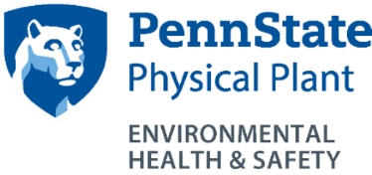
Despite careful training on the importance of purchasing only those chemicals necessary for any given research, excess chemicals are often an end result of many scientific experiments. Disposal of these excess chemicals results in increased volumes for disposal and increased costs. Chemical redistribution can provide a means of using some of these excess materials.
In light of this, EHS has established a program that allows all chemical users within the Penn State University system to obtain, free of charge, chemicals that are unused, but no longer wanted by the original user. This program is limited to uncontaminated chemicals in their original container, with a good shelf life.
EHS acts as the facilitator for this program and maintains an active listing of chemicals available for redistribution. These chemicals are used for PSU research purposes, by or under the direction of qualified personnel familiar with the properties and hazards. Approximately quarterly, a list of available chemicals is sent through unit Safety Officers via email to faculty across the university. Faculty, by contacting EHS by email or phone, identify chemicals for delivery to their individual labs. There is no charge to the lab for this service.
- How do I donate chemicals to this program?
EHS during normal collections identifies chemicals that could be reused by other researchers. If you have extra chemicals in good condition, please label them for possible redistribution.
- How do I know what chemicals are available?
A list of available chemicals will be emailed to you approximately quarterly by your College Safety Officer who maintains a listserv of contacts.
- How do I make arrangements to receive these chemicals?
Call EHS, 865-6391, to notify them that you would like to receive a chemical listed in the email.
- How do chemicals appear in my lab?
Following notification, EHS will deliver requested chemicals to your lab at no charge.
- Is this process the same at non-University Park campuses?
A centralized redistribution program has been developed at UP and faculty at other non-University Park locations are also encouraged to work with each other to share unwanted chemicals. Chemicals may not be transported from other campuses to UP for redistribution.

