Biological Safety Cabinets
Background
Biological Safety Cabinets (BSCs) provide a stable, controlled environment for the aseptic manipulation of microorganisms. When used properly, BSCs can provide protection to the user, the environment and the product. BSCs utilize High Efficiency Particulate Air (HEPA) filters on both the supply and exhaust air. HEPA filters are capable of removing 99.97% of all airborne contaminants in the 0.3-micron size. Larger and smaller particles are removed with even greater efficiency.
Uses
BSCs have a wide variety of applications. They can be used for aseptic tissue culture work, to manipulate pathogenic bacteria and viruses, inoculation of animals with infectious agents, necropsy of infected animals, and many other uses.
Types
Recirculating BSCs can be broadly broken into two categories: Class A and Class B.
Class A – Class A BSCs filter and recirculate a portion of the cabinet air back into the laboratory environment. Typically, 70% of the air is recirculated back into the cabinet and 30% is filtered and exhausted to the room. Class A hoods can be further broken into two types: Class 2A1, which has inward face velocity of 75 feet per minute, and Class 2A2, which has an inward face velocity of 100 feet per minute.
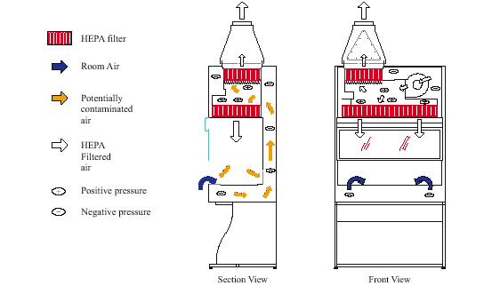
Class 2A BSC
Class B – Class B BSCs also filter the exhaust air, but it is then ducted out of the building. In addition to the fan motor in the hood, there is a second motor in the ductwork to draw the air up and out of the facility. Because the exhaust air is removed from the work area, small amounts of volatile chemicals and radioisotopes can be used in a Class B BSC. These hoods are also further divided into ClassB1, which exhausts 30% of the cabinet air, and ClassB2, which exhausts 100% of the cabinet air. Unless it is absolutely required, EHS does not encourage the purchase and installation of Class B hoods. They are subject to fluctuations in the exhaust air system, and if the upstream fan fails, the ductwork will become positively pressurized.

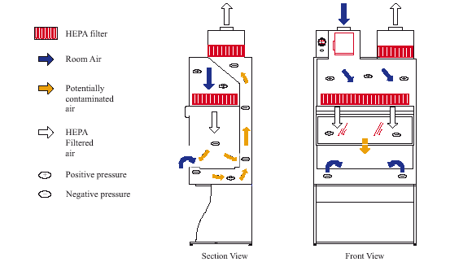
Class 2B BSC
Class III – Class III BSCs, also known as gloveboxes, provide the highest level of protection of all hoods. They are a totally sealed, air-tight (no leak greater than 1 x 10⁻⁷ cc/sec at 3 inches water gauge), and have a double-door pass-through box for introduction of material into the hood. Supply and exhaust air are both HEPA filtered; exhaust air is discharged to the outdoors. Access to materials inside the hood is via two long, heavy-duty rubber gloves attached to ports on the hood. Class III BSCs are extremely cumbersome to work in, and are used when the highest level of protection is required (i.e., BSL-4 pathogens).
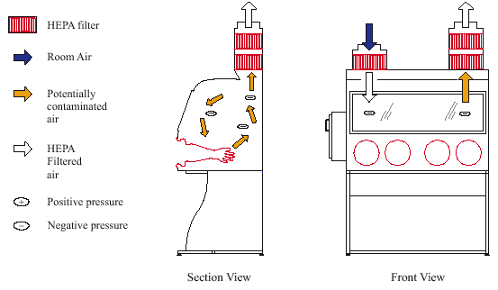
Class 3 BSC
Placement and Installation
Proper placement of a BSC in the laboratory is crucial to the proper operation of the hood. The BSC should be located away from doorways, supply air diffusers, and high traffic areas of the laboratory. Ideally, the BSC should be placed so that people cannot walk behind a person working at the hood.
BSCs should be installed by a professional, preferably a manufacturer’s representative or scientific equipment supplier familiar with the product. Roller jacks should always be used to move the BSC to avoid the potential for breaking the seal around the HEPA filter. House vacuum may be connected to the BSC, but the use of natural gas and open flames in BSCs is forbidden!
Testing and Certification
BScs should be certified:
- When they are initially installed
- Whenever they are moved
- At least annually otherwise
- If the magnehelic (pressure) gauge on the BSC changes significantly, it may be an indication of blockage of the HEPA filter. The BSC should be serviced by a professional.
- Before they are scrapped or given to Lion Surplus.
Testing and certification should be done in accordance with National Sanitation Foundation/American National Standards Institute (NSF/ANSI) Standard 49. This testing and certification cannot be done in-house. It must be conducted by a third party vendor. A list of vendors capable of performing these and other services (i.e., decontamination) is available on the EHS web page.
BSCs must be gas decontaminated (formaldehyde or chlorine dioxide) before service is performed and before the hood is taken out of service.
Proper Work Practices
Following proper work practices in a BSC will help the hood work at peak efficiency, and minimize the potential for product contamination or personnel exposure.
- Turn the hood on 5-10 minutes before planned use to allow air currents to stabilize.
- Arrange materials in the hood from clean to dirty and work in that direction.
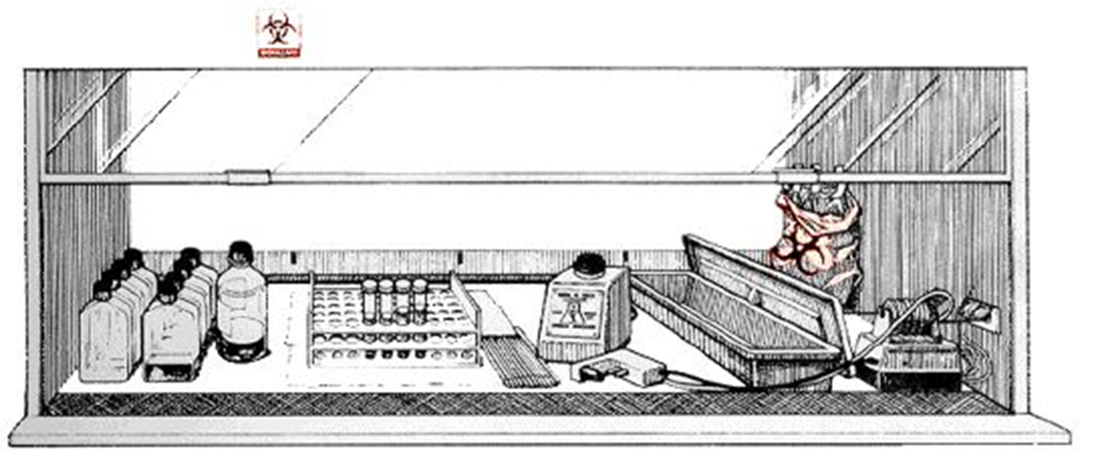
- Limit arm and hand movement in and out of the hood.
- Wipe down the work surface of the hood before use and after you have completed working with a disinfectant shown to be effective against the organism(s) you are using. EHS does not recommend the use of UV lights in hoods. They have limited effectiveness, a short life span, and exposure can cause eye and skin injury.
- Do not use open flames inside a BSC!

