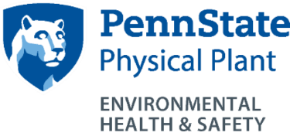
Snapshots!
Hearing Conservation Program
http://ehs.psu.edu/hearing-conservation/overview
EHS Contact: Mark Linsenbigler, msl200@psu.edu
814-865-6391

Who does this program apply to?
- All University employees and students who operate gas powered or other “noisy” equipment or who work in “noisy” areas. Contact EHS is you have questions on making this determination.
  - Rule-of-thumb for “noisy” areas or equipment: If you must raise your voice to clearly communicate with someone 3 feet away you need hearing protection. Contact EHS to confirm they are aware of the noise source.

What are the key requirements of this program?
- Sound level testing by EHS.
- Development and implementation of engineering controls, where possible.
- Proper selection and use of hearing protection when engineering controls are not possible.
- Annual hearing testing and training for affected employees.
- Safety Officers, Facility Coordinators, Managers and Supervisors must:
- Maintain a listing of affected employees in their units.
- Coordinate annual hearing testing and training.
- Ensure employees and students select and properly use hearing protection when needed.
- Notify EHS of new possible “loud” noise sources so sound level testing can be conducted as needed.
- Purchase “quiet” when possible when replacing equipment, etc.
- Employees and students must:
    - Select and properly use hearing protection when needed.
    - Notify supervisors and EHS of new possible “loud” noise sources so sound level testing can be conducted as needed.
  - Training requirements:
    - Hearing Conservation Awareness Training is required annually for employees who are enrolled in the program.
- Self-inspection programs or requirements:
    - Everyone should be observant and report potentially “loud” noise sources to EHS.
    - Ensure employees and co-workers are properly wearing hearing protection (plugs inserted properly; muffs under jacket hoods, not outside, etc.).
- Recordkeeping requirements:
    - Maintain a listing of affected employees (work units).
    - Maintain hearing testing records (PSU Occupational Medicine).
    - Sound level testing data (EHS).

For additional information:
- OSHA Hearing Conservation Publication: http://www.osha.gov/Publications/osha3074.pdf
- OSHA Hearing Conservation information: http://www.osha.gov/SLTC/noisehearingconservation/index.html
- National Hearing Conservation Association (NHCA): http://www.hearingconservation.org/

