The Pennsylvania State University

Machine Shop Safety Program

Introduction

Machine shops are present in many departments throughout the University. Shop equipment is routinely used by employees and students to complete various tasks that have the potential to result in serious injury. It is the policy of The Pennsylvania State University (PSU) to provide a safe working environment within all University machine shops.

Purpose

The purpose of this program is to prevent injuries which may occur in a shop environment. The information included in this document shall be used by supervisors to create a shop safety program. The program is oriented towards work in student and employee shops, but many requirements also apply to work performed outside of formal shop environments.

This program has been developed in accordance with the following regulations and standards:

- 29 CFR 1910 Subpart O, “Machinery and Machine Guarding”
- 29 CFR 1910 Subpart P, “Hand and Portable Powered Tools and Other Hand-Held Equipment”
- “Safeguarding Equipment and Protecting Employees from Amputations” – OSHA publication 3170-02R.
- “A Guide for Protecting Workers from Woodworking Hazards” – OSHA publication 3157.
- A variety of American National Standards Institute (ANSI) safety standards pertaining to machine guarding.
- Penn State University Personal Protective Equipment Program (PPE)
- Penn State University Lockout Tagout Program

Scope

- This program applies to all students and employees at all PSU locations except the Hershey Medical Center and the College of Medicine.
- This program covers all rooms that are dedicated to the housing of shop equipment and are used for either of the following purposes:
  - Student instruction or the completion of tasks/assignments by students.
  - The completion of work tasks by PSU employees.
- Certain provisions of this program also apply to rooms or areas that are not completely dedicated to the housing of shop equipment. (See Section 10.0 of this document for further information).

Table of Contents

- Responsibilities

- Definitions

- Shop Equipment Hazard Classification Matrix

- Training

- Monitoring

- Room Access Control

- Machine Guarding

8.0 Clothing/Hair/Personal Items (Consideration of Entanglement Hazards) AND Accommodations

9.0 Inspections

10.0 Rooms/Areas with Miscellaneous Equipment

11.0 Recordkeeping

12.0 Contractors

Appendix A – Shop Equipment Hazard Classification Matrix
Appendix B – General Shop Information
Appendix C – General Shop Safety Training
Appendix D – Equipment Specific Safety Training
Appendix E – Machine Guarding Reference Guide

- Responsibilities

  - Budget Executives and Budget Administrators:

    - Ensure that responsibilities assigned with this program are carried out within their administrative work unit.
    - Monitor implementation of this program within their work unit.
    - Ensure adequate funding is available to support this program.
    - Ensure a supervisor is designated for the purpose of overseeing each shop under their authority.

  - Environmental Health and Safety (EHS) Department:

    - Provide program oversight and assist work units in implementing the provisions of this program.
    - Maintain records in accordance with this document.
    - Periodically audit machine shops.
    - Update this program as needed.

  - College/Work Unit Safety Officers:

    - Be thoroughly informed of the contents of this program and how it relates to their areas of responsibility and authority.
    - Coordinate implementation of the program within their work unit.
    - Assist in the investigation of all injuries and incidents involving shop equipment within their work unit and direct implementation of corrective actions as required.
    - Ensure that records are maintained for their work unit in accordance with this document.

  - Supervisors (Shop):

    - Be thoroughly informed of the contents of this program and how it relates to their areas of responsibility and authority.
    - Ensure that all provisions of this program are implemented in the shop.
    - Investigate all injuries and incidents involving shop equipment within their work unit.

  - Shop User (Employees & Students):

    - Comply with all provisions of this program, including the use of protective equipment and machine guarding.
    - Attend all training required relative to this program.
    - Promptly report any concerns related to shop equipment or shop safety issues to their immediate supervisor/faculty member.

- Definitions

The following terms are defined to allow for a better understanding of this program:

  - “Employee” – may work for the University in a faculty, staff, technical service or wage payroll capacity.
  - “Graduate Assistant or Teaching Assistant” – A “student” that works and is compensated by PSU similar to an employee.
  - “Monitor”: An individual who has been designated by the work unit to observe others working in a shop in order to ensure a safe work environment is maintained.
  - “Shop Equipment”: A term which encompasses all fixed machinery and portable hand/power tools typically used within a shop environment.
  - “Student” – An individual enrolled at PSU who is seeking an undergraduate, graduate, or doctoral degree.
  - “Supervisor”: A PSU employee who oversees a machine shop on a routine basis. They have full authority regarding equipment use.
  - “Visitor” - Anyone who is not an employee or student. Visitors cannot use shop equipment.
  - “Visiting Faculty” - Visiting appointments apply to academic personnel only. Such an appointment is non-regular, whether full-time or part-time. Visiting faculty can use equipment if they have been trained according to this program.

- Shop Equipment Hazard Classification Matrix (Appendix A)

A hazard analysis of the most common types of equipment used in PSU machine shops has been completed. This analysis has resulted in various pieces of shop equipment being placed into one of three hazard categories: low, medium, or high. The type of equipment present within a given shop will therefore determine the corresponding hazard category.

The matrix located in Appendix A of this document details a number of shop requirements associated with each hazard category. These requirements have been established in order to provide a safe working environment within University shops. The points included within the table include the following:

- The three hazard levels (low, medium, or high) are noted at the top of the matrix.
- The “general design” category contains a basic explanation of the size and power of shop equipment categorized in each hazard level.
- The “common examples” category is a listing of the common equipment types that fit the criteria for each hazard level.
- The “shop monitoring” category outlines what individual must be physically present in order to allow shop equipment to be operated.
- The “training” category outlines the level of training required to operate shop equipment.

4.0 Training

As indicated in Appendix A, training requirements are determined by the hazard level category of the equipment to be used. “General Shop Information” must be reviewed and “General Shop Safety Training” must be provided to any individual who is to operate shop equipment regardless of the hazard category (low, medium, or high). “Equipment Specific Training” must also be provided if the shop equipment has been assigned a hazard level of either “medium” or “high”.

The supervisor is responsible for providing General Shop Information, General Shop Safety Training and Equipment Specific Training.

Note: The following are minimum requirements that must be covered during training. Supervisors may add requirements, information or training that is specific to the shop or work area.

4.1 General Shop Information (Appendix B)
- This form is used to provide basic information to the users of the shop.
- It must be reviewed with shop users as part of their training.
- It must be visibly posted inside the shop.

4.2 General Shop Safety Training (Appendix C)
- This form must be reviewed with shop users as part of their training. It must be performed within each shop the employee/student utilizes.

4.3 Equipment Specific Safety Training (Appendix D)
- This training must be conducted for each employee/student who uses equipment with a hazard level of “medium” or “high”. It must be performed within each shop the employee/student utilizes.
  - Supervisors may choose to forego Equipment Specific Training for employees hired prior to 2013 if competency is already established through prior experience and training. However, Appendix D must be filled out for each employee who falls under this situation. PSU employees new to the shop will need to have General Shop Information, General Shop Safety Training, and Equipment Specific Training.

  - First aid training is strongly recommended for monitors and supervisors.

4.5 Refresher training shall be provided to employees/students under the following circumstances:
    - Changes in the workplace render previous training obsolete.
    - Changes in the type of shop equipment used render previous training obsolete.
    - The operator has been observed using the equipment in an unsafe manner.
    - The operator has been involved in an accident or near miss.

5.0 Monitoring

Adequate monitoring of shop activities is necessary in order to minimize the potential for injury. Individuals who have been designated as monitors must be capable of identifying existing and predictable hazards in the shop environment and have the authority to take prompt corrective measures to eliminate them.

Shop supervisors are qualified to also serve as monitors. Other staff employees, faculty members, teaching assistants, and graduate assistants may also serve as shop monitors. Education, training or past professional experience within a shop environment must be used to determine monitor competency. Undergraduate students may not serve as monitors unless specific approval is obtained from the PSU Risk Management Department and Environmental, Health and Safety.

As indicated in Appendix A, no monitoring is required when students are using “low” hazard equipment. A monitor must be present when students are operating “medium” hazard equipment. Student usage of “high” hazard equipment requires a shop supervisor, faculty member, or staff member with professional level training and experience in applicable tool setup, use and maintenance to be present.

University employees may use any hazard category of shop equipment without a monitor being present.

6.0 Room Access Control

The following outlines the access control requirements of the room so that unauthorized persons are not able to enter and perform work using the shop equipment.

6.1 For student shops the door must be secured (key, electronic, etc.) unless appropriate personnel/supervision is present.

6.2 For employee shops the door must be secured during non-business hours. Trained & authorized employees may enter and perform work. Students are typically not permitted in employee shops, however if students are permitted tool monitoring measures apply.

7.0 Machine Guarding

Each piece of equipment must be properly guarded in order to help prevent injuries. The “Machine Guarding Reference Guide” (Appendix E) contains the minimum guarding requirements for the most common equipment found in shop environments. This appendix can be used by shop supervisors as a general point of reference when evaluating guarding issues. If guarding requirements are not found in this appendix, either EHS or the equipment manufacturer should be contacted.

8.0 Clothing/Hair/Personal Items (Consideration of Entanglement Hazards) AND Accommodations

8.1 All loose clothing, hair, and personal items must be restrained or secured in a manner which prevents entanglement in equipment. The following requirements apply to all University machine shops:

Clothing:
• Long shirt sleeves must be pushed or rolled above the elbows when operating equipment that poses a risk of entanglement. (Such equipment includes but is not limited to lathes, mills, benchtop/standing drill presses, benchtop/standing belt sanders, and benchtop/pedestal grinders).
• Gloves may not be worn when operating equipment that poses a risk of entanglement.
• Hoodie strings must be safely restrained from equipment entanglement.
• Shoes must be close-toed and cover the entire foot.
Hair:
• Hair that is shoulder length or longer must be tied back behind the head in such a way that it eliminates any hair from becoming entangled in equipment.
• Tying hair back behind the head may not be sufficient if the hair could swing to the front of the body when leaning forward. In this case, the hair would need to be secured higher/tighter similar to a “bun”. Alternatively, a tight-fitting head covering shall be worn (baseball cap, skull cap, hair net, or equivalent).
Beards:
- Beards which extend to a point near the bottom of the neck or longer must be secured to eliminate an entanglement hazard when leaning over. Options for securing a beard include use of a beard bonnet, beard bandana, beard cover, or tucking the beard into a shirt.
Personal Items:
• Rings, necklaces, earrings, wrist bands, watches, and other personal items that can become entangled in machinery must be taken off.

The Shop Supervisor or Principal Investigator has the authority to implement stricter clothing requirements if deemed necessary to ensure employee and student safety.

8.2 Accommodations

Any individual with a disability or sincerely held religious belief/observance/practice that limits or prevents their being able to comply with any of the requirements included in Section 8.1 of this document, may seek, but are not guaranteed, a reasonable accommodation.

Students with disability-related accommodation requests should direct them to Student Disability Resources at upsdr@psu.edu or 814-863-1807. For additional information and resources, student should refer to the Student Disability Resources Office’s website at http://equity.psu.edu/student-disability-resources.

Employees with disability-related accommodation requests should direct them to the Affirmative Action Office at aao@psu.edu or 814-863-0471. For additional information and resources, employees should refer to University Policy HR09 (https://policy.psu.edu/policies/hr09) Reasonable Accommodation For University Employees and the Affirmative Action Office’s website at https://affirmativeaction.psu.edu/welcome/access-disability/reasonable-accommodations/.

All religious-related accommodation requests should be directed to the Affirmative Action Office at aao@psu.edu or 814-863-0471. For additional information and resources, employees should refer to University Policy HR09 Reasonable Accommodation For University Employees and the Affirmative Action Office’s website at https://affirmativeaction.psu.edu/welcome/access-disability/reasonable-accommodations/.

9.0 Inspection
9.1 Each dedicated machine shop and room/area with miscellaneous equipment shall be inspected once a year by the:
- Work unit’s Embedded Safety Professional (which are present in the following work units and Colleges at UP - COAS/ARL/ABS/OPP/COE)
OR
- EHS Coordinator assigned to the work unit/College/Campus.
OR
- PSU Occupational Safety Program Manager.

9.2 The shop supervisor shall also inspect each dedicated machine shop under their jurisdiction twice a year. (Locations classified as a rooms/areas with miscellaneous equipment as detailed in section 10 of this document are exempt from this requirement).
- The number of shop inspections required can be reduced from twice a year to once a year if the shop supervisor accompanies the person identified in section 9.1 while they are conducting their annual inspection.

  - The inspections shall be completed utilizing Lionsafe. (ARL is exempt from using LionSafe)

10.0 Rooms/Areas with Miscellaneous Equipment

10.1 These are rooms and areas that are not dedicated entirely as machine shops but instead have a workshop setup with shop equipment present on a smaller scale. Examples are:
- A dedicated workshop inside of a lab, garage, research space, etc.

Although these areas are not classified as dedicated machine shops, they are still obligated to comply with certain aspects of this program. This program shall be used as a reference to develop safe work practices within such areas. Specific sections of the program which apply are as follows:
-Monitoring
-Room Access Control
-General Shop Safety Training (Appendix C)
-Equipment Specific Training (Appendix D)
-Machine Guarding (Appendix E)

These locations are exempt from the annual/biannual documented shop inspection stated in section 9.2 of this document.

Shop classifications are determined by the PSU Occupational Safety Program Manager with consultation from EHS Coordinators and Safety Officers.

EHS maintains a list of all dedicated machine shops as well as those designated as rooms/areas with miscellaneous equipment.

10.2 Labs / research areas / non-labs / garages / warehouses / storage areas / non-traditional work areas such as outdoors, temporary locations, or a stage, etc., that contain few pieces of shop equipment shall ensure machines are properly guarded and training is conducted to safely use the equipment. Examples are as follows:

- A lab with a standing drill press and a benchtop sander.
- A garage with a benchtop grinder and a benchtop drill press.

11.0 Recordkeeping

11.1 Each supervisor is responsible for maintaining the following records for as long as the student utilizes the shop or as long as the person is considered a PSU employee:
11.1.1 General Shop Safety Training
11.1.2 Equipment Specific Safety Training

11.2 Inspection records shall be kept till end of calendar year + 1 year.

12.0 Contractors

12.1 Contractors engaged in activities that require working with shop equipment shall comply with all applicable OSHA regulations.
12.2 Contractors are responsible for providing their own shop equipment and are not permitted to use PSU equipment.

Appendix A
Shop Equipment Hazard Classification Matrix
Hazard Level | Low | Medium | High
General Design | Hand tools (non powered) / Low and medium power tools / Small bench top tools | Powerful portable/ bench top / light industrial tools | Large industrial tools
Common Examples (Not an all-inclusive list) | Less than 24 volts (cordless) and less than 10 Amps (corded) hand drill  3d printers  Belt sander (hand)  Dremel tool  Hand tools (non-powered)  Heat guns  Hot melt glue guns  Jig saw  Laser engravers  Oven  Paint booth  Palm sanders  Scroll saw  Soldering irons and guns  Thermal foam cutters | Angle grinders  Belt / Disc pedestal sander  Bench grinder  Blow molding machine  Circular saw  Chop / Miter saws  Drill press (bench top)  Enclosed CNC machine  Horizontal band saw  24 V or higher (cordless) and 10 Amps or higher (corded) hand drill  Laser cutting  Manual brake  Manual shear  Milling machine (bench top)  Nail gun (all types)  Planer  Plastic injection molding  Reciprocating saw (cordless or corded)  Robot (fully enclosed, and/or benchtop type)  Routers  Table lift / Automobile lift  Water jet machining center | Band saw (standing)  Cranes and Hoists (See PSU Crane, Hoist & Sling Program)  Drill press (standing)  Hydraulic/Mechanical Power Press  Jointer  Lathes  Milling machine (standing)  Open CNC mill  Power Press Brake  Power Shear  Radial Arm Saw  Robot (not fully enclosed, and/or floor mounted)  Shaper/Moulder  Surface grinder  Table saw  Vertical band saw  Welding/Brazing (See PSU Hot Work Program)

Appendix A: Continued
Shop Equipment Hazard Classification Matrix
Hazard Level | Low | Medium | High
Shop Monitoring | Equipment use is only allowed in shops or designated locations  Students, Graduate Assistants and Teaching Assistants ‐ No monitoring required  Employees – No monitoring required | Equipment use is only allowed in shops or designated locations  Students – Monitor must be present. (See footnote 1)  Graduate Assistants and Teaching Assistants – No monitor required but may not work alone.  Employees – No monitoring required | Equipment use is only allowed in shops or designated locations  Students – Shop supervisor, faculty member, or staff member with professional level training and experience in applicable tool setup, use and maintenance must be present. (See footnote 2)  Graduate Assistants and Teaching Assistants – No monitor required but may not work alone.  Employees – No monitoring required
Required  Training:  Student and Employee Shops | - General Shop Information  - General Shop Safety Training | 1) Everything in “Low” hazard category PLUS:  2) Equipment Specific Safety Training
Footnote 1: Approval from PSU Risk Management and EHS is required before an undergraduate student can become a monitor.

Footnote 2: Exemptions to the rule regarding student monitoring requirements when using high hazard tools will be determined on a case-by-case basis by Risk Management and EHS. Exemptions will be based on competency of the individual designated as well as the additional work practices implemented by the area/shop/work unit/department.
Appendix B

General Shop Information

Shop personnel:
- The shop supervisor is_____________________________________________________
- Contact information is______________________________________________________
- Additional contact names and information (If Applicable): ________________________________________________________________________
Emergencies:
- Call 911
- Location of the shop phone/s (if available) are as follows:_________________________
Injury:

Life threatening (large cut, uncontrollable bleeding, amputation, head injury, etc) call 911.

Non-Life Threatening (small cut, burn, scrape, contusion, etc.)
Non-Employee – report to student health services for medical treatment.
Employee – report to Occupational Medicine for medical treatment.

Emergency Equipment Location:
- Fire extinguisher/s_________________________________________________________
- First aid kit/s_____________________________________________________________
- Emergency shutdown ______________________________________________________
- Eyewash/Shower__________________________________________________________
Documentation and Reporting Requirements:

Non-employee (Student)

In the event of emergencies and/or injury, an “Incident Form” must be completed AND a PSU Human Resources Representative must be contacted. See PSU Policy SY03 Emergencies Involving Students.

Employee

Follow employee reporting protocol as found in PSU Policy SY04 Employee Accidents – Reporting and Investigation.

Additional shop or work area requirements, information or training can be added if necessary

Appendix C
General Shop Safety Training
This document must be reviewed by all individuals who utilize student and employee shops.

- If you’re unsure about the safe operation of a tool, stop what you are doing and seek help.
- All machines must be operated with the required guards and shields in place.
- Personal Protective Equipment (PPE) requirements for this shop are as follows:
  - Safety glasses must be worn at all times. Glasses must be labeled with the ANSI Z87 designation.
    - Individuals that wear prescription glasses must wear “over the glasses” safety glasses. Safety glasses worn over regular prescription glasses must be designed for that use.
  - Additional PPE may be required by supervisor.
  - Refer to PSU PPE program for additional information.
- The procedure for obtaining PPE is______________________________________________.
- All loose clothing, hair, and personal items must be restrained or secured in a manner which prevents entanglement in equipment. The following requirements apply to all University machine shops:
Clothing:
• Long shirt sleeves must be pushed or rolled above the elbows when operating equipment that poses a risk of entanglement. (Such equipment includes but is not limited to lathes, mills, benchtop/standing drill presses, benchtop/standing belt sanders, and benchtop/pedestal grinders).
• Gloves may not be worn when operating equipment that poses a risk of entanglement.
• Hoodie strings must be safely restrained from equipment entanglement.
• Shoes must be close-toed and cover the entire foot.
Hair:
• Hair that is shoulder length or longer must be tied back behind the head in such a way that it eliminates any hair from becoming entangled in equipment.
• Tying hair back behind the head may not be sufficient if the hair could swing to the front of the body when leaning forward. In this case, the hair would need to be secured higher/tighter similar to a “bun”. Alternatively, a tight-fitting head covering shall be worn (baseball cap, skull cap, hair net, or equivalent).
- Beards which extend to a point near the bottom of the neck or longer must be secured to eliminate an entanglement hazard when leaning over. Options for securing a beard include use of a beard bonnet, beard bandana, beard cover, or tucking the beard into a shirt.
Personal Items:
• Rings, necklaces, earrings, wrist bands, watches, and other personal items that can become entangled in machinery must be taken off.

The Shop Supervisor or Principal Investigator has the authority to implement stricter clothing requirements if deemed necessary to ensure employee and student safety.

Appendix C: Continued

General Shop Safety Training

- Housekeeping. You are not permitted to leave the shop until after cleaning all shop equipment and work areas has been completed. You must properly dispose of all debris and waste materials by placing them in the appropriate containers (e.g. oily rags in approved metal container, trash in waste can). Shop equipment must be placed in the proper storage location.
- Machines must be turned off when cleaning debris.
- Machines shall only be serviced by shop supervisors/faculty members or other authorized employees.
- Do not use compressed air to clean clothing, hair, or aim at another person.
- Food and drink is only allowed in designated areas.
- Horseplay within shop areas is strictly forbidden.
- Keep your fingers clear of the point of operation by using special shop equipment or devices as needed. (An example would be the use of a push stick when making certain cuts with a table saw).
- Only shop equipment owned or rented by PSU are to be used.
- No personal shop equipment allowed.
- Shop or homemade shop equipment may not be used. “Shop/Homemade Tool” is a tool that can be bought commercially but is made at PSU or at a place of personal residence other than PSU.
- Working alone:
  - Depending on the type of shop equipment required for the job, a monitor, supervisor or faculty member must be present. (See PSU Shop Equipment Hazard Classification Matrix)

Additional shop or work area requirements, information or training can be added if necessary
The majority of the equipment in this shop requires further instruction from the shop supervisor or a trained faculty member before you are allowed to operate the equipment.

Students disregarding shop rules or working unsafely will have their shop privileges suspended.

I have read the “General Shop Information” and the “General Shop Safety Training” documents and understand that I must follow all the above safety rules when working in this machine shop and not operate any equipment until I have been trained.

Student/Employee:
Print: _________________________________________________________________________
Signature: ______________________________________________Date:__________________

Shop Supervisor/Faculty Member:
Print: _________________________________________________________________________
Signature:_______________________________________________Date:__________________

Recordkeeping information: Shop supervisor/faculty member must keep a copy. A copy must also be provided to the student/employee.
Appendix D
Equipment Specific Safety Training
This form documents that an individual has been trained to operate certain shop equipment.

The procedure is as follows:
- The trainer must be a shop supervisor or faculty member at PSU.
- The trainee must go through General Shop Safety Training before Equipment Specific Training can take place.
- The trainer must provide an overview of the equipment and hands-on training regarding safe operation to the trainee.
- Hands-on training may include, but is not limited to: completing a specific type of cut, completing a project, demonstrating proper setup of the equipment, shutting down the equipment, and/or demonstrating how to adjust machine guards.

This training certification is permanent unless any of the following occur:
- Changes in the workplace render previous training obsolete.
- Changes in the type of shop equipment used render previous training obsolete.
- The operator has been observed using the equipment in an unsafe manner.
- The operator has been involved in an accident or near miss.

The following page is a suggested format that can be used to document which shop equipment the individual has been trained on.
Other formats, such as a “wallet/license” card, may be used to show proof of training at the discretion of the shop supervisor.

Additional shop or work area requirements, information or training can be added if necessary

Appendix D: Continued

Tool Specific Safety Training – “Proof of Training”

Initial and date all of the shop equipment that the individual has been trained on and is permitted to operate.

Tool | Trainer’s Initials | Date | Tool | Trainer’s Initials | Date
Angle Grinders |  |  | Nail Gun (all types)
Band Saw (standing) |  |  | Open CNC mill
Belt/Disc Sander (Standing) |  |  | Planer
Bench Grinder |  |  | Plastic injection molding
Chop / Miter Saws |  |  | Power Press Brake
Circular Saw |  |  | Power Shear
Drill Press (Bench Top) |  |  | Radial Arm Saw
Drill Press (Standing) |  |  | Reciprocating Saw (cordless or corded)
Enclosed CNC Machine |  |  | Robot (Fully Enclosed)
Horizontal Band Saw |  |  | Robot (not fully enclosed)
Hydraulic/Mechanical Power Press |  |  | Routers
Jointer |  |  | Shaper/moulder
Laser cutting |  |  | Surface grinder
24 V or higher (cordless) and 10 Amps or higher (corded) hand drill |  |  | Table Saw
Lathes |  |  | Vertical Band Saw
Manual Brake |  |  | Water Jet Machining Center
Manual Shear |  |  | Welding/Brazing (See PSU Hot Work Program)
Milling Machines (Bench Top) |  |  | Other:
Milling Machine (Standing) |  |  | Other:

Student/Employee:  Print:  Sign:  Date: | Trainer:  Print:  Sign:  Date:
Recordkeeping information:
• Shop supervisor/faculty member must keep a copy.
• A copy must also be provided to the student/employee.

Machine Guarding Reference Guide – Appendix E

- The following are general guidelines regarding machine guarding. In many cases there is more than one way to achieve proper machine guarding.
- This is not intended to be an all-inclusive list of shop equipment.
- Consult with EHS and/or the equipment manufacturer for additional machine guarding information.

Guarding Requirements for All Shop Equipment

The following points must be adequately guarded on all types of shop equipment:
- Point of operation:
Guarded
Unguarded
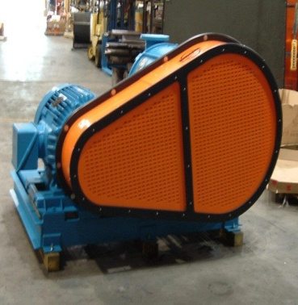
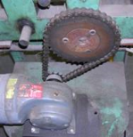
- Area where the machine performs work. (An example would be where a saw blade meets the material being cut).
- Power transmission devices:
  - Elements of the mechanical system that transmits energy. (Examples would include flywheels, belt, chains and pulleys).
- Other moving parts:
  - Other parts of the machine that move when the machine is in cycle.

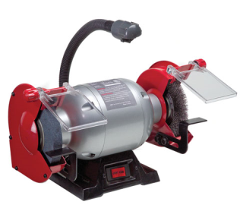
Bench Grinder
Tongue Guards

- Guarding Requirements
- Adjustable tongue guard ¼” from wheel.
- Adjustable work rest 1/8” from wheel.
- Bench grinder needs to be secured to work surface.
- The required guarding for a wire brush attachment is a tongue guard. (A tool rest is not recommended in this situation).
Optional Eye Shield
Work Rests

Appendix E
- Bench Grinder - Safe Work Practices
- Grinding wheel must be dressed to prevent a ridge from forming.
- Perform a ring test before mounting an abrasive wheel.
  - The abrasive wheel must not be used if a dull sound is noted.
  - If the grinding wheel is cracked, do not use because it could shatter.
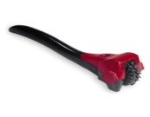
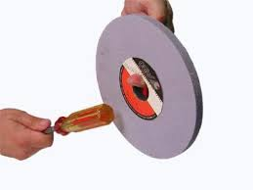
Grinder Dresser Tool
Ring Test
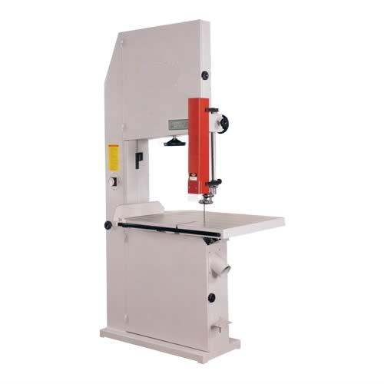
Band Saw
- Guarding Requirements
- Adjustable guard. Set the guard as close as possible to the stock.

Blade guard
Milling Machine
- Guarding Requirements
- Point of operation guard. Adjustable or permanent chip/coolant shield
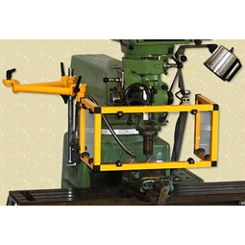

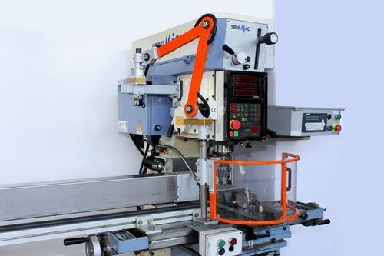
Point of operation guard

Appendix E

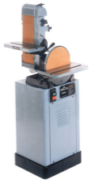
Belt/Disc Sander
- Guarding Requirements
- Fixed guards at pinch and nip points.
Fixed guards

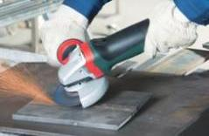
Angle Grinders
- Guarding requirements
- A fixed guard must be on the grinding wheel enclosing one-half or 180° of the grinding wheel.

Table Saw
Clear plastic guard

- Guarding Requirements
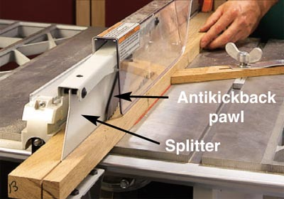
- There are three guards needed on a table saw: a wood spreading guard, anti-kickback guard and a self-adjusting guard over the blade.
- Safe Work Practices
  - A push stick must be used when the stock being cut is small.
  - The top of the teeth of the table saw blade shall not extend ¼” above the material being cut.

Anti-kickback
Wood spreader

Appendix E

Saw Stop – Table Saw
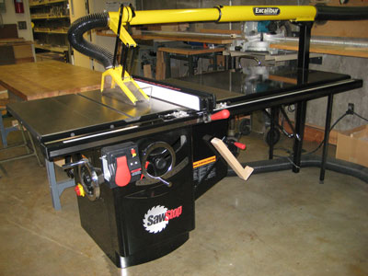

• Guarding Requirements
The guarding requirements for “Saw Stop” table saw are the same as those for a standard table saw.

Radial Arm Saw
- Guarding Requirements
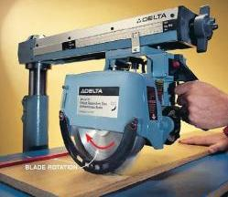
- A self-adjusting guard below the blade
- Safe Work Practices
- The radial arm saw must be returned to the original position after a cut is finished.

Self-adjusting guard

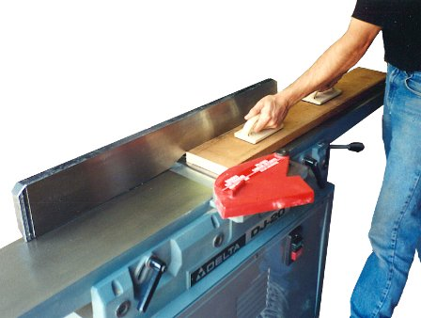
Jointer (manual)
- Guarding Requirements
- Self-adjusting blade guard.
- Safe Work Practices
- If the wood stock is small, use a push stick to feed the stock.
Self-adjusting blade guard

Appendix E

Planer/Moulder (Automatic)
- Guarding Requirements
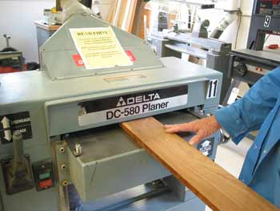
- Cutter heads must be completely enclosed, except for the opening needed to feed the stock into the tool.
Completely enclosed

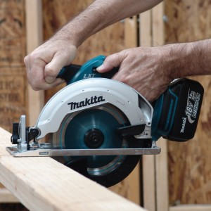
Circular Saw
Self-adjusting blade guard
- Guarding Requirements
- Self-adjusting blade guard.
- Safe Work Practices
- If the saw cut is stopped before the cut is finished, the saw must be turned off before being removed. If the saw is pulled out before stopping, kickback could occur.

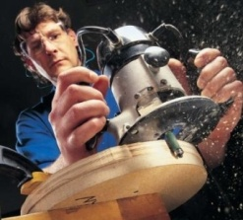
Routers
- Guarding Requirements
  - Self-adjusting guard above cutting bit on bench version. Fixed guard on hand held version.
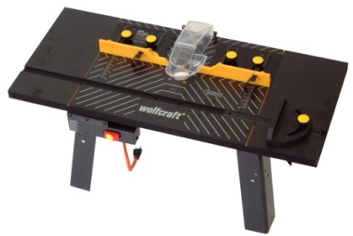

Appendix E

Welding and Brazing
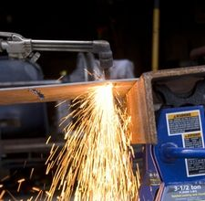
- PPE
- Fire resistance clothing
  - Coat
  - Pants
- Welding helmet or tinted face shield
  - Tinted number depends on what type of welding or torch being used.
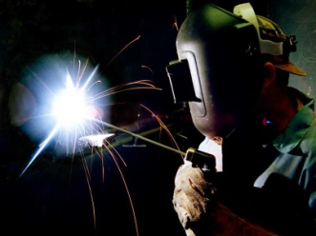
  - If face shield is used, safety glasses are required.
- Leather gloves
  - Heat resistant
- Respiratory Protection (site specific)
- Safe Work Practices
- Cylinders must be secured to a cart by using chain or webbing strap.
- If a cylinder does not have a regulator attached, it must be capped.
- Inspect work area for any combustibles. (Follow PSU Hot Work Permit Program)

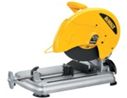
Chop/Miter saws
Chop Saw – self adjusting guard
- Guarding Requirements
- Both saws must have self-adjusting blade guards.
- Safe Work Practices
- Only use the recommended blade based on size and revolutions per minute (RPM).
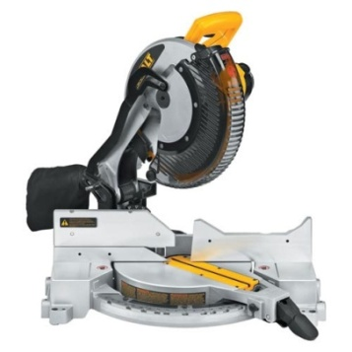
Miter Saw – Self adjusting guard

Appendix E


Reciprocating Saw
- Guarding Requirements
  - Must be equipped with hand/finger guard.

Hand/finger guard

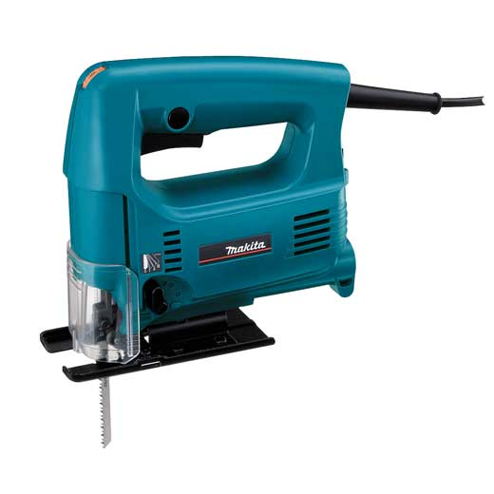
Jig Saw
Blade guard
- Guarding Requirements
  - Upper portion of the blade, above the tool rest, must be guarded.

Scroll Saw
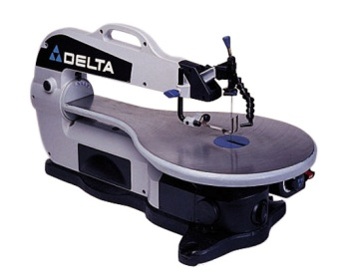
- Guarding Requirements
- Blade guard
Blade guard

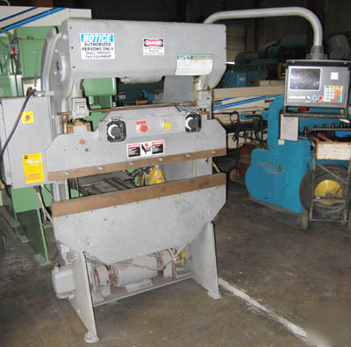
Power Press Brake
- Guarding Requirements
- Note: There are many different methods which can be used to effectively guard this equipment. They are listed below. The best means of guarding will depend on how the press brake is used.
  - Moveable barrier guards
This press is equipped with a properly designed two-hand control
  - Fixed guards
  - Presence-sensing devices
  - Pull back devices
  - Restraint devices
  - Two-hand trip devices

Appendix E

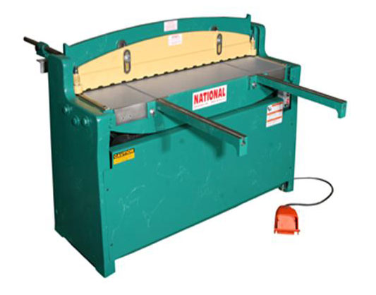
Power Shear
Adjustable guard
- Guarding Requirements
- Adjustable guard

Power Press (Mechanical and Hydraulic) (Part Revolution and Full Revolution)
- Guarding Requirements
- Note: Depending on the size and type of power press a variety of guarding methods are available. The following are examples of such methods. Contact EHS or the equipment manufacturer for consultation.
Mechanical Power Press
  - Point of operation guard
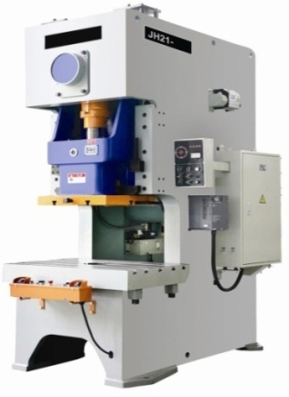
  - Pull back device
  - Restraint device
  - Gate type guards (A and B types)
  - Two-hand trip
Hydraulic Power Press
  - Two-hand control
  - Presence-sensing device

- Safe Work Practices
- Operators must never place their hands in the die area (point of operation) while performing normal production operations.
- Hand tools designed for freeing or removing work or scrap pieces from the die must be used.
- OSHA has a specific standard on Mechanical Power Presses. (CFR 1910.217 – Mechanical Power Presses)

Appendix E

Lathe (Automatic and Manual) (Wood and Metal)
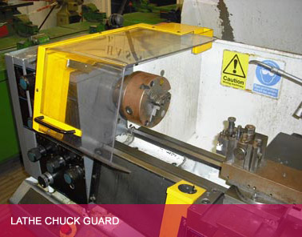
- Guarding Requirements
- A guard over the chuck.
- For lathes used for turning long stock, a guard over top of the stock.
- Safe Work Practices
- Tie back hair and no loose clothing so it doesn’t get caught on the spinning chuck.
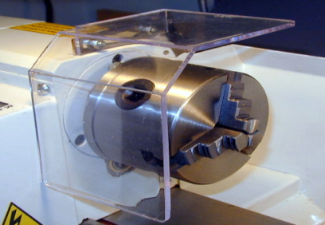
- After making adjustments to the machine, remove the chuck key.

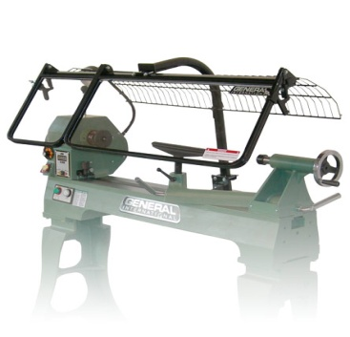
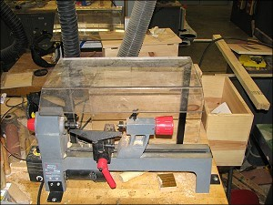

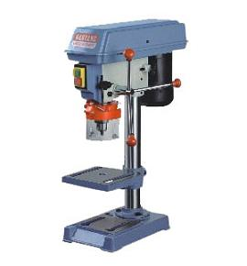
Drill Press
- Guarding Requirements
- Chuck guard
- Safe Work Practices
- Small material being cut shall be clamped to prevent any spinning.
- The drill press machine must be secured so it will not “walk”.

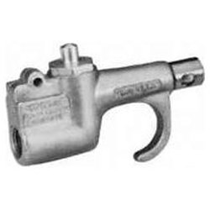
Compressed Air Tools
Safety tip
- Guarding requirements
- Safety tips must be installed to relieve air pressure in the event the nozzle is “dead-ended”.
  - Air pressure must be less than 30 PSI when using compressed air for cleaning.
- Safe Work Practices
- Compressed air tools shall never be used to remove dirt from clothing or skin.

