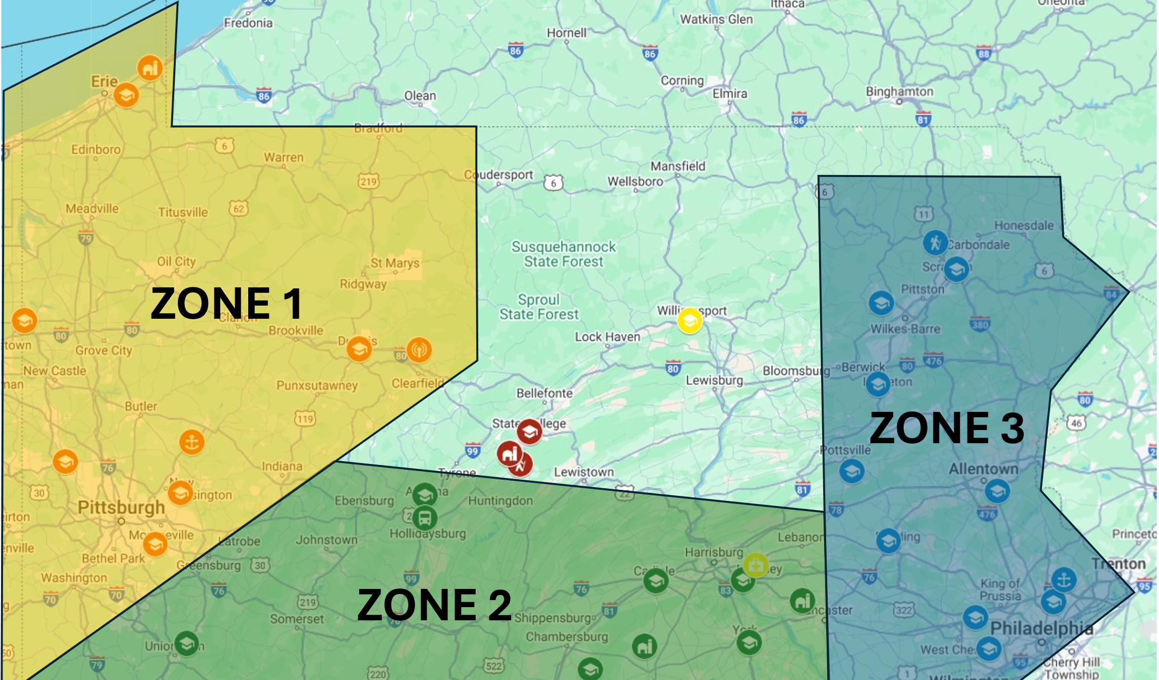

ZONE 2 – Peter Muldoon
- Penn State Altoona
- Penn State Fayette
- Penn State Dickinson
- Penn State Harrisburg
- Penn State Mont Alto
- Penn State York
- Altoona Bus Research
- CoAS Southeast Ag Research
- CoAS Fruit Research
ZONE 3 – Joe Mazzoni
- Penn State Scranton
- Penn State Wilkes-Barre
- Penn State Hazelton
- Penn State Schuylkill
- Penn State Lehigh Valley
- Penn State Berks
- Penn State Abington
- Penn State Great Valley
- Penn State Brandywine
- Fullers Overlook
- ARL Warminster
ZONE 1 – Brandi Baros
- Penn State Behrend
- Penn State Beaver
- Penn State Dubois
- Penn State Greater Allegheny
- Penn State New Kensington
- Penn State Shenango
- CoAS Grape Research
- ARL Freeport/EOC
- WPSU-TV

