Transportation of Chemicals

EHS has been made aware of two occurrences of individuals attempting to transport chemicals improperly. These occurrences could have resulted in serious injury to the individuals or could have resulted in violations with the rules and regulations governing the transportation of chemicals. The two occurrences are listed below to illustrate how not to transport chemicals. The procedures to properly transport chemicals are listed at the end of this document along with pictures showing the proper means to transport the containers.

The first occurrence was two individuals placing five gallon containers of a flammable solvent into the back of their personal vehicle for transport across campus. Chemicals can never be transported in non-University owned vehicles for any reason or distance.

The second occurrence was an individual that was attempting to put a gallon of nitric acid into the back of a University owned vehicle. This bottle was not in secondary containment and broke during the loading of the bottle. The individual suffered a minor burn to his lower leg but this could have been much worse. All chemicals should only be transported using secondary containment to prevent spills and possible injury.

It is preferred that all chemicals be delivered to your lab areas by the University’s Central Distribution department. The employees of Central Distribution have all been trained in the proper handling of chemicals and emergency response procedures. The chemicals are also still packed in their shipping containers and this lessens the chance for breakage or exposure.

If the chemicals must be self transported then the following procedures must be followed. These procedures are for transportation by both vehicle or walking. If by vehicle, it must be a University owned vehicle.

1. All chemicals must be in secondary containment, rubber bottle carriers are permitted, as is a cart with a lip or a rubber bin to contain any spills.
2. Proper personal protective equipment, such as gloves and a lab coat, must be worn.
3. All chemical containers must be labeled properly, chemical names are
required.
4. The most direct route possible should be taken, with no stops in between the two areas.
5. A cellphone or other means of communication should be taken in case of emergency.

6. If using a vehicle, the containers must be secured to prevent them from spilling during transport.
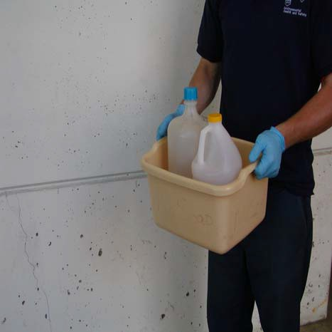7. If multiple chemicals, they must be segregated so that incompatibles are separated.

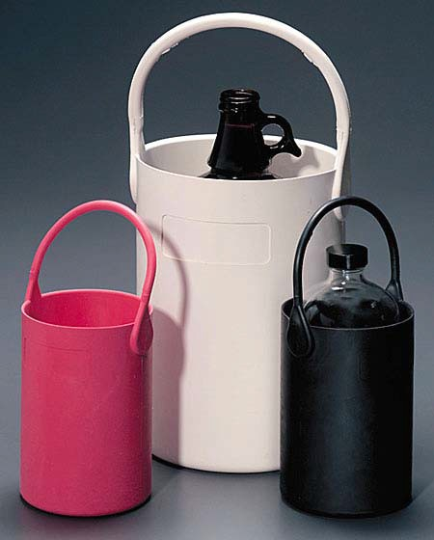

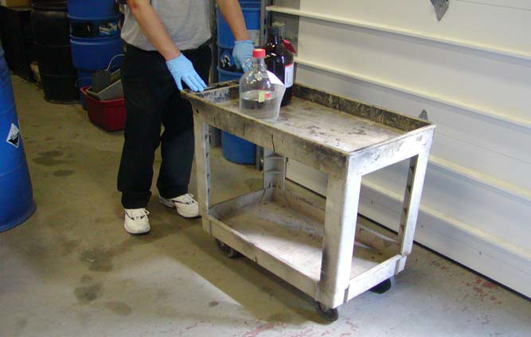

August 2008

