There are Bed Bugs in My Office – Now What?!?

Top Things to Know About Bed Bugs
- It's not about cleanliness—anyone can get bed bugs.
- Bed bugs are often picked up while traveling (spring break, travel abroad, etc.) from hotels and resorts, and can be brought to work with your belongings. Bed bugs can also travel from neighboring apartments through small crevices and cracks in the walls.
- Early detection and treatment of bed bugs is the best way to ensure that the problem doesn’t spread to other offices or to employee’s homes.
What are bed bugs?
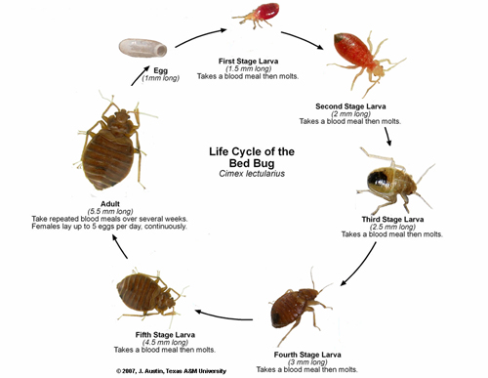
- Bed bugs are small wingless insects with piercing-sucking mouthparts. They do not fly or jump, but rather move by walking or “hitchhiking” from place to place in belongings such as backpacks or luggage.
- Similar to a mosquito, bed bugs bite and suck blood.
- They are oval and flat, ranging from 1/16 to 1/8 inch long, and look like an apple seed.
Are bed bugs harmful?
- Bed bugs are not known to transfer disease.
- Bites will usually only affect the surface of the skin; they are typically small itchy red bumps. You may find clusters showing signs of repeated feeding by a single bed bug.
- Some people may experience allergic reactions from bites which may appear as itchy welts, blister like inflammations, or skin rashes similar to hives.
Where do I look for signs of bed bugs?
- Anywhere people spend time being still, such as beds and chairs.
- In the office they may be in chair upholstery seams, backpacks, behind wall hangings and pictures, at the edge of carpeting, in molding, or in other areas where they can hide – remember they are very small and may not be easy to see.
- At home, check bed seams, frames, and the area around the bed.
- Bed bugs leave dark red spots on mattresses or sheets and can hide in tight crevices in dressers, bed frames, and floorboards. You may also find castings (shed skins).
What should I NOT do if I have bed bugs in my office?
- Do not try to get rid of the bed bugs yourself. It takes a long process to get rid of the infestation.
- Do not immediately throw away belongings. Furniture, clothes, and other belongings can be treated.
How does Penn State handle an infestation?
- Penn State uses Integrated Pest Management (IPM) to deal with all pests found in buildings, including bed bugs. IPM relies on a combination of practices including reducing hiding spots for bed bugs, heat treatments, and pesticides to treat bed bugs.
- Once bed bugs are discovered in an office, all the belongings in it are quarantined. Our pest control vendor will carefully inspect all items before removing them from the office and treat as necessary.
- Typically bed bug control requires several visits over a period of about a month.
- During the treatment period, occupants may want to bring an extra set of clothing sealed in a plastic bag to work to change into at the end of the day. The clothing worn to work can then be heated in a dryer to ensure that you are not taking the bed bugs home with you.
- Treatment will occur after normal working hours. In some cases, occupants may be relocated to another space while the work area is being treated.
- EHS is available to explain the inspection and treatment process and provide assistance as needed.
- If you believe that you have been bitten by bed bugs at work, you should submit a first report of injury and if necessary, seek medical attention through occupational medicine.
- The EAP is available to help employees who are experiencing emotional distress due to bed bugs.
What can I do to minimize the chance of bringing bed bugs from work home?
- While an infestation is on-going, you can limit the possibility of taking them home by placing your clothes in a hot (140°F) dryer for 30 minutes as soon as you get home. Bed bugs can be killed by heat over 113°F degrees, but the higher the temperature the quicker they die.
- Bed bugs can be also killed by freezing temperatures. Temperatures below 0°F (-18 C) for one to two weeks are generally believed to be needed to reliably kill all life stages.
What do I do if I find bed bugs at home?
- It's important to take care of the problem before the infestation gets worse and/or spreads. The process to eliminate bed bugs is lengthy and needs your full cooperation to properly exterminate the bugs. If you have bed bugs in your office and you find them at home, contact Environmental Health and Safety at 814-865-6391. You should not try to eliminate them on your own - It is unlikely that you will be successful without a certified pest vendor.
For more bed bug information: http://extension.psu.edu/pests/bedbugs

