PSU Robot Safe Setup Requirements

Introduction and Scope:
These requirements describe some of the elements of good safety practices and techniques used to ensure safe installation and use of robots.
A robot can have one or more arms, which are interconnected sets of links and powered joints. Arms are comprised of manipulators which support or move wrists and end-effectors. An end-effector is an accessory tool specifically designed for attachment to a robot wrist to enable the robot to perform its intended task.

What type of robots does this requirement apply to?
-Industrial robots similar to the types pictured below, regardless if they are floor or benchtop models.
-This requirement does not apply to mobile robots with integrated wheels/tracks.
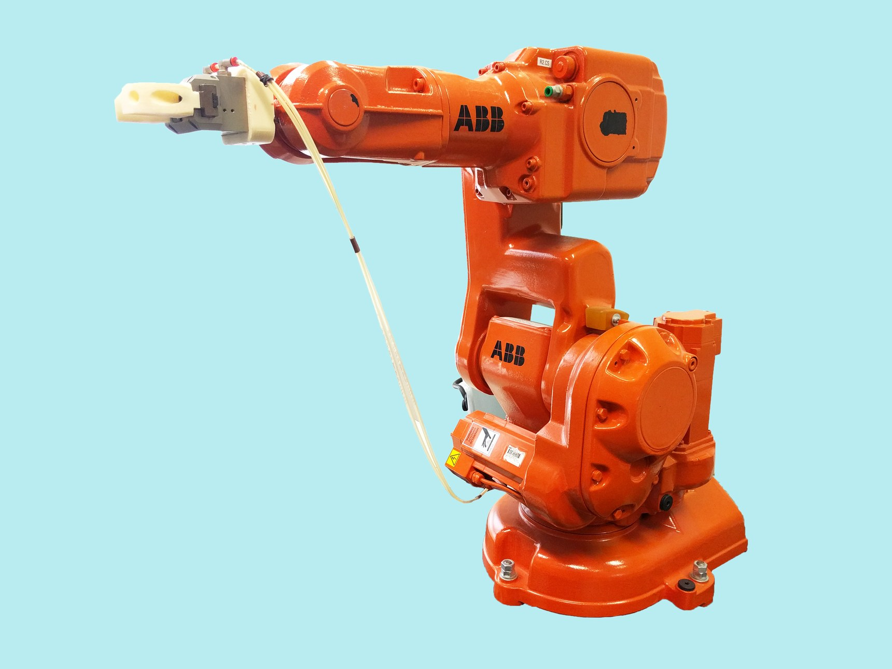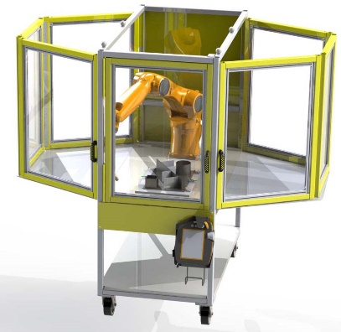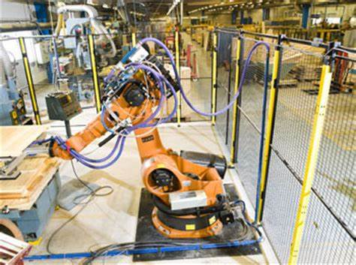

Requirements:

- Create a documented Standard Operating Procedure (SOP) for the robot containing at a minimum the following information:
  - Employee with the overall responsibility for the robot;
  - Intended use of the robot;
  - List of safety devices/systems;
  - Requirements for periodic function testing of safety systems according to the manufacturer (i.e. light curtains, door interlock, emergency stops);
  - List of required personal protective equipment (PPE);
  - Employee/s responsible for training robot operators;
  - List of personnel authorized to operate the robot;
  - Employee/s responsible for performing servicing/maintenance of the robot.

- The manufacturer’s guidelines must be followed pertaining to installation. Including but not limited to the following:
  - Robot must be secured to prevent movement/tipping of the robot;
  - Ensuring that the layout of the cell is assessed for hazards. Some examples of hazards include;
    - Lack of illumination. Illumination of the area must be sufficient enough so that operators and maintenance personnel can clearly see robot parts/controls, perform inspections and adjustments;
    - Blocked traffic routes (pedestrians, industrial vehicles, etc);
    - Blocked building support systems (electric, gas, HVAC, etc);
    - Blocked emergency equipment (fire extinguishers, eye washes, exits, etc);
  - The main control center is located outside of the perimeter guarding.

- For robots that require hard wiring into the building electrical system, such as a disconnect/circuit breaker panel:
  - PSU electricians or other qualified Technical Service employees must perform this work.
    - See the document titled “PSU Safety Risk Assessment for Lab Electrical Equipment document”. https://ehs.psu.edu/laboratory-safety/guidelines

- Additional hazards that have the potential to be created by the specific application/task of the robot must be considered and addressed. These hazards may include but are not limited to welding, laser cutting, machining, etc.

- Safeguarding/guarding methods must include:
  - An enclosure (fence/wall/plexiglass, etc.) around at least 3 sides of the robot, at least 5 feet high for floor robots (the top of the enclosure must be 5 feet high for benchtop robots), and attached to the floor/benchtop, OR light curtains around all four sides.
  - A light curtain or interlocked door at the entrance to the cell. These types of devices cut off power to the robot when crossed (light curtain) or when the door is opened.
  - The portable programming control device contains an emergency stop and all actuating controls are labeled.
  - Mechanical stops are to be installed on the robot’s primary axis to restrict the robot’s movement to only the area necessary to complete the intended task. Mechanical, electromechanical, or electronic limiting devices are installed on axes 2 and 3.

- All robot motion initiated from the teach pendant, when used inside the perimeter guarding, is subject to a slow speed of 10 in/sec (250 mm/sec).

- Employee/s performing the servicing/maintenance of the robot must be trained in Lockout Tagout (LOTO) and knowledgeable with the robot system.
  - There must be a documented LOTO procedure for the robot. Utilize the template found on the EHS website. https://ehs.psu.edu/lockout-tagout/forms

- Use of the robot must comply with all requirements of the PSU Machine Shop Safety Program: See Section 9.0, https://ehs.psu.edu/machine-shop-safety/requirements-guidelines
a. Monitoring requirements of students. (See appendix A)
b. Room Access Control. Examples include locking a door and only those authorized to utilize the robot have the key or locking out the energy isolating devices (i.e. electric, pneumatic) to the robot when it’s not in use.
c. General Shop Safety Training. (See appendix C)
d. Equipment Specific Training. (See appendix D)
i. Training, at a minimum, must cover a review of the safeguarding methods, safe work practices and operation of robot’s controls.
e. Machine Guarding

- Special Requirement: Due to their increased risk of causing a fatal injury, EHS must be notified to review installations pertaining to floor model robots prior to start up.
- Bench top / desk top model robots do not require a review by EHS.

Typical robot work cell and guarding layout (this shows perimeter guarding utilizing a metal fence and a light curtain at the entrance to the work cell)

Perimeter guarding
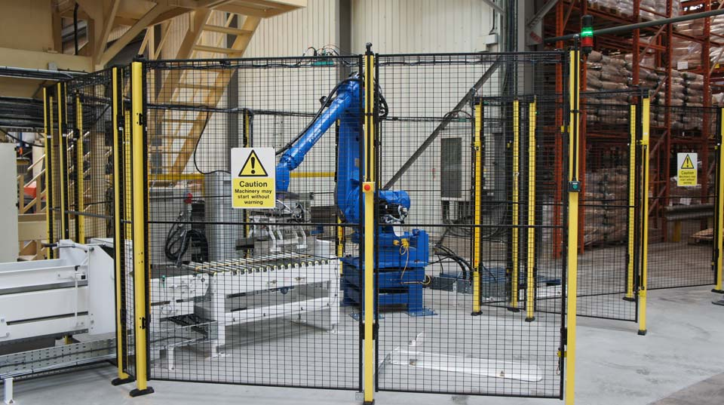
Light curtain at entrance to work cell

Additional guidance for setting up and using a robot safely:
- OSHA Instruction. Guidelines for Robotics Safety. https://www.osha.gov/enforcement/directives/std-01-12-002
- OSHA Technical Manual. Industrial Robots and Robot System Safety. https://www.osha.gov/dts/osta/otm/otm_iv/otm_iv_4.html
- ANSI/RIA R15.06-2012. Industrial Robots and Robot Systems-Safety Requirements.
https://webstore.ansi.org/Standards/RIA/ANSIRIAR15062012

