Liquid Nitrogen Handling Fact Sheet
For small volume users who do tasks such as grinding samples, snap freezing cells, preparing samples for storage, or filling small Dewars

Cryogens such as liquid nitrogen can be hazardous to laboratory workers if not handled properly. Depending on the situation, improperly handled liquid nitrogen can lead to oxygen deficiency, cold burns, and explosions.
____________________________________________
General precautions when working with liquid nitrogen:
- Develop standard operating procedures for working with liquid nitrogen. Remember to include other hazards that may be present, such as other chemicals or biological agents. Determine which specific Personal Protective Equipment (PPE) should be worn based on how you will work with liquid nitrogen.
- Liquid nitrogen splashes can result in cold burns. PPE requirements are designed to avoid eye and skin contact.
- Never handle liquid nitrogen, or items that have been in liquid nitrogen, with bare hands.
- Do not use or store liquid nitrogen in confined areas, walk-in refrigerators, environmental chambers, or rooms without ventilation. A leak in such an area could cause an oxygen-deficient atmosphere.
- Never store liquid nitrogen in a sealed, airtight container at a temperature above its boiling point (-195.8°C). The pressure resulting from the production of gas may lead to an explosion.

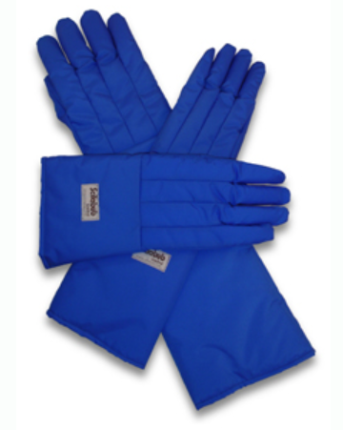Use the following personal protective equipment (PPE) when working with liquid nitrogen:

- Eyes: At a minimum, wear safety glasses. If splashing is anticipated, chemical splash goggles should be worn. A full face shield may also be appropriate.

- Hands: Avoid skin contact with liquid nitrogen. Do not touch anything that has been in liquid nitrogen without protecting your skin. Prevent cold burns by using things like cloth glove liners under nitrile gloves while grinding samples or using tongs to hold and move tubes. Insulated or cryo gloves must be worn while dispensing liquid nitrogen from tanks. Never submerse hands into liquid nitrogen, even while wearing insulated gloves.

- Protect the rest of the body with long pants, lab coat, and closed toe shoes. If wearing boots, it is recommended that pants cover the boots rather than be tucked into them (to avoid liquid nitrogen spilling into the boots).

____________________________________________
In case of exposure to liquid nitrogen:
- Remove any clothing that is not frozen to the skin. Do NOT rub frozen body parts because tissue damage may result.
- Place the affected body part in a warm water bath (below 40°C). Never use dry heat.
- Obtain medical assistance as soon as possible.
____________________________________________
If you need to further guidance:

If you are unsure of what PPE is most appropriate for your work, or need further information on working with liquid nitrogen, contact EHS at 814-865-6391, or visit www.ehs.psu.edu.

Working with larger quantities of liquid nitrogen can also pose additional hazards. Please contact EHS for further guidance if you do tasks such as filling larger Dewars or charging NMR or MRI systems. EHS can assist in assessing the risk of oxygen depletion that may be associated with these tasks.

