Hydrofluoric Acid

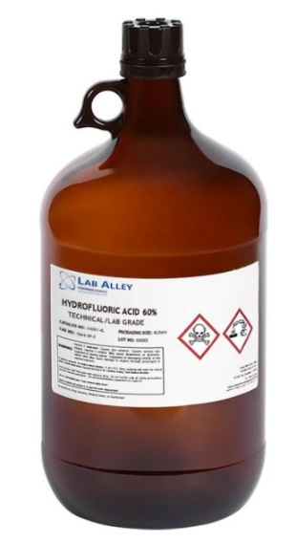
I. Purpose and Introduction

Exposure Notice: If referring to this document after exposure, the affected person must flush the area with water immediately and needs to seek medical attention! Refer to the First Aid section of the document.
The intended audience of this document are those who have exposure to hydrofluoric acid or supervise employees with exposure. The purposes of this document are:
- To serve as an information source for hazard identification and control method selection
- To inform lab-specific standard operating procedures
- To be used as a training tool for substance-specific training and incident response.
This document presents an overview of the hazards and hazard control methods associated with the storage, use, and exposure to hydrofluoric acid (CAS No. 7664-39-3). All users of hydrofluoric acid solutions should review this document.
Hydrofluoric acid (HF) is one of the most corrosive acids known. Concentrated HF is used in the fabrication of electronic components, to etch glass, and in the manufacture of semiconductors. It is also used by geologists to dissolve sedimentary rock. Dilute HF solutions are used in some biological staining procedures. Hydrofluoric acid solutions are clear and colorless with a density like water.
Many fluoride-containing chemicals (e.g. ammonium fluoride, sodium fluoride, sulfur tetrafluoride, and ammonium bi-fluoride) may react with acid or water to produce HF. If the manner in which the fluoride compound is used can create HF, follow these guidelines for HF.

II. Hazards & Routes of Exposure

HF has several physical, chemical, and toxicological properties that make it especially hazardous to handle. Both anhydrous hydrofluoric acid and aqueous solutions are clear, colorless, and highly corrosive liquids. When exposed to air, anhydrous HF and concentrated solutions produce pungent fumes, which are also dangerous. HF shares the corrosive properties common to mineral acids, but HF possesses the unique ability to cause deep tissue damage and systemic toxicity. Prevention of exposure or injury must be the primary goal when working with HF. Any HF user must be intimately familiar with the appropriate first aid in case of an exposure.
Skin Contact
Concentrated HF (>50%) exposure to a small part of the body can cause severe burns, excruciating pain, and death. At lower concentrations, symptoms may be slower to appear and subsequent treatment may be delayed. But regardless of concentration, immediate medical treatment is needed. With direct contact to 20-50% solutions of HF, burns and pain can be delayed for up to eight hours, and at concentrations < 20%, pain and redness may not occur for up to 24 hours. HF could eventually cause burns and even death at concentrations as low as 2% if not effectively washed off.
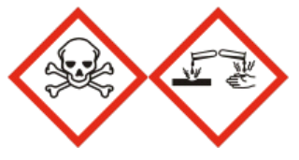
Hydrogen fluoride causes severe burns because as it penetrates the cells it is quickly dissociated into fluoride ions. The fluoride ions then bind with calcium in the body to form insoluble calcium fluoride, destroying tissues and inactivating calcium that is needed for vital body functions. Heart function becomes diminished, the heart beat abnormal, and cardiac arrhythmia, as well as liver and kidney damage, may occur. HF must not be handled while working alone. Exposure to HF can be fatal.
Eye Contact
HF contact with the eye can cause eye burns and destruction of the cornea. Blindness results from severe or untreated exposures. Significant measures must be taken to prevent both exposure to skin and the eyes.
Inhalation
Inhalation of HF vapors may cause laryngospasm, laryngeal edema, bronchospasm and/or acute pulmonary edema. The symptoms of exposure are coughing, choking, chest tightness, chills, fever, and blue skin.
Exposure Criteria – The Permissible Exposure Limit (PEL) set by the U.S. Occupational Safety and Health Administration (OSHA) is a time weighted average exposure for 8 hours of 3 ppm. The National Institute for Occupational Safety and Health (NIOSH) has set the Immediately Dangerous to Life and Health (IDLH) level at 30 ppm (30 min). HF shall only be used in a fume hood or with equivalent engineering controls in place to prevent inhalation exposure.
Ingestion
Severe burns to the mouth, esophagus, and stomach may occur upon ingestion of HF. The ingestion of a small amount of HF has resulted in death. If ingested, medical attention must be received immediately.
III. Work Practices, Procedures and Controls

Preparation and Precautionary Measures
Before any laboratory groups use HF, the PI and/or user should do the following:
- Substitution – Determine if you can use a less hazardous substance in place of HF. Use of HF must be necessary to allow for the risk associated with use.
- Order the most dilute solutions available that will meet experimental needs. Order only the quantity that you need.
- Store the minimal amount feasible for what is needed to conduct research and work tasks.
- If possible, do a trial run with a compound other than HF to identify any experimental, procedural, or handling shortfalls.
- Safety Data Sheets – Review manufacturer’s Safety Data Sheet (SDS) and ensure you have the resources for proper safety measures to be implemented.
- Ensure that a standard operating procedure (SOP) including safety information is available for users and that users will be trained on the SOP. Refer to the Penn State Laboratory Research and Safety Plan and Unit-Specific Plan requirements.
- Read this guidance document.
- Emergency Eyewash/Safety Shower – Identify the location of the nearest eyewash and shower and verify that they are accessible. Immediate flushing in the event of bodily exposure is crucial. The eyewash and shower should be within 10 seconds (45 feet) of where HF will be handled (as close as possible). All users must be trained on access and appropriate use of the eyewash and safety shower.
- Proper Storage – Identify storage location. Ensure storage will comply with SDS requirements.
- Preparation for Emergencies – Obtain 2.5% calcium gluconate gel (e.g., Calgonate® Gel) (available through VWR, Grainger, Fisher Sci.). Review the first aid procedures therein. This gel is essential to preventing catastrophic effects if skin is exposed to HF. It must be immediately accessible to HF users. All HF users must know where it is located and how to properly apply it in the event of exposure. This must be part of the hazard training a supervisor provides employees exposed to HF.
  - It is recommended to also obtain Calgonate Eyewash fluid (1% calcium gluconate fluid) for eye flushing in the event of eye exposure
  - Obtain an appropriate spill kit and review the procedures to follow in the event of a spill. Refer to the Spill Response section of this document.
  - Ensure there will be a Supervisor, Lab Manager, or another person who knows HF emergency procedures is in the area when HF will be used. No one may use HF while working alone. Someone must be readily available to assist in the event of exposure or emergency.

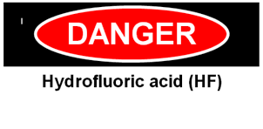
Designated Work Area
- Fume Hood Required – HF shall only be handled inside of a fume hood that is identified with a sign stating “Danger, Hydrofluoric Acid” or something similar.
- A Standard Operating Procedure (SOP) should be posted and must be readily available near the designated area.
- First Aid Treatment – A tube of 2.5% calcium gluconate (consider several tubes/bottles if large volumes of HF are present) must be immediately accessible. The gel should be replaced annually or in accordance with the expiration date on the tube. 1% calcium gluconate eyewash fluid is recommended as well.
- Spill Kit – An HF spill kit or adequate spill clean-up materials must be immediately accessible.
- An eyewash and safety shower must be immediately accessible in the work area.
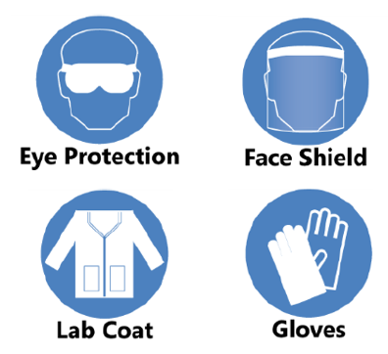
Personal Protective Equipment (PPE)
When using HF, you must wear the following protective clothing:

- Body - Laboratory coat AND acid resistant apron.
- Legs and Feet - Closed-toed shoes and long pants.
- Eyes and Face – Goggles (if potential exposure to vapors); or a faceshield over top of safety glasses (glasses alone NOT enough)

- Hands – (Gloves)

*Preliminary Note: The following are general guidelines. Proper glove selection requires thorough hazard assessment and evaluation of glove protection properties as described by manufacturer’s’ specifications. You must review glove characteristics and ensure they will provide adequate protection based on potential exposure to HF.

  - Brief use of dilute solutions: nitrile gloves ≥ 4mil. Consider double gloving.
  - Brief use of concentrated solutions: Neoprene or Nitrile gloves 22mil – that cover hands, wrists and forearms.
  - For the use of concentrated solutions: use gloves that cover the hands, wrists, and forearms. According to the Quick Selection Guide to Chemical Protective Clothing (5th edition, page 149), the following gloves will provide protection from hydrofluoric acid (30-70%) for 4 hours or more: Butyl rubber, neoprene rubber, Viton®/butyl rubber, Barrier® (PE/PA/PE), Silver Shield/4H® (PE/EVAL/PE), Trellchem® HPS, Trellchem® VPS, Tychem® SL (Saranex®), Tychem® CPF3, Tychem® BR/LV, 4 Tychem® Responder®, Tychem® TK.
  - The following gloves will protect against hydrofluoric acid (>70%) for 4 hours or more: Neoprene rubber, Barrier® (PE/PA/PE), Trellchem® HPS, Tychem® TK.

    - Gloves must be thoroughly inspected prior to each use. Do not use damaged gloves.
    - As a general rule of thumb, change gloves at a frequency of ½ the anticipated breakthrough time (as a safety factor), AND immediately whenever you suspect contamination on gloves.
    - Use proper glove removal technique (without touching gloves outer surface) to avoid skin contact with hydrofluoric acid.

Safe Work Practices and Storage
- Never work with HF alone
- HF reacts with glass. Hydrofluoric acid attacks all silica containing materials, including glass. It must be used and stored in high density polyethylene (PE) bottles and vessels.
- Storage Containers & Practices – Bottles for storage of HF must have secure caps and lids that can provide a gas-tight seal to prevent escape of hydrogen fluoride gas.
  - Store below eye level.
  - Do not store with oxides, organic chemicals, bases, or metals.
  - Primary containers must have manufacturer’s label or GHS label information. Secondary containers must clearly identify the substance and its hazards.
  - Always work with a chemically compatible secondary containment tray.
  - Ensure HF containing vials and flasks are securely supported and not likely to tip over.
  - Keep containers closed to minimize exposure and prevent etching of fume hood glass from HF vapors.
- Avoid heating HF. If heating of HF is required, a documented hazard analysis should be conducted by the research group and must be readily available for review by EHS.
- Transporting HF – If an HF containing solution must be transported from one lab area to another, place the HF in a clean, chemically compatible container and close the lid. Consider using a cart with sidewalls. Remove your gloves before transporting the container to avoid the possibility of chemical contamination on your gloves spreading to door handles and other objects. Or have a lab-mate open doors and handle objects for you, if you keep gloves on.
- Final Cleaning/Decontamination – Once the work with HF is complete, decontaminate the area and any reusable items with a 10% sodium carbonate (Na₂CO₃, also known as soda ash) solution.
IV. First Aid & Emergency Response

Preliminary Note: As further presented, and after initial response measures, any exposure to HF should be immediately followed up by medical review/assistance. The victim’s supervisor should be contacted as soon as possible, following initial treatment and emergency response, to ensure proper incident reporting procedures are followed.

Skin Exposure

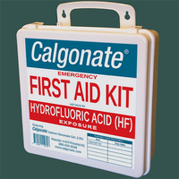
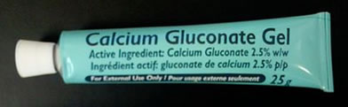
1) Immediately flush affected areas with running water (e.g. emergency shower). While flushing, remove all contaminated clothing as well as jewelry that could trap HF. Wash the contaminated area with copious amounts of running water for 5 minutes. Speed and thoroughness in washing off the acid is essential. If calcium gluconate gel (2.5%) is not available, continue flushing with water for at least 15 minutes or until emergency medical service is obtained.

2) While the victim is being rinsed with water, have someone call 911 and say:
(a) a person has been exposed to hydrofluoric acid.
(b) The person can be found at [give location of victim].

3) After flushing for prescribed time, don a new pair of chemical resistant gloves (to prevent possible secondary HF burns) and massage calcium gluconate gel (2.5%) freely into the affected site. The affected area does not need to be dried first. The gel will turn white (CaF₂ precipitate) upon reaction with the acid.

Note: For suspected/potential exposures, stop work and flush with water and apply calcium gluconate gel as described above. Follow any additional instructions provided with the calcium gluconate gel, and discontinue work. Employees should contact Penn State Occupational Medicine, and Students should contact University Health Services for further instructions. This may involve monitoring affected area and for other symptoms closely for 48 hours. All personnel should seek medical treatment immediately if there is any sign of exposure, skin discoloration, pain, etc.
Eye Exposure

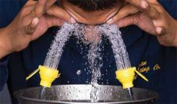
- Immediately flush eyes with cool flowing water at an eyewash station. Hold the eyelids open and away from the eye during irrigation to allow thorough flushing of the eyes. Rotate eyeballs during flushing.
- Obtain assistance. If sterile 1% calcium gluconate solution is available, start using it within the first 5 minutes (via continuous drip into eyes), and continue using it as the preferred flushing agent. Do NOT use 2.5% calcium gluconate GEL on the eyes. If sterile 1% calcium gluconate solution is not available, wash with copious amounts of water for 15 minutes while holding eyelids apart. Swift medical treatment is crucial.

3) While washing the eye, have someone call 911. Inform them of the HF exposure and location. Request ambulance or emergency medical assistance, preferably an eye specialist. Calcium gluconate solution (1%), eyewash, clean water, or ice water compresses should be used to continue to irrigate the eye(s) while transporting the victim.

Inhalation of Vapors

1) Immediately move affected person to fresh air and call 911 for medical assistance. Follow protocol noted above for Skin and Eye Exposure.

2) Supporting emergency medical protocol include: Keep victim warm, comfortable, and quiet. If breathing has stopped, begin CPR at once.

3) The victim should be examined by a doctor and held for observation for at least 24 hours. The reason is that inhalation of HF fumes may cause swelling in the respiratory tract for up to 24 hours after exposure. A person who has inhaled HF vapors may require prophylactic oxygen treatment. Vapor exposure can cause skin and mucous membrane burns and damage to pulmonary tissue. Vapor burns to the skin are treated the same as liquid HF burns.

Ingestion

1) Call 911 immediately. Do not induce vomiting. Never give anything by mouth to an unconscious person.

2) Have the victim drink large amounts of room temperature water as quickly as possible to dilute the acid.

3) Have the victim drink several glasses of milk or several ounces of milk of magnesia, Mylanta, Maalox, or similar products, or eat up to 30 Tums, Caltrate or other antacid tablets. The calcium or magnesium in these substances may act as an antidote. Avoid administering bicarbonates (Alka-Seltzer et al.) at all costs, the carbon dioxide byproduct could severely injure the victim.

4) Proceed to a physician for appropriate treatment.
V. Spill Response

Simple Spill

Preliminary: All personnel working with HF shall receive applicable spill response training. Consult EHS for assistance. If a simple spill occurs inside a fume hood (e.g. palm sized or smaller), trained and comfortable lab personnel are authorized to clean the spill per the following:
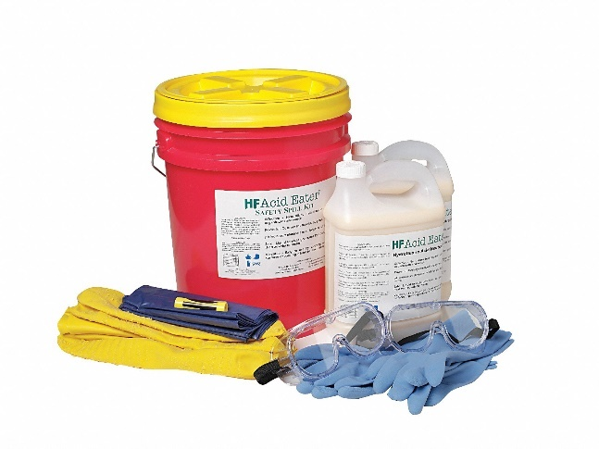
- Don necessary PPE (see PPE section of this document).
- Stop and contain spilled material.
- Alert people in immediate area of spill.
- Use hydrofluoric acid spill neutralizer and absorbent to clean/neutralize spilled solution. An HF spill kit or necessary spill clean-up materials are required to be stored in or near a designated HF use area.
- Collect residue, place in container with a lid, and label with a completed green tag that includes “HF spill clean-up materials,” and dispose of as hazardous waste.
- After neutralization of spill and spill-area, clean the area with soap and water.
- Report all spills to EHS.

Larger Spill or Spill Outside a Fume Hood

- Evacuate the area.
- Call EHS for emergency assistance, or 911.
- Post someone or mark-off the hazardous area with tape and warning signs to keep other people from entering.
- Someone must remain near the incident site to provide information to emergency personnel.

VI. Training

Supervisors/PIs are responsible to assure that workers who may be potentially exposed to hydrofluoric acid are trained to recognize, understand, and reduce health and safety risks. Supervisors/PIs must also ensure user clearly understand first aid treatment required and how to respond in the event of exposure. This document can be used in support of training. Training must include review of pertinent standard operating procedures for the laboratory or specific operations. Such training should be documented and maintained by the Supervisor/PI.

VII. Waste Disposal

- Waste HF should be placed in a chemically compatible container (high density polyethylene) that is clearly labeled with a green Hazardous Waste tag
- Waste shall be placed in a designated satellite accumulation area, in secondary containment, with a closed cap.
- Never store HF waste in a glass container.
- Dispose of HF containing hazardous waste containers following normal hazardous waste disposal procedures.
- Hydrofluoric acid should never be disposed of by drain. Elementary neutralization of HF does not permit drain disposal, even if the resulting solution pH is 7. Neutralization of hydrofluoric acid with a basic material produces metal fluoride salts, which are toxic.
- All materials that have been contaminated with hydrofluoric acid still exhibit a hazard and therefore should also be disposed of as hazardous waste. These materials include research devices, empty bottles formerly containing HF, spill debris, and PPE worn while using HF.

Approvals:
Elliot Laratonda
Author
Various |  | Robert Segura
Reviewer (if applicable) |  | Manager (if applicable)

References

Yale University EHS – Standard Operating Procedure: Hydrofluoric Acid
https://ehs.yale.edu/sites/default/files/files/hyrdofluoric-acid-sop.pdf
Harvard University EHS – Guidelines for the Safe Use of Hydrofluoric Acid
https://chemistry.harvard.edu/files/chemistry/files/safe_use_of_hf_0.pdf
Princeton University EHS – Hydrofluoric Acid
https://ehs.princeton.edu/laboratory-research/chemical-safety/chemical-specific-protocols/hydrofluoric-acid
Mount Sinai Standard Operating Procedure Hydrofluoric Acid
Penn State EHS – Laboratory and Research Safety Plan
https://ehs.psu.edu/laboratory-safety/overview

