Information about Bed Bugs in Public Spaces

With travel today both in and out of the country becoming more frequent, the likelihood of finding bed bugs in public spaces has increased. It is important to understand how bed bugs can be transported, their life cycle, and how they are treated to protect yourself from these pests. While bed bugs can be brought into a public space through someone’s belongings, it is very unlikely at Penn State that more than a few bed bugs will be present before they are discovered and eliminated. The information given below is intended to educate you on these pests so that you can help prevent the presence of a few bed bugs from turning into an infestation.

Top Things to Know About Bed Bugs
- It's not about cleanliness—anyone can get bed bugs.
- Bed bugs are often picked up while traveling (spring break, travel abroad, etc.) from hotels and resorts, and can be brought to work with your belongings. Bed bugs can also travel from neighboring apartments through small crevices and cracks in the walls.
- Early detection and treatment of bed bugs is the best way to ensure that the problem doesn’t spread to other areas or to employee’s homes.
What are bed bugs?
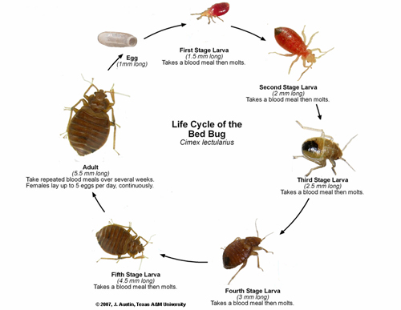
- Bed bugs are small wingless insects with piercing-sucking mouthparts. They do not fly or jump, but rather move by walking or “hitchhiking” from place to place in belongings such as backpacks or luggage.
- Similar to a mosquito, bed bugs bite and suck blood.
- They are oval and flat, ranging from 1/16 to 1/8 inch long, and look like an apple seed.
Are bed bugs harmful?
- Bed bugs are not known to transfer disease.
- Bites will usually only affect the surface of the skin; they are typically small itchy red bumps. You may find clusters showing signs of repeated feeding by a single bed bug.
- Some people may experience allergic reactions from bites which may appear as itchy welts, blister like inflammations, or skin rashes similar to hives.
Where do I look for signs of bed bugs?
- Anywhere people spend time being still, such as beds and chairs.
- They may be in chair upholstery seams, backpacks, behind wall hangings and pictures, at the edge of carpeting, in molding, or in other areas where they can hide – remember they are very small and may not be easy to see.
- At home, check bed seams, frames, and the area around the bed.
- Bed bugs leave dark red spots on mattresses or sheets and can hide in tight crevices in dressers, bed frames, and floorboards. You may also find castings (shed skins).
What should I do if I find a bed bug or signs of bed bugs at Penn State?
- If you can, capture the insect or take a photograph.
- At University Park, report the presence or signs to your facility coordinator, the OPP Work Reception Center (865-4731) or to Environmental Health and Safety (865-6391).
- At other locations, report the presence or signs to your Director of Business Services, Maintenance Supervisor, or to Environmental Health and Safety (865-6391).

What should I NOT do if I find bed bugs?
- Do not try to get rid of the bed bugs yourself. It takes a long process to get rid of the infestation.
- Do not immediately throw away belongings. Furniture, clothes, and other belongings can be treated.
How does Penn State handle a bed bug sighting?
- Penn State uses Integrated Pest Management (IPM) to deal with all pests found in buildings, including bed bugs. IPM relies on a combination of practices including reducing hiding spots for bed bugs, heat treatments, and pesticides to treat bed bugs.
- Once bed bugs are discovered, our pest control vendor will carefully inspect the area and treat as necessary. There will be regular follow-up inspections over a period of at least several weeks.
- Bed bug control may require more than one treatment.
- Treatment will occur after normal working hours. In some cases, areas may be closed off during treatment.
- EHS is available to explain the inspection and treatment process and provide assistance as needed.
- If you believe that you have been bitten by bed bugs at work, you should submit a first report of injury and if necessary, seek medical attention through occupational medicine.
- The EAP is available to help employees who are experiencing emotional distress due to bed bugs.

What can I do to minimize the chance of bringing bed bugs from work home?
- While bed bugs are present, you can limit the possibility of taking them home by placing your clothes in a hot (140°F) dryer for 30 minutes as soon as you get home. Bed bugs can be killed by heat over 113°F degrees, but the higher the temperature the quicker they die.
- Bed bugs can be also killed by freezing temperatures. Temperatures below 0°F (-18 C) for one to two weeks are generally believed to be needed to reliably kill all life stages.
What do I do if I find bed bugs at home?
- It's important to take care of the problem before it gets worse and/or spreads. The process to eliminate bed bugs is lengthy and needs your full cooperation to properly exterminate the bugs. If you have bed bugs in your office and you find them at home, contact Environmental Health and Safety at 814-865-6391. You should not try to eliminate them on your own - It is unlikely that you will be successful without a certified pest vendor.
For more bed bug information: http://extension.psu.edu/pests/bedbugs

