Bed Bug Information
As you have seen or heard in the news, incidents of bed bugs are on the rise throughout the United States. There have been reports of them in hotels, residences, stores, movie theatres, etc. Bed bugs are opportunistic hitchhikers that can move from place to place in luggage, backpacks, or other items where they may be difficult to detect. Because of this, they can show up anywhere. They tend to hide in dark, tight places during the day, coming out at night to feed, though if hungry enough have been known to bite during daylight. Although their bites may be bothersome, they are not known to transmit disease. Bed bugs and their bites are pictured below:
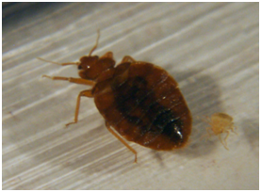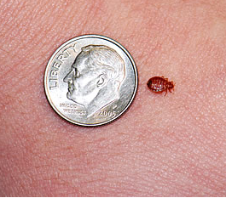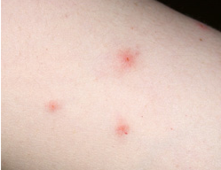
Penn State is carefully monitoring for the presence of bed bugs and has developed a protocol to address them. While there have been bed bug occurrences at PSU (primarily in housing) all have been effectively eradicated. In the rare case where bed bugs could be inadvertently taken to the office or other work area their detection will require your awareness and assistance. If you suspect there are bed bugs in your work area, please contact either your Area Services Office or the Work Reception Center at 865-4731 at University Park or if you work at a Commonwealth Campus, the Campus Business Office.
We will continue to keep the Penn State community updated on this emerging pest. If you have any questions or concerns, please feel free to contact Lysa Holland at Environmental Health and Safety at 814-865-6391.

