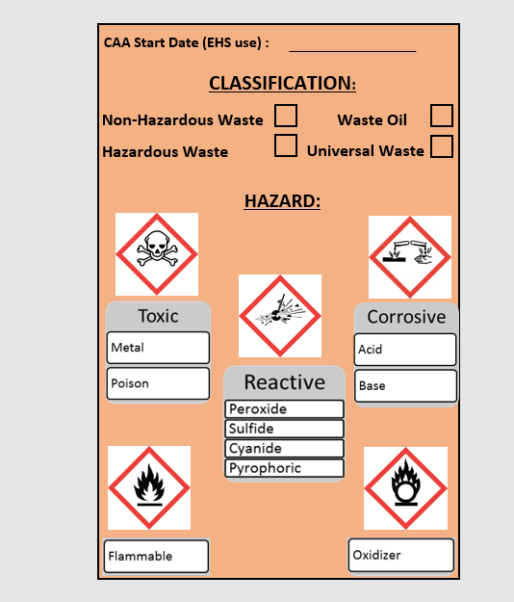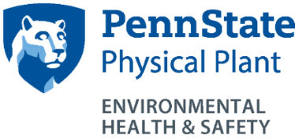

Chemical Spills in the SAA:

**STOP** the source of the spill

**CONTAIN** the spill

**CLEAN** up all small spills immediately using absorbent materials or universal spill pads

**CONTACT** EHS if replacement containers or secondary containment are needed or to report a sizeable spill

Major Spills:

**EHS:** (814) 865-6391 (M-F 8-5)

**University Police:** (814) 863-1111

The total volume of all hazardous waste containers in the SAA should never exceed 55 gallons.

Submit a waste request online at [www.ehs.psu.edu](http://www.ehs.psu.edu) to have waste removed from the SAA.

Containers must be closed, with the exceptions of adding, removing, or venting waste. Containers must be in good condition and stored in secondary containment.

Use the Waste Guidance Document to complete the waste determination on back of tag. **This must be done at the start of waste generation.**

If your item is not included on this chart, contact EHS at   
(814) 865-6391.

The satellite accumulation area must be inspected weekly. Containers must be labeled with a completed orange waste tag, including the waste determination section on the back of the tag.

**SPILLS**

**CONTAINER INFO**

**WASTE TAG**

**SATELLITE ACCUMULATION AREA**

**LOCATION: ______________________________________________________**

**RESPONSIBLE PERSON: _____________________________________________**

**CONTACT NUMBER: ________________________________________________**