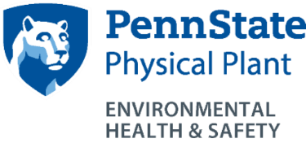
Snapshots!
Asbestos Management Program
http://ehs.psu.edu/asbestos-management/overview
EHS Contacts: Brett Eddinger, bae5082@psu.edu
Steve Rohrbach, szr15@psu.edu
814-865-6391
Who does this program apply to and why does it exist?

- This program applies to all University employees and students
- Asbestos-containing building materials are found in many of our buildings. Examples include: flooring, thermal insulations, plasters, wall and ceiling systems, window/door caulk and glazing putties, etc.
What are the key requirements of this program?
- ALL DAMAGED BUILDING MATERIALS must be reported for repairs to supervisors or maintenance contacts, regardless of whether they may contain asbestos or not.
- No one may handle known asbestos-containing materials unless they are licensed by the PA Department of Labor and Industry or have written approval from EHS.
Responsibilities of Safety Officers, Facility Coordinators, Managers, and Supervisors:
- Identify maintenance, janitorial, housekeeping, and other employees who require Asbestos Awareness Training and ensure that this training is received.
- Ensure that non-maintenance employees and students do not damage building materials.
- Address reports of building material damage in a timely manner.
- Contact EHS prior to all renovations and demolitions.
Responsibilities of all employees and students:
    - Do not handle or disturb known or suspect asbestos-containing materials unless your job description and training allow. Remain observant and report damage of all building materials.
Training
    - Asbestos Awareness Training is required annually for those who may come in contact with asbestos during their normal work activities.
Recordkeeping
    - Employees who attend Asbestos Awareness Training must register on the LRN.
For additional information
PADEP http://www.dep.pa.gov/Business/Air/BAQ/BusinessTopics/Pages/Asbestos.aspx#.Vug-J0bYius
OSHA http://www.osha.gov/SLTC/asbestos/index.html
US EPA http://www.epa.gov/asbestos/

