

**5**

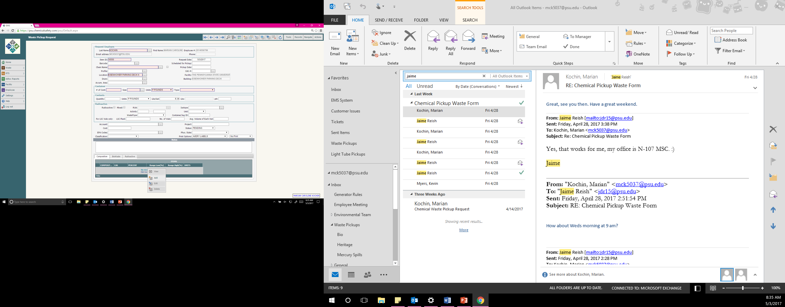

*This is a system generated number, not your PSU ID*

**LAST NAME, ITEM ID,** AND **LOCATION** *fields are auto filled by system.*

*Contact EHS if incorrect.*

These fields must be completed for the waste request to be submitted. Populate **# CONTAINERS** and **SIZE** with a numeric value. Select **UNITS** and **TYPE** from the drop down lists

Please add any **NOTES** here.

**Phone number, additional location information,**

**Need empty containers / tags/drums**

Add mixture compositions by selecting   
**CLICK HERE FOR OPTIONS** in the **COMPOSITION** tab.

Click **ADD** to add the first component.

Right Click on the first component to add additional components.

Type in your **CHEMICAL NAME** and select it from the drop down list. For a mixture, create a name, and select the checkbox to save it for future use.  
*(You must add the components of the mixture in the* ***COMPOSITION*** *tab at the bottom of the request form- SEE STEP 4)*

*When finished with your request,  
 click the* ***SAVE*** *button to submit!!!*

**1**

**2**

**3**

**ONLY FIELDS HIGHLIGHTED IN PINK NEED TO BE COMPLETED FOR SUBMISSION!!**

**4**

**5 STEPS TO CREATING A CHEMICAL WASTE REQUEST**

***Please contact EHS at (814) 865-6391 with additional questions***