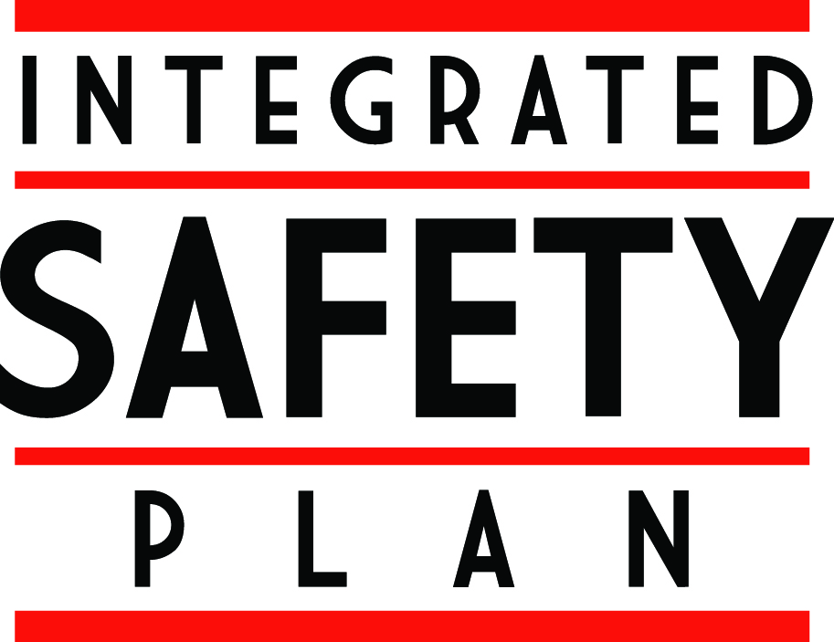

Integrated Safety Plan
ISP Self-Review, Part I

The Integrated Safety Plan (ISP) at Penn State is based upon the implementation of three core elements: Leadership Commitment, Employee Involvement, and Self-Review. This document serves as the initial step in completing the self-review process. The purpose of this form is to identify the general safety issues that impact participating departments.

Each question should be answered with either a “Yes” or “No” response. Questions which generate a “Yes” response will be further evaluated in Part II of the self-review process.

 | Yes | No
- Are there any recognized hazards within this department that require the use of personal protective equipment (PPE)?
- Does this department include any laboratory areas?
- Does this department use or store any chemicals in non-laboratory areas?
- Does this department have any employees who could be exposed to blood or infectious bodily fluids during the course of their work?
- Does this department include any laboratories where hazardous biological materials are used?
- Does this department generate any infectious waste?
- Do emergency evacuation plans need to be developed for any areas within this department?
- Does this department have any employees who perform electrical work?
- Do any departmental employees access unguarded locations six feet or more above lower surfaces?
- Do employees in this department use powered industrial trucks?
- Do employees in this department use any form of aerial lift equipment?
- Does this department include any machine shop areas?
- Do employees in this department service or maintain equipment which could cause injury if unexpectedly energized?
- Do employees within this department enter confined spaces?
- Are there any respiratory hazards associated with department work activities (harmful dusts, fumes, mists, smokes, sprays, or vapors)?
- Are employees in this department involved in any asbestos-related activities?
- Are employees in this department exposed to noise levels greater than 85 decibels averaged over an eight-hour shift?
- Do employees in this department complete any hot work (i.e. welding, cutting, soldering, grinding, etc.)?
 | Yes | No
- Does this department have or use any lasers?
- Does this department have or use any radioactive materials, including sealed sources in machinery or equipment?
- Do employees in this department use any x-ray producing equipment?
- Does this department generate any hazardous waste?
- Do employees in this area ship hazardous materials, chemicals, biological materials, dry ice, dangerous goods, research samples, or diagnostic specimens off-site?
- Does this department have any non-mobile, fixed tanks with a capacity greater than 55 gallons?
- Do employees in this department use, transport, mix, or apply pesticides or enter plots that have been treated with pesticides?
- Does this department have any employees directly exposed to live animals, animal bedding, animal tissue, or animal fluids?
- Are there any ergonomic or material handling issues within this department?
- Do employees in this department operate any cranes or hoists?
- Do employees use or erect any form of scaffolding?
- Does this department have any Automated External Defibrillators (AED)?
- Are there any other unique safety hazards within this department? (If “Yes”, provide further information in “Comments” section)

Comments
(Please include any additional information related to your responses that you feel will be helpful)

Self-Review Completed By:

Completion Date:

