REVISION HISTORY
Revision No. | Reserved | Document/ Change Summary | Document Lead
2016 – 00 |  | SOP Task Group:  EHS – M. Linsenbigler, T. H. Derr, P. Muldoon, G. Conklin,  J. Mazzoni, B. Baros, R. Segura; T. Cygan  OPP – M. Gates, D. Fronk, L. Fisher | EHS – ML, THD

TABLE OF CONTENTS
SECTION NO. | SECTION ID | PAGE NO.
1.0 | Statement of Purpose | 2
2.0 | Introduction | 2
3.0 | Applicability & Scope | 2
4.0 | Terms & Definitions | 2
5.0 | Hazards Associated with Elevator Access & Service | 4
6.0 | Roles & Responsibilities | 5
7.0 | Safe Work Procedures | 5
8.0 | Information & Training | 8
9.0 | Records | 9
10.0 | References | 9
11.0 | Photographs | 9

- Statement of Purpose
This guidance is intended to provide information regarding the hazards, risks, roles/responsibilities, controls, and other safe operating protocol, for the safe access to, and service of elevators on Penn State property, as needed for life safety of employees and the public, and for the protection of property. The contents of this guidance document should be communicated with all Penn State elevator service personnel. In certain cases, additional information will be required to address specific hazards encountered in a given environment.

This information should be an integral part of necessary training and all pertinent EHS programs, such as the permit-required confined space and lock-out/tag-out programs supporting the protection of life and property.

- Introduction
Elevators are used across the Penn State system. These elevator systems are depended upon by Penn State employees, contractors, and the general public for the safe transport of personnel and freight within Penn State facilities. Elevator systems may vary by type (hydraulic vs. electric, etc.) and design, and may have varying means of access for the service of electrical, mechanical, and hydraulic components and controls. Elevator systems include “pits” or service areas located beneath the elevator shaft or car, in which certain equipment components are staged and necessarily maintained, thus these pits constitute a “confined space” by OSHA definition. Access to these pits require specialized procedures and equipment, as well as specific training to ensure personnel can enter safely to perform work. Additionally, since elevators employ various electrical and electromechanical devices, controls, switches and other energy carrying components, these hazardous sources of energy must also be safely controlled per OSHA requirements, when accessed for service.

These hazards are further described at section 3.0 of this SOP.

- Applicability & Scope
This Standard Operating Procedure shall pertain to the safe access, service and maintenance of service elevators, and all associated equipment, designed for the safe transport of personnel and materials within Penn State facilities.

- Terms & Definitions

Buffer stands – Stands that are placed in the elevator pit to contain the props, which support the load of the elevator car.

Confined Space – a space which possesses all of the following characteristics:

(1) is large enough and so configured that an employee can bodily enter and perform assigned work;

(2) has limited or restricted means for entry or exit (for example, tanks, vessels, silos, storage bins, hoppers, vaults, and pits are spaces that may have limited means of entry.); and

(3) is not designed for continuous employee occupancy.
Confined space entry procedures are fully explained in the Penn State Confined Space Program.

Elevator – Per OSHA 1917.116(a), “ ‘Elevator’ means a permanent hoisting and lowering mechanism with a car or, platform moving vertically in guides and serving two or more floors of a structure. The term excludes such devices as conveyors, tiering or piling machines, material hoists, skip or furnace hoists, wharf ramps, lift bridges, car lifts and dumpers.’’ At Penn State, passenger elevators, freight elevators, and dumbwaiters shall all be considered elevators.

Hoistway – “Elevator shaft”, or area containing mechanical track and equipment supporting safe movement of the elevator car.

Hoistway door – Entry door to the elevator shaft, which may be manually controlled.
Lockout/ Tagout – Procedure whereby a lock and/or tag device is used to hold an energy-isolating device (such as a switch, valve, etc.) in the “off” or safe position.
Penn State “9-Step”
Lockout Tagout Program – Refer to the Penn State Lockout Tagout Program for definition of stepwise requirements.

Pit hydraulic valve – Where applicable, controls hydraulic fluid flow serving the elevator.

Props – Schedule 40 iron or steel pipe, or other structural tubing or articles which support the elevator car when all hazardous energy sources are disengaged.

Pit Ladder Per ASME 17.1 Elevator code -2002 Addenda –
[There shall be installed in the pit of each elevator, where the pit extends more than 900mm(35 in.) below the sill of the pit access door, a fixed vertical ladder of noncombustible material, located within reach of the access door. The ladder shall extend not less than 1 200 mm (48 in.) above the sill of the access door. The rungs, cleats, or steps shall be a minimum of 400 mm (16 in.) wide. When unavoidable obstructions are encountered, the width shall be permitted to be decreased to less than 400 mm (16 in.). The reduced width shall be as wide as the available space permits, but not less than 225 mm (9 in.). The rungs, cleats, or steps shall be spaced 300 mm (12 in.) on center. A clear distance of not less than 180 mm (7 in.) from the centerline of the rungs, cleats, or steps to the nearest permanent object in back of the ladder shall be provided. When unavoidable obstructions are encountered, the distance shall be permitted to be reduced to 115 mm (4.5 in.). Siderails, if provided, shall have a clear distance of not less than 115 mm (4.5 in.) from their centerline to the nearest permanent object. The nearest point of the ladder shall be within 1 000 mm (39 in.), measured horizontally from the means to unlock the egress door from the pit. Pit access by a ladder shall not be permitted when the pit floor is more than 3 000 mm (120 in.) below the sill of the access door, except where there is no building floor below the bottom terminal landing, this height shall be permitted to be greater but not more than 4 200 mm (165 in.).]

Refer to the Penn State EHS Confined Space and Lockout Tagout programs for additional definitions.

- Hazards Associated with Elevator Access & Service
  - Specific Hazards

5.1.1 Atmospheric
Oxygen Deficiency and Asphyxiation – Elevator pits, which are located below building floor grade, and depending on facility type, may serve to contain oxygen-displacing gases, if present. Oxygen-displacing gases may include: carbon dioxide, helium and noble gases, nitrogen, etc. Gas cylinder leaks may build up within elevator pits, to displace oxygen.

Liquid nitrogen dewars may be a significant source. Liquid nitrogen expands by approximately 700 times in volume, going from liquid to gas at ambient temperature. If the oxygen concentration falls below 18% adverse effects will occur resulting in loss of mental alertness and performance combined with distortion of judgment. In atmospheres containing less than 10% oxygen, death by asphyxiation is rapid.

Toxic and flammable gases – May include numerous types of gases, often stored in compressed gas cylinders, and which may have various effects on the human body. Certain toxic gases may also be heavier (denser) than air, and accumulate in sub-grade spaces.

Flammable gases (such as hydrogen, carbon monoxide, methane, or acetylene) may also be toxic, heavier than air, and accumulate in elevator pits or confined spaces, if present. Flammable gases which are present in the flammability or explosive range by percent gas in relation to air, may combust in the presence of a spark or ignition source. Proper ventilation is the primary means of controlling the build-up of toxic, flammable, or oxygen-displacing gases.

Oxygen-enrichment may also occur where compressed oxygen, or liquid oxygen is maintained, which may lead to health symptoms and/or an explosive environment. Escaping liquid oxygen, while not a flammable gas by itself, can combine with combustible materials and cause spontaneous combustion. Oxygen clings to clothing and cloth items and presents an acute fire hazard for approximately one-half hour after exposure.

5.1.2 Other Potential Hazards

Mechanical, electrical, slips-trips-falls, crushing, pinch and other physical hazards, and hazardous energy may accompany elevator service and related work. Please consult pertinent Penn State programs and support at the Penn State EHS webpage

http://www.ehs.psu.edu/

- Roles & Responsibilities
  - Maintenance Supervisors, and Penn State elevator service personnel are responsible for ensuring that this SOP is implemented and that SOP dissemination is provided to the relevant Penn State work unit and campus, including: all affected University Park and Campus faculty, staff and students, and ensuring that suitable training, maintenance and inspection procedures are set up and documented, supporting safe elevator access and service.

6.2 Facility Coordinators/ Safety Officers are responsible to review specific elevator SOP’s in coordination with Maintenance Supervisors and Penn State elevator service personnel to ensure SOP’s address the pertinent hazards present, within a specific location, and that additional or alternate procedures are implemented for the safety and health of employees.

Principle determining factors will include: exhaust ventilation, types and quantities of gases or cryogen stored and/or used in proximity to elevators, and other factors.
    - Additional safety reviews must follow any system modification to ensure that no potentially hazardous condition has been overlooked or created and that updated operational and safety procedures remain adequate.

7.0 Safe Work Procedures

7.1 Personnel Safety – Personal Protective Equipment (PPE)

Standard personal protective equipment which must be used during elevator service includes:
- Safety glasses with side shields,
- Suitable work gloves
- Safety shoes
- Long hair must be pulled back or restrained, as necessary to protect against becoming caught in machinery or moving parts

Additional specialized personal protective equipment may depend on type electrical service which must be encountered. Consult EHS for assistance.

7.2 Elevator Work Procedure
SUMMARY: Verify the hoistway door interlock stops the car in flight, and that the pit switch, and other controls are functioning properly, i.e. verify equipment is de-energized, and verify by pit switch in ‘off’ position. With respect to hydraulic elevators, if hydraulic valve is in machine room, close valve for hydraulic line. If located in the pit, do NOT close the hydraulic valve.

KEY ELEMENTS:
- Complete operational control of the elevator must be maintained at all times while conducting this procedure.
- Procedure requires that two controls must be tested and verified prior to entry into the hoistway.
- The hoistway door must be mechanically blocked at critical points during the process.
- Each elevator service technician must be able to demonstrate and/or explain essential policies and procedure for how to maintain control of the elevator.
PRELIMINARY HAZARD ASSESSMENT & REQUIREMENTS:
- Identify, assess, and eliminate or control any hazards which may impact elevator entry, such as hazards associated with water influx, oil, electrical, and any work-related hazards introduced to the elevator pit/ confined space.
- Based upon historical measurements, most elevator pits do not accumulate atmospheric hazards, particularly where no hazards have been introduced, nor spills have occurred within the elevator pit. In absence of no supporting information, or where potential hazards may exist due to presence of actual nearby hazards (gas or cryogen cylinders, or combustion engines or sources, etc.), representative/continuous air monitoring, or objective determinations must be conducted. Refer to the Penn State Confined Space Program for entry requirements, including but not limited to completion of a Penn State CS Permit. Where potential or recognized atmospheric hazards are present, continuous ventilation may be used in conjunction with an Alternate Entry SOP, in lieu of a Confined Space Permit. Refer to PS Confined Space Program.
- Verify the installation of a proper elevator pit ladder prior to entry, and properly use for elevator pit entry. Notify FACILITY COORDINATOR OR RESPONSIBLE PARTY as needed to secure/ install ELEVATOR PIT LADDER.

7.2.1 ELEVATOR ENTRY FOR ARTICLE RETRIEVAL (ONLY)
7.2.1.1 APPLICATION:
Retrieve keys, cellular phone or small articles. Collect items and leave immediately.
7.2.1.2 ARTICLE RETRIEVAL PROCEDURE (ONLY):

1) Take control of the elevator. Take car to the bottom landing.

2) Use elevator buttons – press two (2) floor landing calls, and step off the elevator at the lowest landing.

3) Once car door closes, elevator will start up.

4) Using the elevator door key, open the elevator approximately 6 inches when the car has moved a distance of about 7 feet above current floor level. The elevator should stop as the door is opened, as verification that the hoistway door interlock will open the safety circuit.

5) Insert the door wedge tool to block the hoistway door open.

6) Turn on the elevator pit light, and take a visual picture of the elevator car floor location (i.e. include in the photographs- limit switch, rail bracket, sump pump pipe clamp.

7) Locate and engage the pit switch (OFF POSITION). Pit switch is RED in color (may be a toggle switch to break circuit; pit switch is a redundant control).

8) Remove the door wedge tool, and close the hoistway door.

9) Depress bottom floor “hall call” (should now be non-operational), and wait 20 seconds.

NOTE: For Hydraulic Elevators – Close the pit valve to hydraulic line if pit valve is located in the machine room. DO NOT CLOSE off the pit valve, if located in the elevator pit.

10) Re-open hoistway door, to verify the elevator has not moved.

11) Re-insert the door wedge tool, and block the hoistway door open (1/2 open or less)

12) Verify the hoistway door interlock stops the car in flight, and that the pit switch, and other controls are functioning properly.

13) Prepare and execute all Penn State confined space entry and other pertinent procedures, as above highlighted at PRELIMINARY HAZARD ASSESSMENT & REQUIREMENTS.

14) Verify the installation of a proper elevator pit ladder prior to entry, and properly use for elevator pit entry.

15) Immediately collect article(s), and

16) EXIT elevator pit. Remove door wedge tool and close lowest hoistway door.

17) Open the hydraulic shut-off valve (hydraulic elevator, as applicable).

18) Re-insert the wedge tool; block hoistway door open (1/2 open or less).

19) From bottom floor landing, turn pit switch to ON position.

20) Turn the elevator light switch to OFF position.

21) Remove the wedge tool and close hoistway door.

22) Elevator will now be in normal operation.

23) Press call button to the floor landing.

24) Ride elevator to confirm proper operation.

7.2.2 ENTRY FOR ELEVATOR SERVICE

7.2.2.1 APPLICATION:

All other elevator entries such as but not limited to: troubleshooting, sump pump removal, spill clean-up, inspection, servicing/maintenance, etc. Campus Personnel: Limited to spill clean-up, sump-pump removal, repair, replacement. SERVICE TO ELEVATOR ONLY BY QUALIFIED SERVICE PROVIDERS.

7.2.2.2 ENTRY FOR ELEVATOR PIT SERVICE OR MAINTENANCE PROCEDURE:

1) – 9) REPEAT STEPS OUTLINED ABOVE AT 7.2.1.2.

10) Perform true 9-Step Lockout/Tagout Procedure associated with Elevator electric service:

a) Verify power/operation of meter at low-voltage source (110v)

b) Check phase-to-phase, and phase-to-ground at controller lugs

c) Open disconnect,

d) Re-check phase-to-phase, and phase-to-ground

11) Re-open hoistway door, to verify the elevator has not moved.

12) Re-insert the wedge tool, block the hoistway door open (1/2 open or less)

13) Prepare and execute all Penn State confined space entry and other pertinent procedures, as above highlighted at PRELIMINARY HAZARD ASSESSMENT & REQUIREMENTS.

14) Verify the installation of a proper elevator pit ladder prior to entry, and properly use for elevator pit entry. Refer to References, 10.4.

15) Upon entering elevator pit, close the pit hydraulic valve (if valve is in pit).

16) Install lockout device, lock and tag on pit valve.

17) Install props in buffer stands. Props must be structurally capable to hold elevator car weight.

18) Close hoistway door to within 6 inches of closed position, and block with wedge tool.

19) Perform the necessary work, following verification of all electrical LOTO procedures.

20) Prior to leaving pit, review all pertinent steps for safe closure of work, including all necessary lock-out/tag-out steps.

21) Open the pit hydraulic shut-off valve (as applicable)

22) Remove the props, buffer stands, and as pertinent, secure within pit.

23) Exit pit.

24) Re-insert the wedge tool; block hoistway door open (1/2 open or less).

25) From bottom floor landing, turn pit switch to ON position.

26) Turn the elevator light switch to OFF position.

27) Remove the wedge tool and close hoistway door.

28) Remove all LO/TO equipment.

29) Elevator will now be in normal operation.

30) Press call button to the floor landing.

31) Ride elevator to confirm proper operation.

8.0 Information & Training Requirements

8.1 Training Requirements – Elevator Service Technicians, Maintenance Staff & Supervisors, Other Responsible Parties

The following minimum training requirements are required for elevator service personnel:

8.1.1 Penn State Confined Space Entry – minimum initial aspects for safe confined space entry, monitoring, and use of confined space permit or alternate entry procedure.

8.1.2 Minimum initial training for control of hazardous energy (LO/TO) and annual evaluations.

8.1.3 Minimum annual or periodic refresher in oil or spill control procedures.

8.2 Training Proficiency – The effectiveness of training shall be determined via results of a proficiency test, administered to each individual completing the training session, and documented.

8.3 Training Documentation – Training documents and records shall be located within the applicable work unit, and/or the EHS department. Such records shall include the nature of the training, sponsor, content, the date and length of time employed, instructor(s), participants, and training proficiency results by participant.

8.4 Training Frequency – Training shall be conducted on initial assignment, and as necessary for applicable personnel to retain proficiency. Certain training should be conducted annually, as necessary to refresh concepts or practices, and/or as required by EHS programs.

9.0 Records

9.1 All monitoring, permit, training, and procedural records shall be maintained in accordance with requirements of the applicable Penn State EHS programs.

9.2 Elevator access service, equipment maintenance records, and supporting documentation shall be maintained on file by the responsible work unit, and be made readily available to EHS, or other EHS-approved designees, upon request.

Records shall be maintained according to current Penn State requirements.

10.0 References
The following general references are provided for user support:

10.1 Wedge tool suppliers - RESERVED

10.2 Instructional videos - RESERVED

10.3 National Elevator Industry Equipment Handbook
10.4 ASME Standard A17.1 – Safety Code for Elevators and Escalators, 2002 Addenda, Section 2.2.4, Access to Pits
11.0 Photographs
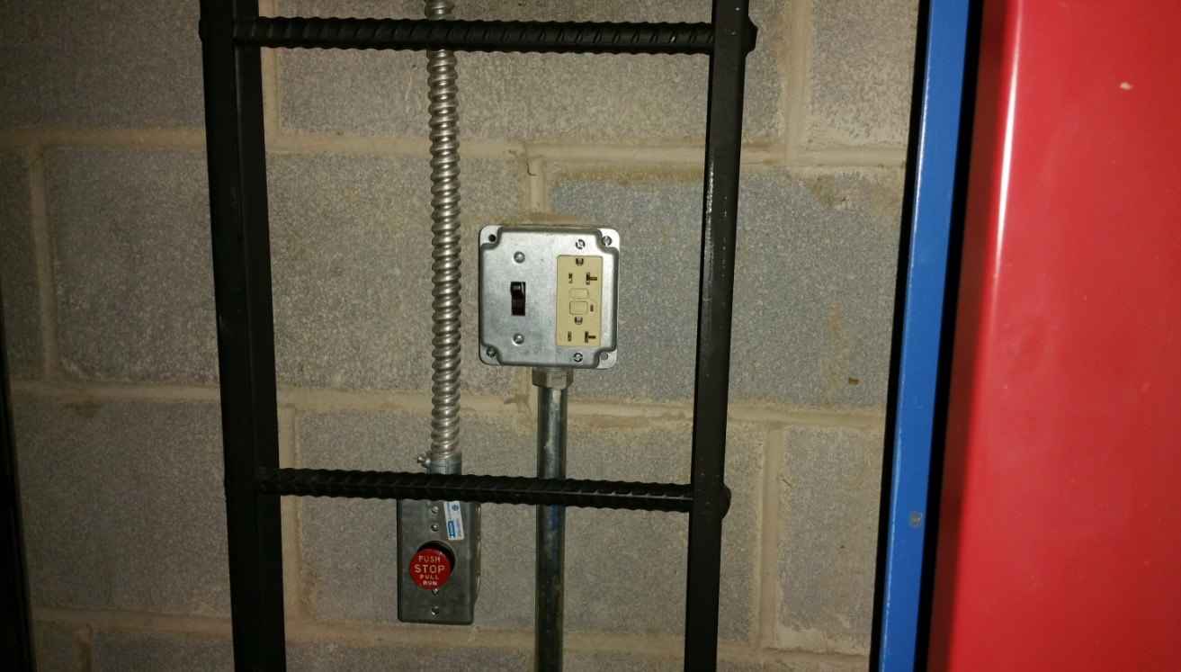

Pit Switch (Stop- red push/pull) Pit Light Switch (beside recepticle)
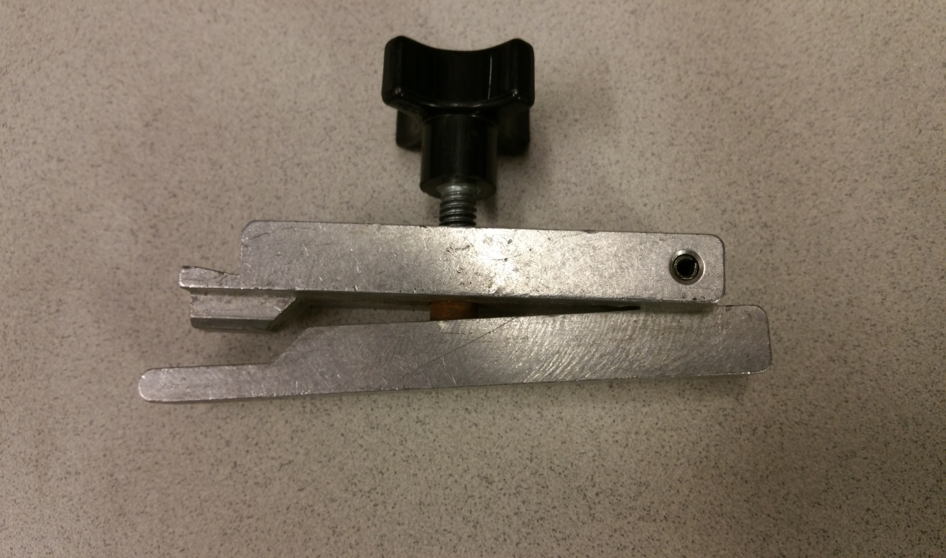

Elevator Door wedge tool

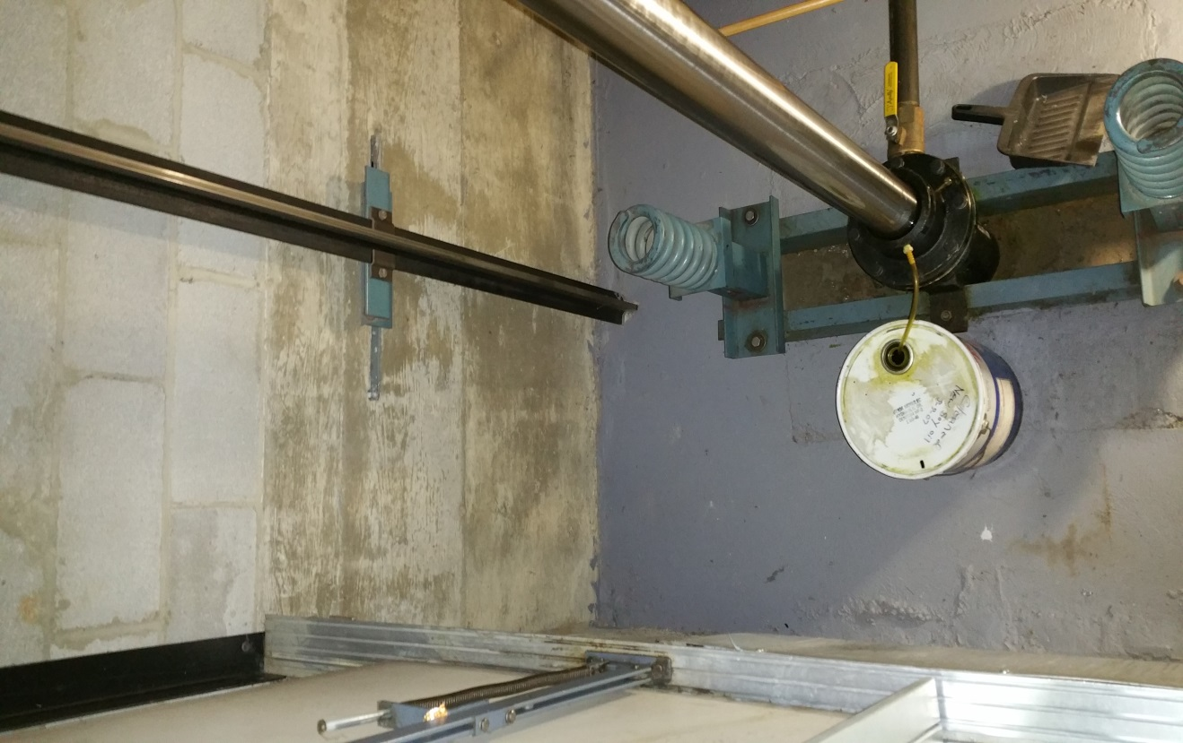

Elevator pit valve
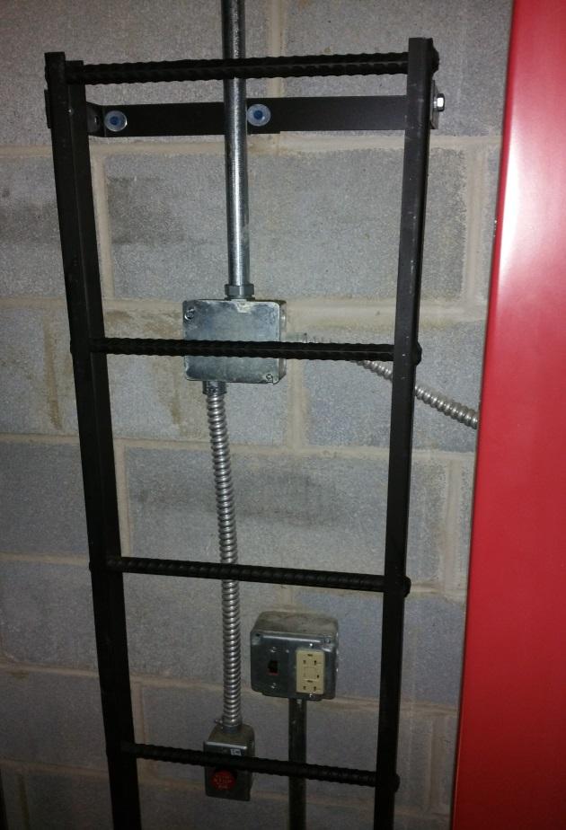

Elevator pit ladder

