(SOP) Standard Operating Procedure
For PCB HALT System
03/24/2022

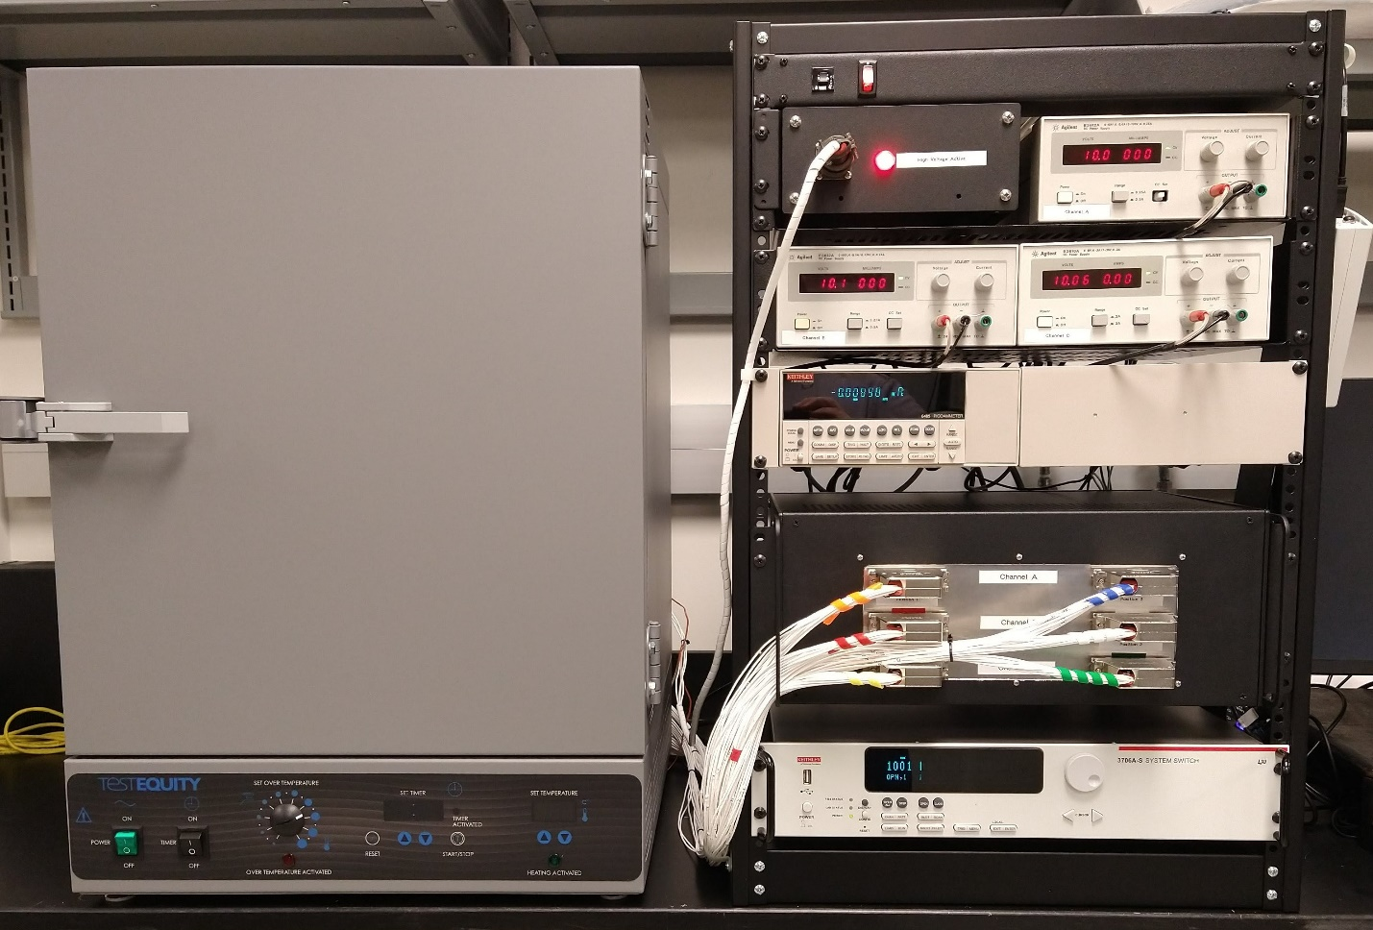

EMERGENCY SHUTDOWN PROCEDURE:

If Possible:

Step 1. Turn off the high voltage power supplies and other measurement equipment by using the front panel Main Power switch.

Step 2. Turn off the oven using the front panel main POWER switch.

Location:
N221A Millennium Science Complex Building

LEO Equipment Name:
Electrical: PCB HALT

Chemicals:
- None used for this process.

Chemical Hazards:
- None to note.

Other Hazards:
High Surface Temperatures-
- The internal oven surfaces become hot during use and pose a burn hazard. Verify the oven is at room temperature before opening the door.

Multiple Lethal High Voltage Sources-
- This system is designed to simultaneously use up to 3 independent 1kV voltage supplies, one per channel. Ensure all high voltage supplies are set to zero and turned off before opening the oven door for sample loading/unloading.
- High voltage can be present on the cable connections between the High Voltage Interlock and voltage supplies when the supplies are powered on. Ensure all high voltage supplies are set to zero and turned off before connecting, disconnecting, or reconfigure these cable connections.

Printed Circuit Board Sample Holders (Material Limitations)-
- Not all printed circuit board materials can be used to high temperature. Do not exceed the temperature limit of your board material.

Engineering Controls:
- An interlock switch on the oven door prevents high voltage application to the samples while the door is open by:
  - Opening 3 high voltage relays disconnecting each measurement channel from their perspective high voltage power supply/supplies.
  - Opening 3 relays (one for each channel) that can be used to switch off high voltage supplies equipped with digital enable type interlock.

- A red LED light illuminates on the High Voltage Interlock control box when high voltage supplies are actively connected to the samples. Never open or enter the oven while voltage is applied. Ensure all high voltage supplies are set to zero and turned off before opening the oven door or loading/unloading samples.

- The oven is intended to be an interlocked safety enclosure for the samples. All work must be performed inside the oven with the door shut. Do not run any kind of auxiliary cables though the oven door or any other opening.

Required personal protective equipment:
- For user operation - Whatever is currently required to work in this lab.
- For maintenance/service of home-built test circuits/equipment - Whatever is currently required to work in this lab with the following conditions:
  - All high voltage supplies (up to 3 supplies) are set to zero output, powered off, and disconnected from the system.
  - The High Voltage Unification box is installed and connected to a power supply of less than 40 volts maximum.

Spill response measures:
This process does not include the use of any chemicals. No spills are anticipated.

Waste disposal procedures:
This process should not produce waste. All samples should be removed from the system when the measurement is complete. Inform a lab manager if your process will produce waste.

Decontamination procedures:
Hands should be thoroughly washed when work is completed.

Nonstandard use of this equipment:
All experiments run outside the scope of this SOP must be approved by a lab manager. This may include extra training and/or the development of an additional SOP before you begin the work.

Reporting equipment failures and other hazardous conditions:
All users must do the following in the event of an equipment failure or recognized hazard.
- Turn off affected equipment, if safe to do so.
- Post a warning sign identifying and hazard to other users.
- Report issues and relevant details to the lab manager immediately.
All malfunctioning equipment can pose a life threating danger to you and other users. Never just walk away from an equipment failure or other hazard without taking the above actions. Failure to do so may result in loss of access to equipment within the Electrical Characterization Lab.

Description of how to perform the experiment or operation:
This procedure should only be performed after you read and understand the User Manuals for the HALT System, the HALT system oven, and any connected power supplies.

Loading the samples
- Put on the required personal protective equipment.
- Verify the process temperature of the oven is at room temperature. If not, lower the set point and wait for the oven to cool.
- Check that all high voltage supplies (up to 3 supplies) are set to zero and powered off.
- Check that the High Voltage Active Light turns off when you open the oven door. If not, stop and ask a staff member for help.
- Load the sample boards into channels A – C.
- Close the oven door and confirm the High Voltage Active Light turns on.

Starting the measurement
- Set the oven to the desired temperature. Wait for the process temperature to stabilize.
- Open the measurement program and adjust the measurement parameters.
- Turn on the high voltage supplies and adjust for the correct process volage for each channel.
- Start/Run the program.

After all samples have failed
- Quit the program.
- Return all power supplies to zero output and turn them off.
- Lower the oven setpoint to the OFF position and allow the oven to cool.
- Check that the High Voltage Active Light turns off when you open the oven door. If not, stop and ask a staff member for help.
- Remove samples.
- Remove measurement data from the computer hard drive. This system isn’t intended for long term data storage.

